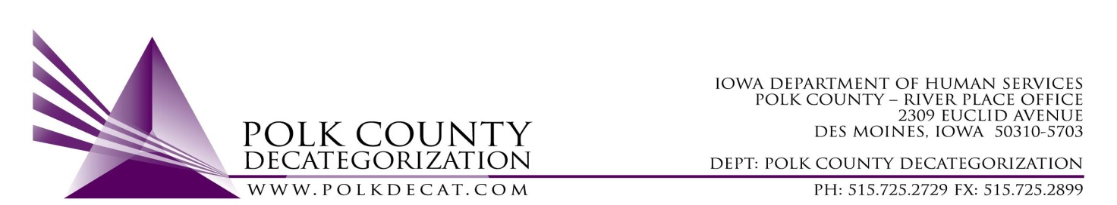

STEERING COMMITTEE MEETING
Friday, July 13, 2018
8:30 - 10:00 AM
Polk County River Place
2309 Euclid Avenue, Des Moines, IA 50310
Conference Room 2

MEETING MINUTES

Call to Order

Nikolle Ross, called the meeting to order at 8:32 am. Present were Teresa Burke, Jordan Kauffman, Ellen Overton, Diamond Denney, Tamra Jurgemeyer, Tracy White, Whitney Buchanan, Al Perez, Katie Kamienski, Kim Ayotte, Angela Wacker, and Joyce Bruce.

Review & approve minutes from April 13, 2018 meeting

Tamra Jurgemeyer moved to approve the minutes. Whitney Buchanan seconded the motion. All approved the motion, none opposed. The motion was carried.
Update on Steering Committee Structure to include CPPC Shared Decision Making Team

Members of Polk CPPC Shared Decision Making Team will begin joining the Steering Committee meetings each quarter. This will take the place of a separate SDM Meeting in that particular month. Combining the meetings will strengthen the linkage between Decat & CPPC, streamline communication, assist in aligning goals & priorities as well as helping the groups identify areas where their efforts differ. Increased collaboration & communication will provide another layer of information and transparency to the Polk Decat Board. Welcome to Whitney Buchanan, JCO, and Lori Shultice, Parent Partner, who join us today from CPPC Shared Decision Making!

Review of FY19 Polk Decat and CPPC Budgets

Happy Fiscal New Year!

Teresa Burke, Decat Coordinator, shared that DCAT5-15-002, PRC Nurse Services, was terminated at the close of FY18 due to budget constraints. Thanks to YESS staff & nurses for your work throughout the life of this contract.

FY19 Outlook
Polk Decat operates and manages contracts using dollars that may be carried over from up to two fiscal years ago. And we make plans for dollars up to 2 fiscal years in advance! In FY19, monies have been carried over from 3 funding sources: DHS, JCS, and Decat, from fiscal years 17 & 18, in varying amounts. DHS may not have any FY18 funds to carry over to Decat, as the fiscal situation at the Department is “budget neutral” – meaning DHS as a whole must operate within a total budget that was cut twice in FY18. State dollars can only be carried over for 2 years prior to expiring; Teresa indicated there are $42,399 of FY17 Decat dollars that will need to be spent in FY19 or that money will expire.

The group generated a lot of good discussion around the possibilities around how these dollars could be spent – one Steering Committee member mentioned the One Economy report, and the implications regarding the black community in Des Moines. Specifically, the conversation centered around increasing awareness & availability of mental health services; de-stigmatizing asking for help and seeking mental health treatment, especially among people of color; “what happened to you” v. “what’s wrong with you”; possible mental health access pilot program at Corinthian Baptist; mobile mental health care clinic. Lots of excitement was generated. Tamra said she would share a “Compassion Fatigue Survey” that had been used among staff at YWRC, and she did follow up by emailing that – should be available alongside these minutes.

When a Decat project “spends” money, the project is actually managing a procurement & contracting process on behalf of DHS, JCS, or both. In FY19, a number of contracts for important community-based services will be funded on behalf of DHS & JCS through Polk Decat. Any FY19 dollars that are unallocated or “unencumbered,” will be carried over to FY20 to fund those contracts.

Jordan shared the FY19 CPPC Budget, which includes a number of exciting events & learning opportunities. She asked for input from the group about their concerns and/or support regarding Polk CPPC becoming a Host Site for an AmeriCorps Member beginning in September. The APPC Member would build capacity within CPPC by managing Community-Based Family Team Meeting Activities, as well as assisting with the CPPC Weekly Resources page. The Steering Committee asked questions about the function & cost of the APPC Member, and was supportive of the idea.

Voting Items

Community Event Requests
Mt. Hebron Baptist Church – Statewide Leadership Conference / $500 - approved

Other Funding Requests
Project Iowa: Train the Trainer, Healing Art & Yoga / $500-$1000 - opposed
Project Iowa: Zen Dens / $500-$1000 - opposed
Orchard Place: 2018 Resilient Iowa Workshop sponsorship / ~$1000 - opposed
Al Perez/DMPD: Youth Police Academy / ~$6,000-$12,000 – more info requested
Adjorn by Nikolle Ross at 10:37a

