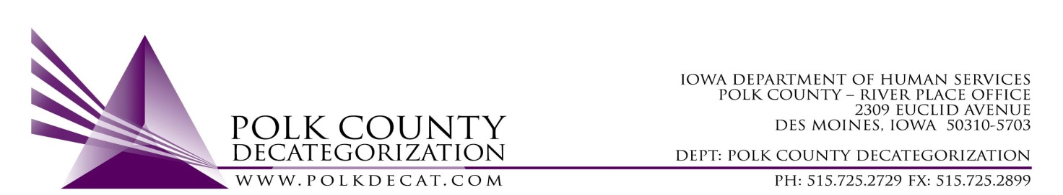

Special STEERING COMMITTEE MEETING
Friday, January 12, 2018
8:30 - 10:00 AM
Polk County River Place
2309 Euclid Avenue, Des Moines, IA 50310
Conference Room 2

MEETING MINUTES

Call to Order

Teresa Burke, sitting in for Nikolle Ross, called the meeting to order at 8:36 am. Present were Teresa Burke, Jordan Kauffman, Ellen Overton, Joyce Bruce, Kim Ayotte, Angela Wacker, Betty Devine, and Alison Mahoney Doran.

Review & approve minutes from October 13, 2017 meeting

Joyce Bruce moved to accept the minutes. Angela Wacker seconded the motion. All approved the motion, none opposed. The motion was carried.
Update on Decat Staff and Needs Assessment

Robert Smith visited from Washington DC to do an in-person interview for the Restorative Justice & Cultural Equity Coordinator position. Robert met many people from the community and was very well received. At this time, however, he has declined to accept the position due to financial circumstances. We wish him well in his future endeavors.

Jordan Kauffman talked about plans to embark upon a Community Needs Assessment. She will utilize Google Forms to reach stakeholders throughout Polk County. The purpose of the Needs Assessment is to identify community strengths as well as disconnects to help Polk County Decat, CPPC, and partner agencies improve connecting services to those people in need of them. In addition, the data gathered will help Polk Decat/CPPC better take on the role of a community information hub. Alison Mahoney at Proteus offered translation services for this project, and we are grateful.

Contract Performance Review and Desk Review

Jordan Kauffman shared highlights of the FY18 1st Quarter Contract reports. The Steering Committee can expect more detailed data in the future; specifically, hard numbers & percentages to back up performance measure assessments of Met/Not Met. Decat would like to create a Quarterly Report training for contractors to provide guidance & examples of the caliber of numeric & narrative data we seek from our contractors. This will be dependent on Decat team capacity moving forward.

The desk review was performed on DCAT5-15-002, the PRC Nurse Contract. These more structured reviews are an opportunity to spotlight our different contracts and to provide a more in-depth look at some of the services funded through the Decat project. The formal review process also serves as a learning opportunity for both contractor & monitor, as sometimes finer contract details are “lost in translation” of staff turnover over the course of the life of the contract.
Bid evaluators for March 5th & 6th and for April 5th & 6th

Kim A. expressed interest in participating in the evaluation for the Preventive Law & Guidance bids in March. Angela W. & Joyce B. expressed interest in participating in the evaluation for the Psychological Evaluations bids in April.

Update on community trainings

Polk Decat/CPPC has several community trainings in the hopper, including:
- Screenings of the films “Paper Tigers” and “Resilience”
- CPPC Immersion 101 (early May)
- “Day in the Life” of refugee/immigrant neighbors
- Community Building
- FTDM/YTDM
- Connections Matter (possible)

Adjorn by Teresa Burke at 10:01a

