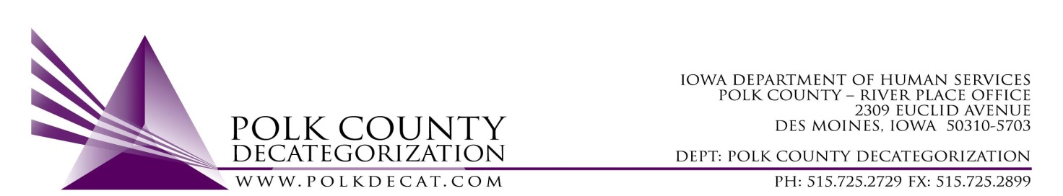

STEERING COMMITTEE MEETING
Friday, October 12, 2018
8:30 - 10:00 AM
Polk County River Place
2309 Euclid Avenue, Des Moines, IA 50310
Conference Room 2

A G E N D A

- Call to order & introduce any new CPPC Steering Members | Nikolle Ross
- Review & approve minutes from July 13, 2018 meeting | All
- Introduce Jackson Meister, AmeriCorps member, & review his role in Decat | Jackson & Jordan
- Review of FY19 Polk Decat, RJCE and CPPC Initiatives & Budgets and Committee input | All
- Voting items, if any | Jordan
- Adjourn | Nikolle Ross

