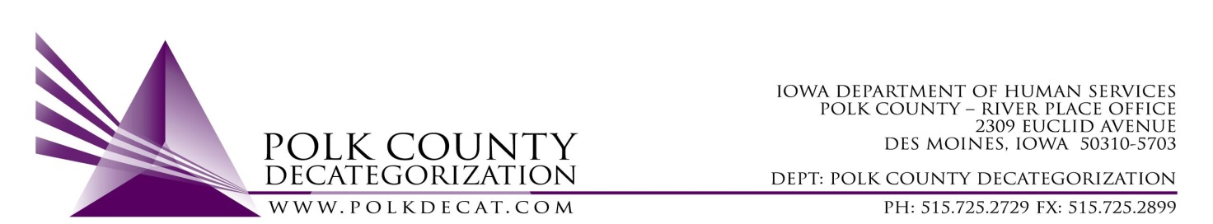

STEERING COMMITTEE MEETING
Friday, July 13, 2018
8:30 - 10:00 AM
Polk County River Place
2309 Euclid Avenue, Des Moines, IA 50310
Conference Room 2

A G E N D A

- Call to order | Nikolle Ross
- Review & approve minutes from April 13, 2018 meeting | All
- Update on Steering Committee structure to include CPPC Shared Decision Making team | Teresa & Jordan
- Review of FY19 Polk Decat and CPPC Budgets | Teresa
- Voting items | Jordan
- Adjourn | Nikolle Ross

