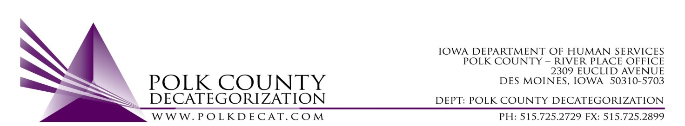

STEERING COMMITTEE MEETING
Friday, April 13, 2018
8:30 - 10:00 AM
Polk County River Place
2309 Euclid Avenue, Des Moines, IA 50310
Conference Room 2

A G E N D A

- Call to order | Nikolle Ross
- Review & approve minutes from January 12, 2018 meeting | All
- Update on Decat Staff | Teresa
- Update on FY19 new contracts and renewals | Teresa
- Needs assessment – finalize | Jordan
- Current and future community trainings – update and input | All
- How can we make Polk Decat data and reporting more cohesive? | All
- Adjourn | Nikolle Ross

