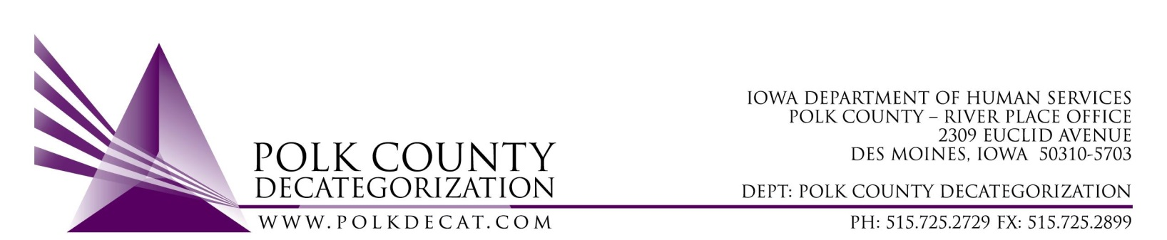

Special EXECUTIVE COMMITTEE Conference Call Meeting
Monday, October 29, 2018

Meeting Minutes

- Mike McInroy called the meeting to order at 9:05 am. Also present were Chad Jensen, Jim Ward, Betty Devine, Eric Kool and Teresa Burke.

- Discussion and vote: Whether or not to replace the Administrative Assistant position that will be vacated by Ellen Overton on November 2, 2018, and the salary range:
  - Mike expressed that he is not yet ready to vote on replacing the Admin Assistant position. It is unlikely that DHS will have any other funds to transfer to Decats for FY20 which means a substantial reduction or elimination of Flex Funds. Fulfillment, tracking and auditing of Flex Funds can take between 50% to 75% of this person’s time, depending on the week.
  - Given that this may be our future, Mike suggested that we wait to vote on this position until he has had a chance to look over the available funds more closely and have a discussion on the use for this role.
  - Teresa provided the board with information on the current salary levels of those covered under the Decat Contract. The Admin Assistant position also loads resource information on the website, tracks contract expenditures and assists with GAX tracking. The Admin Assistant position is responsible for various aspects of meeting functions. Teresa also reminded the board that Jordan Kauffman and she would be responsible for all Flex Fund fulfillment and tracking in the interim, along with our regular duties.
  - Chad moved that this vote be tabled until a later date. Jim seconded and the motion was carried.

- Adjourn: Eric moved to adjourn the meeting and Chad seconded. The meeting was adjourned at 9:23 am.

The next regularly scheduled meeting will be Thursday, October 11, 10:00 am in Conference Room 3.

