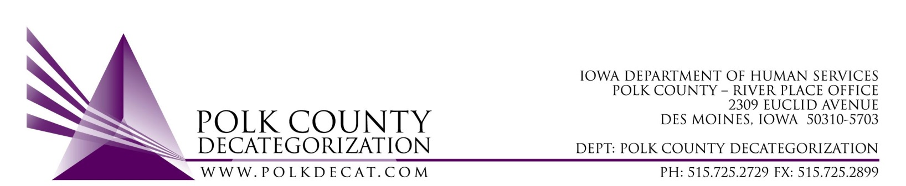

Polk Decat Special EXECUTIVE COMMITTEE Meeting
Thursday, April 26, 2022

Meeting Minutes

- The meeting was called to order, via Microsoft Teams video and conference call, at 1:01 pm by Eric Kool. Also present were Robert Smith standing in for Jana Rhoads, Tamra Jurgemeyer, John Hawkins, and Jim Ward, plus Teresa Burke. Absent was Jana Rhoads.

- Discussion and vote: Refer to Minutes Addendum on remainder of FY23 contract renewal voting.

- Next meeting:
  - Review of FY22 and FY23 budget
  - Possible voting on any other new contract activities
  - Other Decat, RJCE, CPPC and PAD activities

- Adjourn: Jim moved to adjourn the meeting at 1:26 pm. John seconded, all were in favor, and the motion passed unanimously.

The next regularly scheduled meeting will be on Thursday, May 12, 2022, via video and conference call.

tkdb

