POLK COUNTY COMMUNITY FAMILY AND YOUTH SERVICES
CHILD AND ADULT CARE FOOD PROGRAM
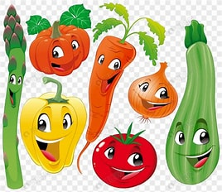
The program year is from October 1- September 30. Contact us at 515-286-2136 to sign up.
Benefits of being on our program
- Learning about feeding Nutritious meals to your daycare children to develop good eating habits.
- Learn about what foods that are Vitamin A and C and introduce a variety of foods.

- Free in person and on-line Nutrition training for our daycare providers on our program. Only 2 hours is required per year.
- Helping to make you more money by entering your work daily.
- Having access to CPR/First Aid classes for our daycare providers on our program.
- We come into the home 3 times a year. One of the visits we must view a meal. We also do fun activities with the children. We often hear from the children, “it is the food lady.”
- We love to hear when our daycare providers do fun activities with the children like pajama day or silly hair day.
- Checks are mailed out the 3rd full week of the month on a Wednesday.
- Learn about what components must be served for each meal and what is a whole grain.
- Importance of serving family style and eating with the daycare children is encouraged.
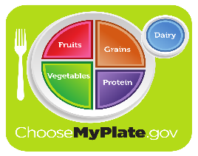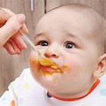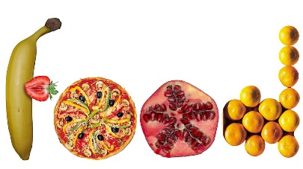
This Photo by Unknown Author is licensed under CC BY-NC

