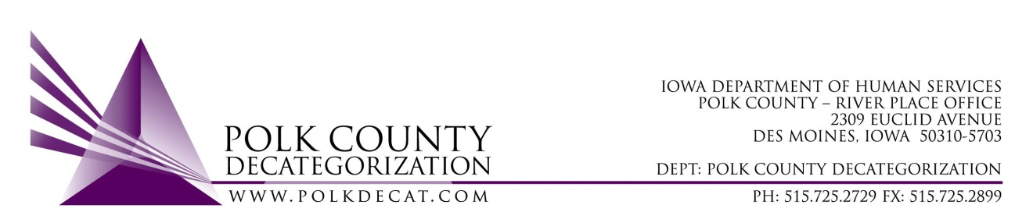

EVENT FUNDING REQUEST FORM

Polk Decategorization (DECAT), Community Partnerships for Protecting Children (CPPC) and Minority Youth & Families Initiative (MYFI) may have funding available to support local events that are family-friendly and include activities for all ages.

Please be aware:
- The maximum amount available for request for each event is $500.00.
- Include appropriate demographic information. For example, MYFI funds are specific to addressing the reduction of disproportionality of African Americans in the Child Welfare System. Any project considered for MYFI funds must include information specific to that demographic.
- Please allow a minimum of three weeks from the date of receipt of the fully completed request for a response on funding availability.

Name of Requestor: | Click here to enter text.
Sponsoring Agency/ Organization: | Click here to enter text.
Description of Sponsoring Agency/Organization | Click here to enter text.
Event Name: | Click here to enter text.
Event Date & Time: | Click here to enter text.
Event Location (including zip code): | Click here to enter text.
Brief Description of Event: | Click here to enter text.
Target Event Attendees:  (number and demographics) | Click here to enter text.
Requested Amount (up to $500.00): | Click here to enter text.
Specific Use for Funds: | Click here to enter text.
Check should be made out to: | Click here to enter text.
Address to send check to: | Click here to enter text.

Signature of Requestor: Click here to enter text.
** The Signatory Requestor must be authorized by the Sponsoring Agency or Organization to request and receive funds on behalf of the Sponsoring Agency or Organization. *

MEMORANDUM OF UNDERSTANDING

1. Purpose
This Memorandum is between the Iowa Department of Human Services, Polk County Decategorization and the above named Sponsoring Agency/Organization. This memorandum establishes the ways the Agencies and/or Organizations will support and exchange information about local events that are family-friendly and include activities for all ages.

2. Effective Dates
This M.O.U. shall remain in effect from date of approval by Polk County Decategorization, until cancelled in writing by either party, or upon the 40th day after the event takes place as noted in section “Event Date and Time”. This M.O.U. may be extended by mutual agreement of both parties for up to 30 days. If an extension is desired, it will be executed in writing at least 10 days before expiration of the current agreement.
3. Event Funding
Payment for the approved event will be sent no earlier than 30 days in advance of the event. If the event is delayed or canceled, a revised M.O.U. or termination will need to be completed according to section 2.
4. Reports
As part of this M.O.U. the Sponsoring Agency/Organization shall provide an executive summary of the completed event not more than 30 days after the date listed under “Event Date and Time”, that shall include the following minimum information:
- Brief description of event and how it meet the goals of either: the Decategorization, CPPC or MYFI initiative
- Number and demographics of the attendees
- Noteworthy Outcomes
5. Contacts
All questions, comments or other communications should be routed through the following contact:
Teresa Burke
Polk County Decategorization
DHS River Place Office
2309 Euclid Avenue
Des Moines, IA 50310-5703
tburke@dhs.state.ia.us

Polk County Decategorization: Approval Denial

_______________________________ ______________
Mike McInroy, Board Chair Date
FOR OFFICE USE ONLY:
DECAT ☐ CPPC ☐ MYFI ☐

