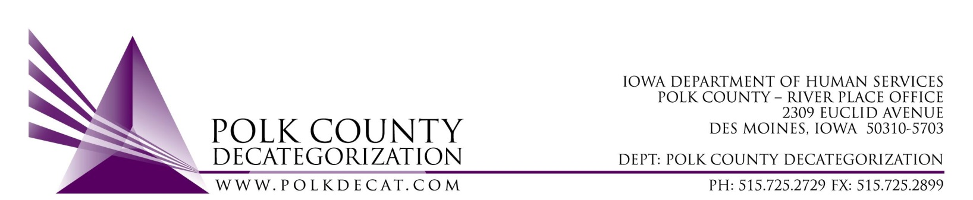

EXECUTIVE COMMITTEE Meeting
Thursday, December 10, 2020

Meeting Minutes

- The meeting was called to order, via Microsoft Teams video and conference call, at 10:09 am by Eric Kool. Also present were Jim Ward, Jana Rhoads, Robert Smith, Stephanie Swartz, Teresa Burke, and Decat Staff Cassie Kilgore. Absent was John Hawkins.

- The November 12, 2020, minutes were reviewed. Robert moved to approve the minutes and Jim seconded. All were in favor and the motion was carried by unanimous vote.

- The FY21 budget was provided to the board. Teresa pointed out to the board again that DHS is still short just over $149,000.00 in State funds to cover their contract obligations for FY21. Teresa, Jana and Robert met this week to discuss the shortfall and what funds were available to cover a portion of the shortfall in the Fiscal Agent contract. There are older Decat funds that will not carry-over to FY22 so $100,000.00 of those funds can be used to cover a portion of that shortfall, as well as some PSSF funds that will expire October 1, 2021. That should be more than suffient funds to cover the current spending levels by DHS Social Workers.

- Discuss and vote: Accept DHS Transfer of Funds letter:
  - No DHS Transfer of Funds letter has been received. Jana reported that transfer letters will be issued next week..
  - Based on this information, Stephanie moved to table this vote until the next board meeting. Jana seconded, all were in favor and the motion was carried unanimously.

- Discuss and vote: Possible adjustment of FY21 DCAT5-19-001 Fiscal Agent contract value based on available funding.
  - Based on the prior conversation (under item 4) , Jim moved to table this decision until the January Board meeting. Robert seconded, all were in favor and the motion was carried unanimously.

- Review contract performance level follow-up: Cassie Kilgore provided an update on monitoring efforts on those contracts who had performance measures that were regularly not met. Meetings were convened with each contractor
  - DCAT5-16-001, Sex Offender Treatment, Woodward: The contractor established a plan to expedite the ISTBA certifications for the two specialists who work with the S.O. Clients. Certificates of class completion have been sent to confirm their effots towards certification.
  - DCAT5-16-002, Re-entry & Transitioning Youth, Woodward: The meeting with the contractor covened December 8th so those notes will be available soon.
  - DCAT5-17-052, Restorative Justice & Cultural Equity Coordination: Due to changes in priority, staffing and general evolution of duties, some of the Scope of Work no longer applies. Diamond Denney is writing a list of her current job duties so she can report on those in her quarterly reports, as well as planning for a more updated Intergovernmental Agreement that more closely matches her work with DHS, JCS and Decat.
  - DCAT5-18-044, Behavioral Health Coordination, DMPS: The Scope of Work for this contract is a bit convoluted because the Deliverables are descriptive of Stephanie McFarland’s job, the Performance Measures are descriptive of what DHS and JCS wanted for data related to their clients in DMPS (information that Stephanie cannot access), and the real services that DHS and JCS wanted was the Intensive In-Home Services (Boys Town). Interestingly enough, the BT services are not for system-involved youth and families. Teresa met with Jana and Robert earlier this week to obtain their input on data they would like to see and options for these services on-going. At the time the contract was crafted, leadership at DHS did not want the BT services interfering with FSRP services, which is why system-involved families would be excluded. Jana believes the new Family Centered Services would have little to know overlap with the BT services and the goals would be completely different. Teresa will touch base with John Hawkins to get his feedback on this contract. More data has been requested from BT and DMPS on outcomes for those involved in the BT services.
  - DCAT5-19-003, Preventive Law & Guidance, Iowa Legal Aid: The requirements for attorneys from ILA to attend AMP, Agency Transition and Aftercare meetings is not netting the youth legal assessment referrals that would allow the contractor to meet the number of legal assessment goals in the contract. The attorney time could better be used either working with youth on assessments or providing legal assistance on issues that youth are actually encountering. ILA provided a set of questions that can be used to query transitioning youth to ascertain their legal liabilities. Cassie is working with Jan Huff to determine if these questions could be incorporated into the transition planning process.
  - DCAT5-20-060, Supports for African American Youth & Families, DMACC/Evelyn K. Davis Center: The main focus of this contract is the provision of Strong African American Families curriculum. The contract provided only one cohort of this class in FY20, serving only 15 people. Covid impacted the provision of these classes but they could have had at least 2 cohorts completed before the pandemic started. They are working on being able to provide the classes virtually, using funds that would normally cover food and child care costs to purchase tablets/laptops to address any barriers in families being able to meet virtually. A new cohort began in November so there should be information available soon on the success, or not, of the virtual model.

- RJCE and CPPC updates:
  - RJCE – Diamond is extremely busy with her regular activities with the AACCT meetings for both DHS and JCS, SWs of color support group, facilitating the Equity Team meetings for DHS Polk County, participation in the DHS Statewide Cultural Equity Alliance, assisting JCS in developing and implementing the Pre-Arrest Diversion programming with DMPD, IDI Assessments and follow-up consultations with DHS and JCS personnel and groups, and managing the DMACC Student Mentoring project.
  - CPPC – Cassie has organized several trainings. Iowa Mediation Service has provided a community training on Transforming Conflict and one is coming up soon on Motivational Interviewing. Also scheduled are three Domestic Violence community trainings that will be conducted by Leah Vejzovic. Cassie is also working with Sarah Welch (ACEs 360) and Andrea Dencklau on getting trained on implementing the Sesame Street initiative in the community and within DHS.

- Next meeting topics:
  - Transfer(s) of funds, if any
  - Possible adjustment to DCAT5-19-001, Fiscal Agent contract FY21 value
  - Another RFP for FY21, discussion and vote
  - Review of FY21 budget & re-look at financial status of Polk Decat
  - Review of DCAT5-16-002 contract monitoring activity
  - Initial FY22 Contract Renewal discussion
  - RFP Updates
  - RJCE and CPPC activities
  - Anything else

- Adjourn: Stephanie moved to adjourn the meeting at 11:11 am. Robert seconded, all were in favor, and the motion was passed unanimously.

The next regularly scheduled meeting will be Thursday, January 14, 2021, 10:00 am, via video and conference call.

tkdb

