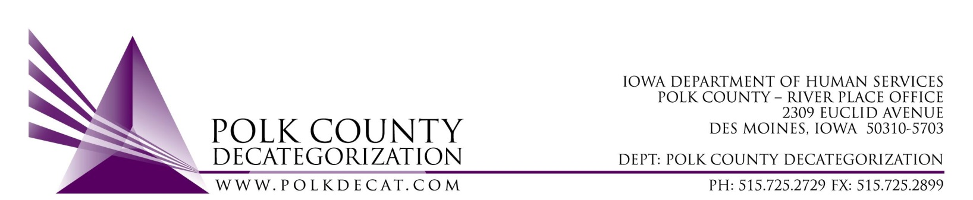

EXECUTIVE COMMITTEE Meeting
Thursday, November 12, 2020

Meeting Minutes

- The meeting was called to order, via Microsoft Teams video and conference call, at 10:03 am by Eric Kool. Also present were Andrea Vitzthum for Jim Ward who was absent, Jana Rhoads, Robert Smith, Stephanie Swartz, John Hawkins, Teresa Burke, and Decat Staff Cassie Kilgore.

- The October 8, 2020, minutes were reviewed. Andrea moved to approve the minutes and Robert seconded. All were in favor and the motion was carried by unanimous vote.

- The FY21 budget was provided to the board. Teresa reminded the board that DHS is still short just over $149,000.00 in State funds to cover their contract obligations for FY21. It was also indicated that there are other available funds to fill some of those gaps.

- Discuss and vote: Accept DHS Transfer of Funds letter:
  - No DHS Transfer of Funds letter has been received. Jana reported that there will be a Service Area Manager meeting next week which transfers to Decats may be revealed.
  - Based on this information, Stephanie moved to table this vote until the next board meeting. Robert seconded, all were in favor and the motion was carried unanimously.

- Discuss and vote: Possible adjustment of FY21 DCAT5-19-001 Fiscal Agent contract value based on available funding.
  - Based on the prior conversation (under item 4) , Andrea moved to table this decision until the December Board meeting. Jana seconded, all were in favor and the motion was carried unanimously.

- Discuss and vote: Re-procure JCS Sex Offender Treatment Services to be effective July 1, 2021.
  - Polk Decat has supported community Sex Offender Treatment Services for JCS for many years. The services are very successful and recidivism of the community treated low risk offenders is very low. The current S.O. contract will end June 30, 2021. If the services are to continue, the Board must vote to re-procure the services under a new contract that would be effective July 1, 2021.
  - John moved to re-procure the JCS Sex Offender Treatment Services under a new contract that would begin July 1, 2021. Stephanie seconded, all were in favor and the motion was carried unanimously.

- Discuss and vote: Re-procure JCS Youth Reentry and Transition Services to be effective July 1, 2021.
  - The current contract for the JCS Reentry and Transitioning Youth Services will end June 30, 2021. With the advent of FFPSA, the services under this contract meet the Family First “Aftercare” requirements for JCS youth who are discharged from a QRTP (Qualified Residential Treatment Program). John indicated that JCS most likely would not be ready with any statewide service by July 1, 2021, that would address “Aftercare” services, and would depend on local districts to have those services in place in the meantime. The RFP, therefore, should include the same pre- and post-discharge reentry and “aftercare” services as does the current contract, in addition to the transition planning services. The Board agreed that the “Aftercare” services should be clarified.
  - Teresa confirmed that, besides JCS staff, volunteers from the Polk Decat Steering Committee/Shared Decision Making Team will be used for scoring bids received on RFPs.
  - John moved to re-procure the JCS Reentry and Transitioning Youth Services under a new contract that would begin July 1, 2021. Stephanie seconded, all were in favor and the motion was carried unanimously.

- Discuss and vote: Review and approve FY20 Polk Decat Annual Progress Report:
  - The FY20 Polk Decat Annual Progress Report was shared with the Board prior to this meeting. It was also reviewed by the Steering Committee/Shared Decision Making Team prior to the Board viewing it. The report complies with and contains the content that is required.
  - Jana moved to accept the FY20 Polk Decat Annual Progress Report. Andrea seconded, all were in favor and the motion was carried unanimously.

- Next meeting topics:
  - Transfer(s) of funds, if any
  - Possible adjustment to DCAT5-19-001, Fiscal Agent contract FY21 value
  - Review of FY21 budget & financial status of Polk Decat
  - Review of contract monitoring activites
  - RJCE and CPPC activities
  - Anything else

- Adjourn: Jana moved to adjourn the meeting at 10:24 am. Andrea seconded, all were in favor, and the motion was passed unanimously.

The next regularly scheduled meeting will be Thursday, December 10, 2020, 10:00 am, via video and conference call.

