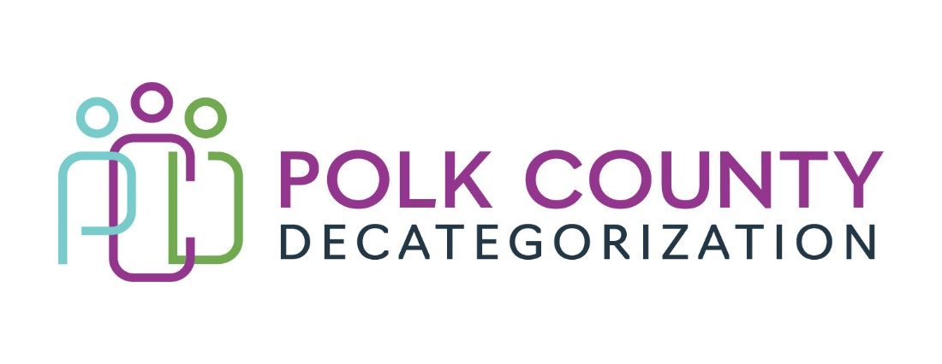

Polk Decat EXECUTIVE COMMITTEE Meeting
Thursday, October 13, 2022

Meeting Minutes

- The meeting was called to order in person at the Polk County Family Enrichment Center Conference Room, at 10:05 am by Eric Kool. Also present were Mindy Norwood sitting in for Jana Rhoads, John Hawkins, Tamra Jurgemeyer, and Andrea Vitzthum, as well as Joy Ihle from Polk County CFYS, Amanda Marshall from DHHS, Teresa Burke, and Cassie Kilgore from Polk Decategorization. Absent was Jana Rhoads.

- Review and approval of the September 22, 2022, meeting minutes.
  - Mindy moved to approve the September 22, 2022, minutes. Tamra seconded and the motion was carried by unanimous vote.

- Review of the FY23 budget:
  - Highlighted was the spending for contract DCAT5-22-112, Reentry and Aftercare Services. Two months of GAX have already spent down the contract 23%. Because the service was competitively procured, the most the contract can be increased is by 10% of the annual value. That still would not be enough to cover the entire fiscal year at the current rate of spending.
  - The Transfer of Funds letter from JCS that will be voted on later in the meeting was already input into the FY22 JCS carryover aggregate funds.

- Discussion and vote: Accept FY22 JCS Transfer of Funds & Letter.
  - JCS issued a second designation Transfer of Funds letter to Polk Decat for the Reentry Aftercare contract in the amount of %56,3223.37. The first designation transfers did not include sufficient funds to fully cover the FY23 annual value of the Reentry contract. This second designation will cover a portion of that deficit.
  - John moved to accept the Transfer of Funds and Letter from JCS. Andrea seconded and the motion was carried by unanimous vote.

- Contract Performance Review FY22 final.
  - Cassie Kilgore presented the FY22 Contract Performance highlights document updated for the second half of FY22. Deficiencies, barriers, successes were highlighted.
  - The Board expressed the excellent work of Dr. David Beeman who provides psychological evaluations to JCS youth through the DCAT5-19-002 contract as well as DHHS clients mostly through court-ordered services. His reports to the court and to the agencies are thorough and professional, providing sound advisement on the placement and resources best suited for the clients’ needs and situation. He also has been an asset to the community because for several years he provided oversight for Psychology Fellows to achieve licensure.
  - The Reentry and Aftercare (DCAT5-22-112) contract spending was addressed in relation to their staffing. FY22 closed out with the Contractor overspending the annual contract value and not being able to be fully reimbursed for June 2022. The Contractor has indicated that they have plenty of capacity to take on more referrals. In the next Contractor meeting, we can address if their staffing can be adjusted rather than taking on more referrals.

- Flex Funds usage review:
  - Cassie Kilgore provided the Board with a summary of the FY22 Flex Funds usage. DHS used 74% of the funds in the contract (including PSSF funds) and JCS used 18%. MYFI made up the remaining 8%. Transportation/gas was the most used support with clothing, beds and food being next in that order. The “Other” category was used most heavily in situations where more than one support was being requested and for other non-listed supports, such as National Online Training for diversion youth, store cards for outer counties, incentives for DMPS students involved in B2B and S4S activities, wellness activities, and conferences.

- Discussion on how RIGs can be used more effectively and how to better market the service to DHHS and JCS staff:
  - Following up on a suggestion from the last Board meeting, this discussion centered on internal methods within DHHS and JCS for making more referrals to RIGs and using them more effectively. JCS now invites the RIG Coordinator to have regularly scheduled time at their offices. DHHS referrals ebb and flow, mostly because of staffing turnover and newer staff being unaccustomed to remembering RIGs are available for their refugee cases.
  - The Contractor is aware of and makes efforts to market their services. In FY22 they used some Contract funds to create materials to market their services and assist SWs, JCOs, and other community providers to make referrals to the program with refugee families and youth are involved or at risk of involvement in either system.
  - Eric mentioned there would be an opportunity for the Contractor to have a space at the Welcome Center once it is up and running.
  - Mindy indicated that the Contractor could present on the services at any SW2 large group meeting.

- Other Decat, RJCE and CPPC Updates:
  - RFP Updates: RFP development meetings have occurred for 2 of the potential RFPs and one is scheduled for later in October. Involved JCS staff have been very helpful in the discussions and willing to participate in the bid reviews that will take place in early 2023.
  - Cassie Kilgore provided an update on the small grants program, explaining that we had to put a hiatus on accepting any more applications this year due to a backlog in processing and funds set aside for the grants being depleted quickly. The small grants opportunity will be resurrected in the Spring again.
  - Parent Café supports are now the focus of that initiative since the 3 trainings have taken place. Cassie has heard requests for another host training which we may consider supporting in the spring. LSI is conducting Parent Cafes now and has requested supports.

- Next meeting:
  - Review of FY23 budget and expenditures
  - FY22 Polk Decat Annual Progress Report approval vote
  - Discussion and possible vote on use of unencumbered funds
  - Other Decat, RJCE and CPPC activities
  - Anything else?

- Adjourn: Mindy moved to adjourn the meeting at 11:24 am. John seconded, all were in favor, and the motion passed unanimously.

The next regularly scheduled meeting will be on Thursday, November 10, 2022, 10:00 to 11:30 am, in person in the Polk County Family Enrichment Center (FEC) Conference Room.

tkdb

