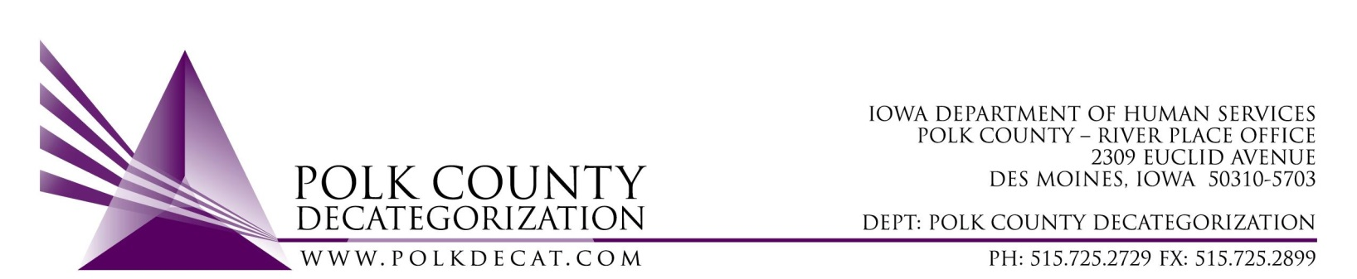

EXECUTIVE COMMITTEE
Thursday, October 11, 2018

Meeting Minutes

- Betty Devine called the meeting to order at 10:05 am. Also present were Eric Kool, Jim Ward, Chad Jensen, Kelly Cox and Teresa Burke. Absent was Mike McInroy and Nikolle Ross.

- The June 14, 2018, August 9, 2018, and September 13, 2018, minutes were available for review. The appropriate representatives have not been available to vote on the older minutes in the past two board meetings, so the votes were table. The board reviewed the minutes and elected to vote on all three sets of minutes with one vote. Eric moved to accept all of the stated minutes as written. Jim seconded and the motion was carried unanimously.

- The FY19 Budget was reviewed. GAX have been entered for those contractors who provided them to date. Teresa reviewed those contractors who have not yet submitted GAX. The unencumbered funds were reviewed for FY20 use.

- Discussion only: Add $8,732.00 of unencumbered MYFI funds to DCAT5-17-052, the RJCE Coordination Services, contract to cover the increase in activity in the Student Mentoring project. The Student Mentoring project has focused on assisting students of color at the DMACC Urban Campus who either are majoring in Social Work or in Liberal Arts with a plan to major in Social Work at a 4-year college after graduation from DMACC. The Social Work department at the DMACC Ankeny campus is very interested in bringing this project there, which will entail additional funds to cover the student incentives. This would increase the contract from $132,516.00 to $141,248.00 for FY19. The Board will be requested to vote on this item in the November meeting when DHS representation is present.

- Discussion and vote: Possible change of use of FY17 Decat unencumbered funds, tabled from the September 13, 2018 meeting.
  - Because there is no DHS representation at this board meeting, the board agreed to table this discussion again until the November board meeting.
  - Chad moved to table the vote on this item until the November board meeting. Eric seconded and the motion was carried unanimously.

- Discussion only: Switch $15,000.00 of DHS MYFI funds from DCAT5-17-120 (Student Support Services – DMPS) contract into the DCAT5-19-001 (Fiscal Agent Services) contract for the purpose of providing incentives and youth/family supports.
  - Teresa explained that Des Moines Public Schools is unable, due to limitations imposed by their types of funding, to use their education funds for incentives for youth and families prior to requesting reimbursement for those expenses. Therefore, they requested that we take back some of the funds in the DCAT5-17-120 contract in order to purchase incentives. They were instructed that, if the board agreed to this, they would be required to provide information back to Decat on who received the funds, how much, when and for what purpose, which they agreed to.
  - This switch in funding will increase DCAT5-19-001 to $277,000.00, a portion of which would go to the Admin Fee. It will decrease DCAT5-17-120 to $52,000.00.
  - The board will vote on this item in November when there will be DHS representation.

- Discussion and vote: Modify DCAT5-16-002, Re-entry & Transitioning Youth Services contract, Scope of Work Deliverable 1.3.1.6.c, to change link for statewide FTDM/YTDM standards to https://www.iatrainingsource.org/ftdm-ytdm-documents.
  - In reviewing the DCAT5-16-002 contract deliverables for the upcoming on-site review, it was observed that the link to the DHS FTDM and YTDM procedures and documents was out of date. The contract deliverable should be updated to reflect the new link for these resource materials.
  - Eric moved to amend the DCAT5-16-002 contract to replace the outdated FTDM/YTDM link to the new one. Jim seconded and the motion was carried unanimously.

- Status of Polk County funds for DCAT5-19-002, Psychological Evaluations contract.
  - Betty Devine indicated that the $30,000.00 Transfer of Funds letter from Polk County to the Polk Decategorization Project is on the Polk County Board of Supervisors agenda for October 16, 2018.
  - The Board will be able to vote to accept the transfer of funds in the November board meeting.

- Updates:
  - RJCE Activities:
    - Diamond Denney has been very active keeping up with her many activities. The JCS African American Case Review Team (AACRT) is underway now due to Diamond’s efforts.
  - Decat/CPPC Activities:
    - The agenda for the October 31st through November 2nd visit from Chris Foreman, the Trauma Technical Advisor, is set. Teresa reminded the Board that the technical assistance is provided through the generosity of Mid Iowa Health Foundation, based on a community desire to be of help to both DHS and JCS. Chris Foreman will also be providing a training on Secondary Traumatic Stress as part of the Central Iowa ACEs 360 Coalition, while she is in Des Moines.
    - Although the use of the FY17 Decat Unencumbered funds is still in the air, Teresa has continued working on a RFP in case all or part of the funds are used for small community contracts.
    - The FY18 Annual Decat Progress Report is due to state stakeholders by December 1st, so the Board will review and vote on this report in the November 8th meeting. Teresa will request that the Decat Steering Committee review the report prior to providing it to the board for review.

- For the next meeting:
  - Vote to approve the FY18 Polk Decat Annual Progress Report.
  - Discuss and vote on use of FY17 Decat Unencumbered funds.
  - Switch funds from the DMPS Student Support contract, DCAT5-17-120, to the Fiscal Agent Services contract, DCAT5-19-001, for the purposes of being able to provide concrete supports and incentives to students of color and at-risk students involved in DMPS programming.
  - Report out on the October 19, 2018, DCAT5-16-002, Re-entry & Transitioning Youth contract on-site monitoring.
  - Required change to the Decat contract as a result of having an AmeriCorps member.
  - Vote to accept the Polk County Transfer of Funds letter.

- Adjourn: Eric moved to adjourn the meeting at 10:59 am. Chad seconded and the motion was passed unanimously.

The next regularly scheduled meeting will be Thursday, November 8, 2018, 10:00 am in Conference Room 3.

