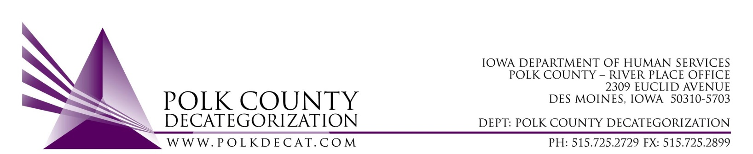

EXECUTIVE COMMITTEE Meeting
Thursday, October 8, 2020

Meeting Minutes

- The meeting was called to order, via Microsoft Teams video and conference call, at 10:04 am by Eric Kool. Also present were Stephanie Swartz, Jim Ward, Jana Rhoads, John Hawkins, Teresa Burke, and Decat Staff Cassie Kilgore.

- The September 10, 2020, minutes were reviewed. Jim moved to approve the minutes and Stephanie seconded. All were in favor and the motion was carried by unanimous vote.

- The FY20 final (post-reconciliation) and FY21 budgets were provided to the board. Teresa explained how the old-for-new exchange of monies works to establish part of the carry-over of state dollars from FY20 to FY21. The State Carry-over dollars and how funds were being used in FY21 contracts were highlighted. The DHS is still short just over $149,000.00 in State funds to cover their contract obligations for FY21. It was also indicated that there are other available funds to fill some of those gaps.

The DCAT5-19-001 Fiscal Agent contract (Wraparound Flex Funds) is underspending and this would be the contract where a funding level adjustment could be made to address the shortage in funds. Because this contract is underspending and because there are other available funds to fill some of the shortage, the Board discussed tabling adjusting the funding level of this contract.

- Discuss and vote: Accept DHS and/or JCS Transfer of Funds letter:
  - Although a DHS Transfer of Funds was not received since the last Polk Decat Board meeting, a JCS 2nd Designation Transfer of Funds letter was received, in the amount of $14,795.76. A copy of the letter was shared with the Board.
  - John moved to accept the JCS 2nd Designation Transfer of Funds letter and Stephanie seconded. All were in favor and the motion was carried unanimously.

- Discuss and vote: Possible adjustment of FY21 DCAT5-19-001 Fiscal Agent contract value based on available funding.
  - Based on the prior conversation (under item 3) , Jana moved to table this decision until the November Board meeting. Jim seconded, all were in favor and the motion was carried unanimously.

- Teresa requested the opportunity to have Cassie Kilgore explain a pilot project that Polk Decat would be supporting. Cassie summarized her discussions with Bethany Christian Services about their pilot Dula program for pregnant women of color. Because the death rate is so disproportionate for this population, the goal of the pilot is to reduce this by assigning one-on-one Dulas to assist with training on proper pre and post delivery healthcare, safety and nurturing, and advocating within the healthcare system on behalf of the mothers where biases sometimes take place. Polk Decat plans to support 3 Dulas as part of the pilot. In addition, Cassie and Teresa were able to connect Bethany Christian Services with the Greater Des Moines Community Foundation and Mid Iowa Health Foundation who were also interested in supporting the pilot and, depending on outcomes, services on-going. This is a great example of how Decats support new and innovative approaches that are preventive and collaborative.

- Next meeting topics:
  - Transfer(s) of funds, if any
  - Possible adjustment to DCAT5-19-001, Fiscal Agent contract FY21 value
  - Review of FY21 budget
  - Trauma Informed Supervision Project update
  - RJCE and CPPC activities
  - Anything else

- Adjourn: Jim moved to adjourn the meeting at 10:33 am. Stephanie seconded, all were in favor, and the motion was passed unanimously.

The next regularly scheduled meeting will be Thursday, November 12, 2020, 10:00 am, via video and conference call.

