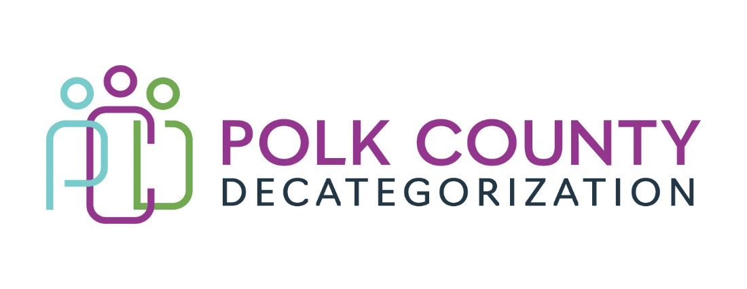

Polk Decat EXECUTIVE COMMITTEE Meeting
Thursday, September 22, 2022

Meeting Minutes

- The meeting was called to order in person at the Polk County Family Enrichment Center Conference Room, at 12:08 pm by Eric Kool. Also present were Jana Rhoads, John Hawkins, and Andrea Vitzthum, as well as Joy Ihle from Polk County CFYS, Teresa Burke, Diamond Denney, and Cassie Kilgore from Polk Decategorization. Absent was Tamra Jurgemeyer.

- Review and approval of the August 11, 2022, meeting minutes.
  - Andrea moved to approve the August 11, 2022, minutes. Jana seconded and the motion was carried by unanimous vote.

- Review of the FY23 budget:
  - The FY23 budget was reviewed and the unencumbered balances were highlighted. It was pointed out that the contract amendments to be voted on later in the meeting were already included but could be changed depending on voting. The Transfer Letter that will be voted on has not yet been added to the FY22 JCS Aggregate funding block.

- Discussion and vote: Accept FY23 Decat Annual Service Plan.
  - The Decat Annual Service Plan is a required report and is due to State officials and the Decat Board on or before October 1 every year.
  - The Service Plan has required header categories, and with which the FY23 Polk Decat Annual Service Plan is compliant.
  - Highlights of the demographics were covered as well as a reminder on the format required.
  - John moved to approve the FY23 Decat Annual Service Plan. Jana seconded and the motion was carried by unanimous vote.

- Discussion and vote: Approve Amendment, amended budget and increase in the FY23 value for DCAT5-22-144, Restorative Justice & Cultural Equity Coordination Services from $156,566.00 to $164,366.00:
  - Budget for FY23 was estimated prior to salary information and other costs being available.
  - Salary and “other” budget line item costs now confirmed for FY23, and current contract value is insufficient by $7,800.00 ($3,870.00 DHHS MYFI and $3,930.00 JCS State) to cover costs.
  - Possibly table this voting item for 1 or 2 months.
  - Given that Diamond Denney just turned in her resignation and we do not know how long it will take to be ready to refill the position, the board discussed tabling this item until a later date since it is possible that, due to no salaries and benefits being paid out, no addional funds would be needed.
  - Andrea moved to table the vote on this amendment. Jana seconded and the motion was carried by unanimous vote.

- Discussion and vote: Approve Amendment, amended budget and increase in the FY23 value for DCAT5-22-145, Pre-Arrest Diversion Case Management & Coordination Services from $91,155.00 to $96,855.00:
  - Budget for FY23 was estimated prior to salary information and other costs being available.
  - Salary and “other” budget line item costs now confirmed for FY23, and current contract value is insufficient by $5,700.00 (JCS State) to cover costs.
  - Jana moved to increase the contract by $5,700.00 and approve the amendment. Andrea seconded and the motion carried by unanimous vote.

- Discussion and vote: Approve Amendment and increase in FY23 value up to $302,000.00 from $265,250.00 (increase of $36,750.00), for DCAT5-19-001, Fiscal Agent Services (Flex Funds):
  - Funds to support DHHS Child Welfare and JCS Team Building, and work life supports, cultivating resilient and positive work environments for effective client services.
  - DHHS State amount - $22,775.00 ($21,186.00 for disbursement, $1,589.00 for Contract Fiscal Agent Fee).
  - JCS State amount - $13,975.00 ($13,000.00 for disbursement, $975.00 for Contract Fiscal Agent Fee).
  - John moved to approve the addition of the funds and the amendment. Jana seconded and the motion carried by unanimous vote.

- Discussion and vote: Approve switch of $4,376.00 in unused JCS State funds from FY22 to FY23 in DCAT5-22-121, JCS Internal Climate Survey & Individual Interviews Contract.
  - The first term of the contract is 4/11/22 through 6/30/23, crossing over two fiscal years, FY22 and FY23. The FY22 portion was $10,250.00 and the FY23 portion was $21,251.00, for a total first term value of $31,501.00.
  - Because there will be no change to the first term value nor the overall value of the contract, the unused funds from FY22 can be added to the FY23 portion with an “Amended PCQ”. No contract amendment is required.
  - The adjusted fiscal year split would now be FY22 - $5,874.00, FY23 – 25,627.00 with the amended PCQ.
  - Teresa reminded the board that the unused funds from FY22 were back in the JCS FY22 State unencumbered funds so this PCQ amendment would use up current unencumbered funds.
  - Andrea moved to approve the adjustment in funds from the FY22 portion of the first term of this contract to the FY23 portion. John seconded and the motion was carried by unanimous vote.

- Discussion and vote: Transfer of Funds letter approval, transferring $51,285.00 of FY22 JCS State Carry-over funds to Iowa Department of Human Rights/CJJP, to secure another Vocational Rehab Re-entry Navigator for Juvenile Court Services District 5, Polk County.
  - The Navigator program is a pilot project aimed at reducing recidivism among eligible youth involved with the Juvenile Justice system returning to the community from an out-of-home placement. Navigators provide services to youth with disabilities, i.e., they have an IEP or covered under the provisions of Section 504.
  - This transfer would cover half of the costs for 1 additional Navigator for D5 for FFY23. There may be additional funds requested, depending on how much of these funds are used in FFY23 and assuming the program is continued until the pilot period is over, on September 30, 2024. The funds will expire on June 30, 2024, which would be the end of when the funds could actually be used.
  - The nature of the Vocational Rehab federal grant funds match does not allow us to contract with CJJP as the match needs to occur at the point of draw down. Because Decat contracts are state contracts, payment is always after the service has been provided, making the one-to-one match at the point of draw down unattainable.
  - John provided background on how successful the Vocational Rehab Reentry Navigator has been serving youth in Polk.
  - Jana moved to approve the transfer of funds and the Transfer letter to CJJP. John seconded and the motion carried by unanimous vote.

- Discussion and vote: Reprocure for FY24 the Early Services Program contract, DCAT5-24-148.
  - Current ESP contract will end June 30, 2023, and JCS sees the need to continue these services for the very young offenders.
  - An RFP Development Committee has been established to define the Scope of Work and costs (contract value).
  - It was noted that youth involved in this service exhibit higher mental health and other needs in the past few quarters, according to the quarterly reports.
  - The Board discussed possible changes to the current services.
  - Jana moved to approve the reprocurement of the Early Services Program. John seconded and the motion carried by unanimous vote.

- Discussion and vote: Reprocure for FY24 the Sanctions Learning Services contract, DCAT5-24-149.
  - The current Sanctions contract will end June 30, 2023, and JCS sees the need to continue Sanctions services as an option for community service and learning.
  - An RFP Development Committee has been selected to define the Scope of Work and costs (contract value).
  - The Board discussed possible changes to the current services.
  - Jana moved to approve the reprocurement of the Sanctions Learning Services. John seconded and the motion carried by unanimous vote.

- Discussion and vote: Reprocure for FY24 the Trauma Informed Services in Polk County Detention contract, DCAT5-24-150.
  - The current TIS Services in Detention contract will end June 30, 2023, and JCS as well as Polk County Detention value the need to continue these services.
  - An RFP Development Committee has been selected to define the Scope of Work and costs (contract value).
  - The Board discussed possible changes to the current services.
  - Jana moved to approve the reprocurement of the Trauma Informed Services in Polk Detention. John seconded and the motion carried by unanimous vote.

- Discussion and vote: Post for replacement for Diamond Denney, RJCE Coordinator, who recently turned in her resignation.
  - Diamond assured the Board that she was reviewing her job description for edits
  - Reviewing the salary classification and range is also an option. The current classification is Project Specialist.
  - The board discussed how posting for open positions are handled with Polk County and where else we are able to post.
  - Jana suggested that she, John, Eric and Teresa meet to discuss the job description and duties.
  - Jana moved to approve replacing the position left open by the resignation of Diamond Denney. John seconded and the motion was carried by unanimous vote.

- Contract Performance Review will be discussed at the October 13, 2022, Board meeting.

- Other Decat, RJCE and CPPC Upates:
  - RJCE:
    - Diamond reported that her hope was DHHS Child Welfare and JCS would work more closely and in tandem on Equity efforts.
    - The DHHS Polk Equity Team has been very fruitful, assisting with reframing the hiring practices for Polk Child Welfare.
    - The DHHS AACCT activities have been very robust and the Casey Foundation grant involved a lot of time and effort to enhance the services and outcomes.
    - Diamond has been involved with the JCS DMC Committee in conjuncti0on with CJJP, making strides especially with girls of color involved in Juvenile Justice.
    - Diamond mentioned that when the JCS Courageous Conversations were in place, the feedback received was very positive on its impact on JCOs.
    - Diamond emphasized that the MYFI Student Incentive project was worth investing more time, effort and funds into as it supported and incentivized more students of color to get their degrees and even advanced degrees. It could be expanded to include Juvenile Justice.
  - Decat/CPPC:
    - Cassie covered the multiple trainings that CPPC will be sponsoring this fiscal year, including but not limited to: A-TIP, Iowa Mediation Services trainings on Motivational Interviewing and Dealing with Difficult People, Active Shooter, DHHS and JCS 101s, Youth Mental Health First Aid, etc.
    - Parent Cafes are really absorbing a lot of time, energy and funding. Another Host Training was recently sponsored by CPPC, and the target audience this time were members of Corinthian Baptist Church and their satellite churches. They are very excited about having Parent Cafes as one of their regular parent supports.
    - Cassie updated the Board on the Community Grants program and how popular it has been this later summer/fall. We are looking to shut off grants in the Winter and re-open the opportunity in the Spring in order to take a break and ensure there are enough funds for trainings and other projects. This fiscal year we will not be setting aside a specific pot of funds for DMPS grants. Those DMPS Community Coordinators who are active and know to reach out to us already do that.

- Next meeting:
  - Review of FY23 budget and expenditures
  - Semi-annual contract performance review
  - FY22 Flex Funds usage review
  - Discussion on how RIGs can be used more and how to market better to staff
  - Other Decat, RJCE and CPPC activities
  - Anything else?

- Adjourn: John moved to adjourn the meeting at 1:24 pm. Andrea seconded, all were in favor, and the motion passed unanimously.

The next regularly scheduled meeting will be on Thursday, October 13, 2022, 10:00 to 11:30 am, in person in the Polk County Family Enrichment Center (FEC) Conference Room.

tkdb

