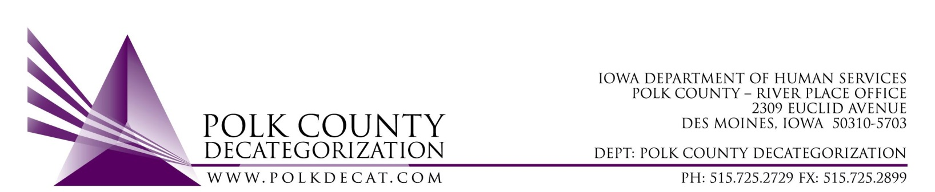

EXECUTIVE COMMITTEE
Thursday, September 13, 2018

Meeting Minutes

- Betty Devine called the meeting to order at 10:04 am. Also present were Kelly Cox sitting in for Chad Jensen, Kevin Brownell sitting in for Jim Ward, Nikolle Ross and Teresa Burke. Jordan Kauffman was also in attendance for the two CPPC-related topics. Absent were Mike McInroy and Darin Thompson.

- The August 9, 2018 minutes were available for review. Nikolle moved to table approval of these minutes as well as the June 14, 2018 minutes, since there were not enough attendees available to vote on the accuracy of the minutes. Kelly seconded. The motion to table approval of the August 9, 2018, and the June 14, 2018 minutes until the next Executive Committee meeting was carried.

- The FY19 Budget was reviewed. The Board was made aware that July and August GAX received to date cannot yet be forwarded to Accounting for payment until certain new contract and renewal items are received back as copies of those must accompany the first GAX of the new fiscal year.

- Discussion and vote: Possible change of use of FY17 Decat unencumbered funds:
  - The Board was informed of possible alternative use of the FY17 Decat unencumbered funds from what was voted on in the last meeting. However, since there are no DHS representatives present in this Board meeting, that discussion would need to be tabled.
  - Nikolle moved to table this discussion and vote until the next Board meeting. Kelly seconded and the motion was carried.

- Discussion and vote: Review and accept the FY19 Polk Decat Annual Service Plan.
  - The FY19 Polk Decat Annual Service Plan was shared with the Board via email on September 6, 2018, and paper copies provided for review during the meeting. The Board was reminded that the Decategorization Handbook indicates that the two required annual reports come from the Decat Board. Jordan and Teresa fielded questions about the report.
  - Kevin moved to accept the report as written. Kelly seconded and the motion was carried.

- Discussion and vote: Review and approve revised budget and proposal for CPPC AmeriCorps member for Polk County.
  - Jordan provided copies of the AmeriCorps contracts and budget to the board, including a narrative of the budget. Although the AmeriCorps position was approved by the Board in the August 9, 2018, Board meeting, the person who was planned for the position found full-time employment elsewhere which was very well suited to her skill-set. Another candidate is very interested but he requires training and coaching to become a certified Family Team Decision Making Meeting Facilitator. The budget was adjusted to reflect this change.
  - The budget was reviewed and corrected for addition errors.
  - Kelly moved to approve the new budget with corrections. Nikolle seconded and the motion was carried.

- The FY18 final quarterly performance reports were recounted by Jordan. She prepared a summary document and highlighted some of the great and not-so-great performance responses. For those contractors where the reports could be more thorough, Jordan has set-up meetings to review the type of information that they should be including in the reports. She also amended the quarterly reporting forms to include prompts for entering more specific information on numbers and percentages describing each performance measure achievement.

- Status of Polk County funds for DCAT5-19-002, Psychological Evaluations.
  - The $30,000.00 of Polk County funds to cover psychological evaluations in Detention has not yet been transferred. Betty will check on the status of this transfer letter.

- Updates:
  - RJCE Activities:
    - Diamond has finally been able to execute the commencement of the African American Case Review Team (AACRT) for Juvenile Court Services. This has been in development for almost 2 years and she worked diligently in her short time here to get this accomplished. She is also re-energizing the DHS AACRT and has scheduled trainings for and by the AACRT teams.
    - Diamond was chosed to be part of the Results Count team and is with Mike McInroy, Chad Jensen, and others attending the related conference in New Orleans this week.
    - Diamond is working on a Climate Survey for JCS, picking up where the previous RJCE Coordinator left off.
  - Decat/CPPC Activities:
    - The visit from Chris Foreman, the Trauma Technical Advisor, is scheduled for October 31 through November 2. Meeting invitations have been sent for the JCS/Detention/LSI Trauma Services in Detention Stakeholders as well as to DHS Secondary Traumatic Stress (STS, or vicarious trauma) stakeholders. There will also be a Community Learning Circle where Chris will be training. Betty recommended that the training address STS and where front line staff are encouraged to attend.
    - Although the use of the FY17 Decat Unencumbered funds is still in the air, Teresa has continued working on a RFP in case all or part of the funds are used for small community contracts.
    - The FY18 Annual Decat Progress Report is due to state stakeholders by December 1st, so the Board will review and vote on this report in the November 8th meeting. This report is currently in progress.

- For the next meeting:
  - Discuss and vote on use of FY17 Decat Unencumbered funds.
  - Switch funds from the DMPS Student Support contract, DCAT5-17-120, to the Fiscal Agent Services contract, DCAT5-19-001, for the purposes of being able to provide concrete supports and incentives to students of color and at-risk students involved in DMPS programming.
  - Review and approval of the June 14, 2018, and August 9, 2018, minutes.

- Adjourn: Nikolle motioned that the meeting be adjourned at 11:36 am. Kevin seconded and the motion was carried.

The next regularly scheduled meeting will be Thursday, October 11, 10:00 am in Conference Room 3.

