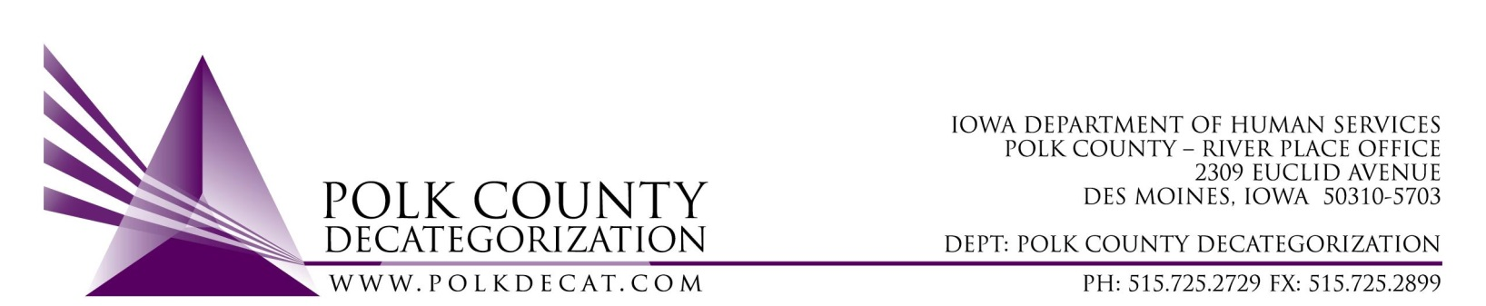

Polk Decat EXECUTIVE COMMITTEE Meeting
Thursday, September 9, 2021

Meeting Minutes

- The meeting was called to order, via Microsoft Teams video and conference call, at 10:02 am by Eric Kool. Also present were Joy Ihle, John Hawkins, Jim Ward, Tramra Jurgemeyer, Jana Rhoads, Robert Smith, and Mindy Norwood, plus Teresa Burke and Cassie Kilgore from Polk Decat. Jana introduced Mindy Norwood as the new Des Moines Service Area Executive Officer II. Mindy will represent DHS at Polk Decat Board meetings when Jana or Robert are absent.

- Review and Approval of the September 9, 2021, meeting minutes.
  - Jan moved to approve the minutes for the September 9th meeting. Tamra seconded and the motion was carried by unanimous vote.

- Review of the FY22 budget.
  - Teresa pointed out the addition of the FY22 Polk Decat Legislative Allocation since the last Board meeting. In addition, the unencumbered $46,550.54 in FY20 DHS State Carry-over funds were highlighted and noted for importance later in the meeting.

- Discussion and vote: FY22 Polk Decat Annual Service Plan.
  - A copy of the FY22 Polk Decat Annual Service Plan was provided to the Board prior to the meeting. The Board expressed appreciation of the Polk County demographic information in the first few pages of the report as well as the detailed plan. Teresa thanked the Board for the positive commentary and noted that many of the demographic indicators drive the focus areas of Polk Decat.
  - Robert moved to accept and approve the FY22 Polk Decat Annual Service Plan. John seconded and the motion was carried by unanimous vote.

- Discussion and vote: Sole Source/Emergency contract for Child Welfare Family Visit Services.
  - Jana Rhoads provided background on the need for this contract. Changes in the statewide Family Centered Services (FCS) contract limited family visits covered under that contract to 10 times per month per case. Judges often court order more visits than the FCS contract can cover. Social Workers are required to meet with the children on their caseloads once per month, and that requirement is being met. However, they are unable to keep up with the additional supervised family visits that the FCS contrated services are unable to cover. DHS needs the contractor to cover the additional visits that the FCS contract and Social Workers are unable to cover.
  - At this juncture, either a Sole Source or Emergency contract were being considered as possible methods for contracting for these services. Robert was applying to the Department of Administrative Services (DAS) to seek approval. Eric commented that an Informal Procurement would probably be appropriate with the current considerations, although the assistance is needed sooner rather than later and a procurement takes time. If the Sole Source is not approved by DAS, then an Informal Procurement would be inevitable.
  - The Board discussed what they should vote on since so much is not yet determined. The Board agreed to vote to use the DHS FY20 State Carry-over funds that are unencumbered for these services and the Board can vote, hopefully, in the October meeting on either the contract or the RFP, depending on circumstances.
  - Tamra moved to use the unencumbered DHS FY20 State Carry-over funds to cover the family visits services with a later vote on a specific contract or RFP. Jim seconded and the motion was carried.

- Polk Decat contract performance review:
  - The detailed Contract Performance Tracking Spreadsheet and Contract Performance Highlights document were sent to the Board prior to the meeting. Cassie reviewed the highlights document to close out FY21. Cassie commented that Covid very much globally affected the manner and ability of contractors to provide services. The Board commented on the helpfulness of the Highlights document. Teresa reminded the Board to review the Contract Performance Tracking document for details on every performance measure under each contract.

- Other Decat, RJCE and CPPC Updates:
  - Pre-Arrest Diversion Case Manager hiring update: The posting closed on August 31st and over 70 resumes were received. Sam Powell and Diamond Denney are reviewing resumes. We are also reviewing interview questions which will be used when we are ready to interview candidates.
  - Black Doula project update: Cassie provided information to the Board on how the seed funds provided by Polk Decat impacted the expansion of this project and results that Bethany Christian Services has made available results of the project, which were provided to the Board during the meeting.
  - New Contract updates: Teresa has had meetings with JCS and both CFI on the new Transition Youth contract and Boys Town on the new Reentry Aftercare contract. They are new contractors and the services had been overhauled from what they previously were. Both contractors have started off running with several referrals from JCOs. Boys Town is already hiring a third case manager, which is supported by the contract funding level. Teresa and JCS will meet quarterly with these contractors for at least the first year to ensure start up issues are being dealt with and the contracts’ Deliverables and Measure are appropriate.
  - JCS Psychological Evaluations are provided by Dr. David Beeman under the DCAT5-19-002 contract. He has had issues with retaining subcontractor Licensed Psychologists for various reasons but he has stated that the lack of licensed Psychologists in the state has made it difficult to find others to subcontract. He currently has one subcontractor Licensed Psychologist and may have another one soon, although at this time he is the only one providing evaluations under the contract so he is unable to keep up with the recent increase in referrals. He is reconsidering using a Psychology Fellow, as he has in the past. It does require quite a bit of oversight on his part, but it does help free up his time, provides evaluations at a more reasonable cost, and helps build the pool of licensed Psychologists in the area. He is currently attempting to find an appropriate Doctorate Fellow who he feels would be a good candidate.
  - Cassie provided an update on the 2 trainings that we have slated thus far for Polk CPPC. She also described the Girls of Color Matter project that we are supporting. The services include provision of the Health Relationships curriculum to young, teenage girls of color as well as other self-image building activities.
  - Cassie also presented her idea to the Board to enlist a volunteer, Brittney Hutchinson, with the intent to use her as an APPC (CPPC AmeriCorps) member this winter and possibly into next year. The main project that we would like her to assist with is building capacity for Parent Cafés in Polk County. There has been a lot of interest from various sectors in implementing Parent Cafes. Initiating a new parenting curriculum is always a lot of work and having some assist with capacity building would help get it off the ground.

- Next meeting agenda items will include but may not be limited to:
  - Review of FY22 budget
  - Possible vote on contract or RFP for family visit services
  - Possible discussion of the use for some of the JCS unencumbered funds.
  - Sesame Street in Communities update
  - APPC (CPPC AmeriCorps) member for Polk Decat voting item
  - Other Decat, RJCE and CPPC activities

- Adjourn: Robert moved to adjourn the meeting at 11:12 am. Jim seconded, all were in favor, and the motion passed unanimously.

The next regularly scheduled meeting will be Thursday, October 14, 2021, 10:00 am, via video and conference call.

tkdb

