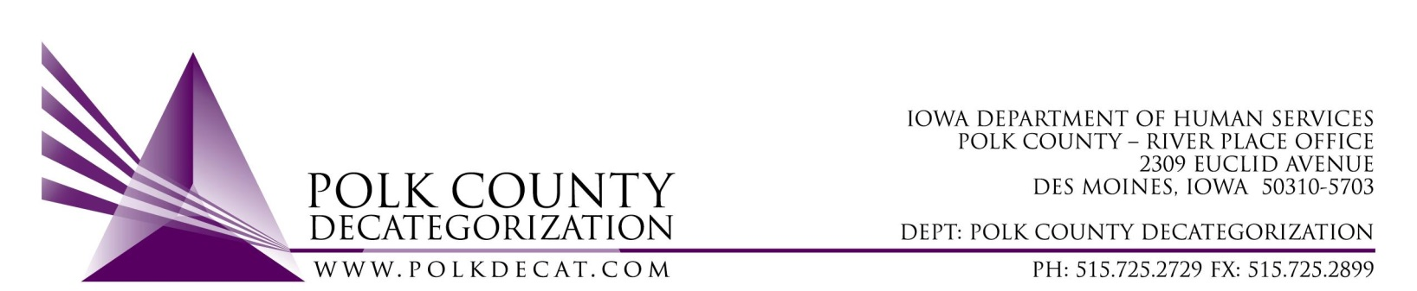

Polk Decat EXECUTIVE COMMITTEE Meeting
Thursday, August 12, 2021

Meeting Minutes

- The meeting was called to order, via Microsoft Teams video and conference call, at 10:03 am by Eric Kool. Also present were Joy Ihle, John Hawkins, Jim Ward, Tramra Jurgemeyer, Jana Rhoads, and Teresa Burke and Cassie Kilgore from Polk Decat.

- Review and Pproval of the May 13, 2021, and August 5, 2021, meeting minutes.
  - Jim moved to approve the minutes for both indicated meetings. Robert seconded and the motion was carried by unanimous vote.

- Review of FY21 and FY22 budgets.
  - Teresa provided and overview of the final FY21 budget, highlighting the impact of the recent transfer out of $125,000.00 in FY19 Decat funds. The amount of FY19 funds that will be reverted are now less than $5,900.00. Teresa reminded the Board that other funds were transferred out in the winter in anticipation of a large reversion and it is better to transfer funds to areas that can use them rather than let them revert.
  - The FY22 initial budget was reviewed. Highlights included a look at the unencumbered FY20 and 21 state funds that can be used either this fiscal year or possibly into FY23.
  - Jana indicated that a possible use of the unencumbered FY20 DHS state funds is to support case aide for additional visits being court ordered. There is a shortage of Social Workers and In Home workers to cover the increase in court ordered visits, especially with the constant “churning” that occurs in these positions with resignations and new hires. Jana and Robert will be having discussions in the next week regarding how they wish to move forward on this issue. If possible, the Board could even vote on a new Sole Source or Emergency contract in the next meeting.

- Discussion and vote: FY21 Polk CPPC Annual Report.
  - A copy of the FY21 Polk CPPC Report and Budget was provided to the Board prior to the meeting. Cassie covered CPPC activities and results for FY21 with the Board.
  - Tamra moved to accept and approve the FY21 Polk CPPC Annual Report. Robert seconded and the motion was carried by unanimous vote.

- Introduce Polk Decat logo and image rethink.
  - Polk Decat staff have had internal discussions regarding our logo and how we want to be represented and who we are as a “brand”. The current Decat logo has been in place since Polk Decat was initiated and branded, when Denise Hotopp was the first Polk Decat Coordiantor.
  - Cassie introduced and reviewed with the Board options for re-branding. Project 7 is the design company that we are looking at using for this service and who came highly recommended from Tamra Jurgemeyer. Their costs are reasonable and they are a local provider of image and website services. Cassie mentioned that part of the process of creating a new branding image was getting input from the Decat Team, Board and Shared Decision Making Steering Committee.
  - Although rebranding would impact the look and function of the Decat website, the funding available will only provide for the re-image activities for this fiscal year. Changing the website can be part of Polk Decat’s FY23 goals.
  - The Board agreed that rebranding Polk Decat after 30 years with the current logo and look would be important for our work in the community. The funds for this change are already available in the Polk Decat & CPPC contract, DCAT5-18-002.

- Other Decat, RJCE and CPPC Updates:
  - New contracts are up and running, with FY22 GAX sent to all contractors. We still are waiting on the contract actions back from the state on the new Sex Offender Treatment contract, DCAT5-22-001.
  - Jana indicated that DHS is currently down in the number of Social Workers and also one Supervisor, so it is “all hands on deck” for ensuring court-ordered visits get done. She also stated that the new Executive Officer 2 is Mindy Norwood. She would like Mindy to attend the Polk Decat Board meetings.
  - Jana also indicated that the Bureau of Refugee Services will be serving perhaps over 2000 new refugees to Iowa this year, which is a large increase from prior years.
  - Eric Kool indicated that the Family Enrichment Center just got approved to expand by 3 staff to serve the increase in those needing services.
  - John Hawkins mentioned that long-time JCS Supervisor Kim Garrison is leaving and that several JCO retirements are on the horizon. They are in the middle of interviewing for several openings and probably will be continue to interview for on-going openings probably for the rest of the year.

- New meeting agenda items will include but may not be limited to:
  - Review of FY22 budget
  - FY21 final performance review
  - Possible Sole Source or Emergency procurement for DHS visits
  - Introduce Mindy Norwood, the new DHS EO2
  - Possible discussion of the use for some of the JCS unencumbered funds.
  - Other Decat, RJCE and CPPC activities
  - FY22 Polk Decat Annual Plan

- Adjourn: Jim moved to adjourn the meeting at 11:15 am. Robert seconded, all were in favor, and the motion passed unanimously.

The next regularly scheduled meeting will be Thursday, September 9, 2021, 10:00 am, via video and conference call.

tkdb

