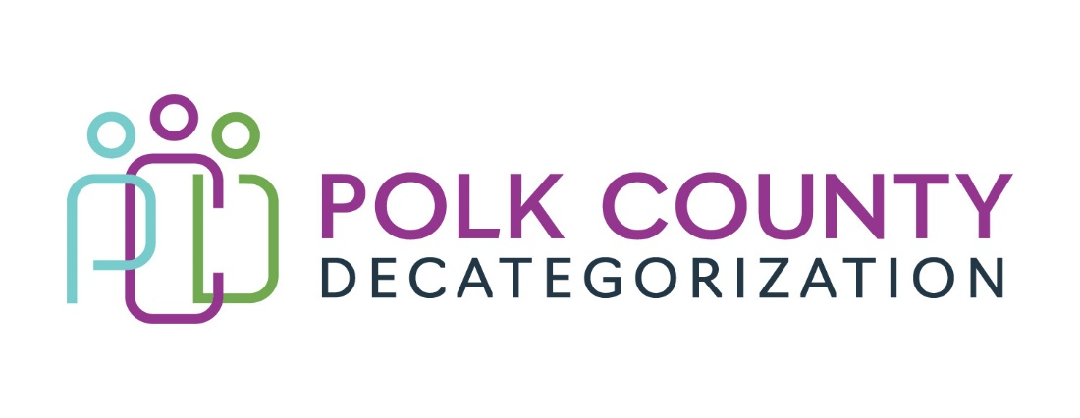

Polk Decat EXECUTIVE COMMITTEE Meeting
Thursday, August 10, 2023

Meeting Minutes

- The meeting was called to order in person at the Polk County Family Enrichment Center Conference Room, at 10:00 am by Eric Kool. Also present were Amanda Marshall sitting in for Jana Rhoads, Christy Burkhart sitting in for John Hawkins, Andrea Vitzthum, Stacie Nessa, and Teresa Burke. Absent were Jana Rhoads, and John Hawkins. Also in attendance was Lisa Cort, Jaime Stevens, and Jay Hansen from Polk Decat.

Jaime Stevens was introduced to the Board as the new Polk Decat Project/CPPC Coordinator. Jaime has over 20 years with Polk County in various departments, including Juvenile Detention, Senior Services, and most recently the jail.

- Review and approval of the May 11, 2023, meeting minutes.
  - Amanda moved to approve the May 11, 2023, minutes. Christy seconded to approve the minutes as amended and the motion was carried by unanimous vote.

- Review of the FY23 and FY24 budget discussion:
  - All FY23 GAX have been received and recorded. Because there were more FY22 JCS funds expended than FY21 DHHS and Decat State dollars unspent and unencumbered, all old monies could be exchanged with newer monies due to the state Accounting method of using all old funds first to pay GAX regardless of if they are DHHS, JCS or Decat Allocation funds. Polk Decat will have no FY21 funds to carry over into FY24. The FY23 Aggregate funding/spending tab was reviewed by the Board for how the funds were exchanged.
  - The Aggregate funding/spending tab of the FY24 Expenditures Tracking Spreadsheet was reviewed for the funds carried over into FY24. Because DHHS did not make a transfer of carry-over State funds, $10k of Decat Legislative Allocation funds were put into the Fiscal Agent contract for DHHS concrete supports and $15K in the Decat Coordination contract for Trauma Informed Supervision services for DHHS. It is very likely that PSSF Family Preservation funds will be available soon to add to the Fiscal Agent contract for DHHS client supports. The FY24 Polk Decat Legislative Allocation was also reflected in the document.

- Discussion and vote: Terminate DCAT5-20-004, Criminal Records Checks, contract for FY24, to be effective October 1, 2023:
  - Historically the Criminal Records Checks contract was used more heavily by DHHS Social Workers. Personnel at the Polk County Attorney’s Office (PCAO) have been conducting these checks with overtime hours and using just the Iowa Courts Online database. In more recent years, the SWs have either been doing their own background checks or DHHS Admin staff have assisted with that. The SW who has been using the PCAO recently left DHHS and this seems like a good time to terminate the contract.
  - Andrea Vitzthum mentioned that due to recent legislation that allows county attorneys to access the National Crime Information Center (NCIC) database on CHIA cases, her office trained 3 people to use the database for their own research into cases where relative caregivers, etc., have recently moved to Iowa from out of state. Although the NCIC print out cannot be distributed or used as exhibits, the PCAO can use the information from the reports to assist DHHS in determining if a relative is a viable placement option and for visits. Andrea, Jana Rhoads, and Teresa Burke met recently to discuss if there was a need to continue the DCAT5-20-004 contract and it was mutually agreed that it did not serve the purpose as originally intended and the NCIC information from the PCAO would be more useful as that is information the SWs are unable to access.
  - Amanda moved to terminate the DCAT5-20-004, Criminal Records Checks contract. Stacie seconded and the motion was carried by unanimous vote with Andrea abstaining from voting.

- Discussion and vote: Increase DCAT5-20-005, Diversion & Mediation Services contract by $3,000.00 (from $15,000.00 to $18,000.00) in MYFI funds.
  - Andrea and Teresa also met with Jana on how Mediations could be more effectively used by SWs to deter DHHS families from deeper system involvement. This is especially important for DHHS-eligible cases to help families engage with services so issues that got them involved in Child Welfare do not become more serious.
  - The funding level for this contract was reduced in FY24 from $25,000.00 to $15,000.00 due to lower usage. It is recommended that the contract be increased from $15,000.00 to $18,000.00 with MYFI funds so more families of color can be served by Mediations.
  - Stacie moved to add $3,000.00 of MYFI funds to DCAT5-20-005, increasing the value from $15,000.00 to $18,000.00. Christy seconded and the motion was carried by unanimous vote with Andrea abstaining from voting.

- Discussion and vote: Review and approve Polk Community Partnerships for Protecting Children (CPPC) FY23 Annual Report and Budget.
  - The CPPC FY23 Annual Report and Budget were provided to the Board one week prior to the meeting for review. The Board was reminded that the Polk Decat Shared Decision Making Steering Committee first reviewed the report to provide feedback. Teresa reminded the Board that there was no Project/CPPC Coordinator for over 7 months of FY23 but that the SDM Steering Committee still discussed, recommended, and voted on supporting several events, services, and trainings for the community. Also, more detailed outcomes for the community supported activities would not be reflected in this report but, rather, in the FY23 Decat Annual Progress Report that the Board will review in the September meeting.
  - Amanda moved to approve the Polk CPPC FY23 Annual Report and Budget. Andrea seconded and the motion was carried by unanimous vote.

- Discussion: Contracts up for procurement in FY24 for July 1, 2024, start date:
  - The following contracts will require re-procurement during FY24:
    - DCAT5-19-001, Fiscal Agent Services
    - DCAT5-19-002, Psychological Evaluations (for JCS)
    - DCAT5-19-003, Preventive Law & Guidance (for DHHS clients)
  - Considerations for moving forward with the procurement process:
    - Results from the DHHS assessment of Decats and CPPCs from the current list of services undergoing review.
    - If and how FY24 and forward JCS state funds can be recoded for carry-over and use in Decats, who would own the contracts, reporting on use of funds, etc.
    - Teresa spoke with Amanda on how RFPs and other related documents could be drafted and ready to use once questions are answered.

- Other Decat, RJCE, and CPPC Discussion Items and Updates:
  - A brief overview of all the orientation that Jaime Stevens has gone through was provided as well as trainings she will need to take, including the DHHS BSCS Contract required trainings.
  - Jay Hansen provided a summary of FY23 PAD numbers and the success of the program:
    - Demographics: 100 youth participated in FY23. The DMPD change to a new system, TYLER, made referrals more challenging and workarounds were created to ensure youth eligible for Pre-Arrest Diversion services did not get charged and send to Detention Intake.
Male: 53 = 53%
Female: 46 = 46%
Other: 1 = 1%

African American: 45 = 45%
Hispanic: 12 = 12%
Asian: 2 = 3%
White: 31 = 31%
Other: 10 = 10%

Successful: 71 = 81%
Fail: 17 = 19%
    - Of the unsuccessful or “Fail” youth, 10 youth never met with Jay, 6 due to parent refusal and 4 due to having new charges prior to being able to meet. So, if those youth were removed from the total, the success rate of youth who participated in the program and were successful (completed programming) was 92%.
    - Additional information:
Tier 1:33
Tier 2:49
Tier 3:18

Top 3 charges
Assault:23
Marijuana:18
Trespass:14
    - Officer Deb Vanvelzen is moving to another post with DMPD. She has been instrumental in making this program work within the Police Department. They are currently looking for her replacement.
    - Andrea suggested that, for cases where parents are refusing to believe the charges against their children, they be referred to Youth Law Center or other legal defense entity to discuss. Teresa will put Jay in touch with Jami Hagemeier, Director of the Youth Law Center.
  - DHHS Town Hall meetings: The experiences of those who attended one of the DHHS Town Hall meetings or small groups was shared.
  - Teresa Burke announced that her retirement will be in late October or the first week of November. An exact date will be forthcoming soon.
  - No other updates from the Board.

- Next meeting:
  - Review of FY24 budget
  - Review and vote on Polk FY24 Annual Service Plan
  - Discussion and possible vote on procurements.
  - Decat Coordination and PAD contract value changes
  - Other Decat, RJCE and CPPC activities, including hiring updates.
  - Anything else?

- Adjourn: Andrea moved to adjourn. Christy seconded and the motion passed unanimously. The meeting was adjourned at 11:01 AM.

The next regularly scheduled meeting will be on Thursday, September 14, 2023, 10:00 to 11:30 am, in person in the Polk County Family Enrichment Center (FEC) Conference Room.

tkdb

