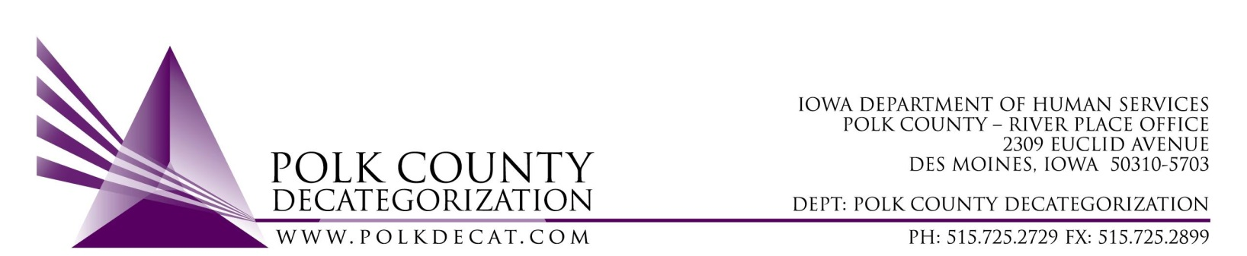

Emergency EXECUTIVE COMMITTEE Meeting
Thursday, August 5, 2021

Meeting Minutes

- The meeting was called to order, via Microsoft Teams video and conference call, at 10:31 am by Eric Kool. Also present were Robert Smith, Tamra Jurgemeyer, Jim Ward, John Hawkins, and Teresa Burke.

- Review and vote: Transfer out of FY19 Polk Decat Allocation funds to Boone and Ames Decat Clusters:
  - Even with efforts in the spring to transfer out of Polk Decat approximately $175,000.00 of FY19 State JCS Carry-over Funds, we will still revert somewhere between $130,000.00 to $140,000.00 of FY19 unused dollars. Robert and Teresa were informed last week by David Philmon, a Budget Analyst with DHS Bureau of Budget and Planning, that we could still transfer out FY19 funds to another Decat within our Service Area but that it would need to be completed on or before August 15, 2021, including the other Decats’ acceptance of the transfers.
  - There were still Covid-based limitations in providing in-person services with many Polk Decat contracts throughout FY21. Contracts that typically would have spent down most or all of their annual funds fell well short of that spending, which is the main reason behind the over-abundance of unspent older dollars. The transfer out will limit the reversion of FY19 funds to somewhere between $15,000.00 and $20,000.00, which is still not ideal, but vastly better than $140,000.00.
  - The transfers out being proposed are:
Ames Clulster - $45,000.00
Boone Cluster - $80,000.00
For a total of $125,000.00 in FY19 Decat Allocation funds.
  - John moved that the FY19 funds be transferred as described to the Boone and Ames Decat Clusters. Tamra seconded, all were in favor, and the motion was passed unanimously.

- Adjourn: Jim moved to adjourn the meeting at 10:37 am. Robert seconded, all were in favor, and the motion passed unanimously.

The next regularly scheduled meeting will be Thursday, August 12, 2021, 10:00 am, via video and conference call.

tkdb

