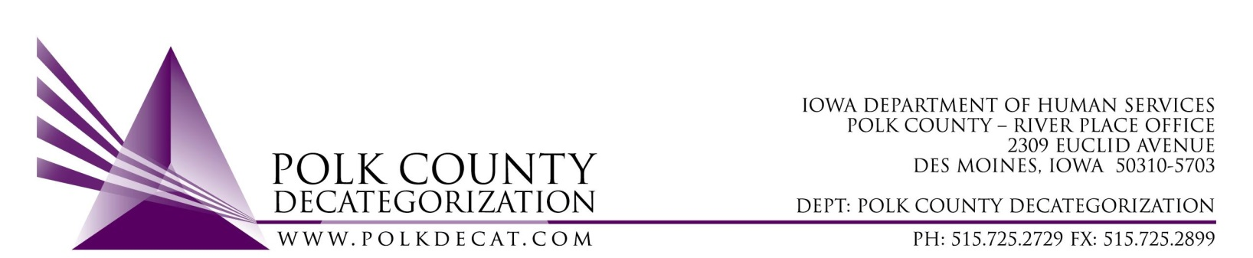

EXECUTIVE COMMITTEE – Phone Board Meeting
Thursday, June 14, 2018

Meeting Minutes

- Mike McInroy called the meeting to order at 10:02 am. Also present were Betty Devine, Chad Jensen, Amber Leon sitting in for Jim Ward (who was absent), Nikolle Ross and Teresa Burke.

- The May 10, 2018, minutes were reviewed. Amber moved to approve the minutes and Nikolle seconded. The motion was carried.

- Discussion and vote: Accept modification to March 1, 2017, Transfer of Funds from the Des Moines Cluster (Polk County) Decategorization to CJJP.
  - JCS has requested that the March 1, 2017, Transfer of Funds letter be modified to change the use of the funds from EPICS training to covering training for Functional Family Therapy. Other funding sources were used for the EPICS trainings and, due to the increased costs to train therapists in Functional Family Therapy and due to turnover in therapists, funds are needed to cover FFT training costs.
  - Betty moved to modify the March 1, 2017, Transfer of Funds and Amber seconded. The motion was carried. Teresa will have Mike sign the modification letter after the meeting is adjourned.

- For the next meeting:
  - No July meeting unless a voting item comes up. We can conduct a phone board meeting.

- Adjourn: Betty motioned that the meeting be adjourned at 10:06 am. Nikolle seconded and the motion was carried.

The next regularly scheduled meeting will be Thursday, August 9, 2018, 10:00 am in Conference Room 3.

