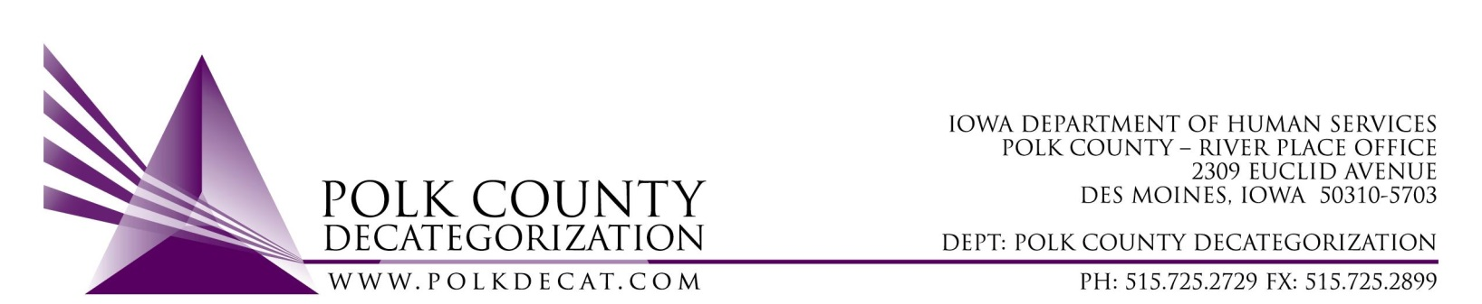

EXECUTIVE COMMITTEE Meeting
Thursday, June 11, 2020

Meeting Minutes

- The meeting was called to order, via conference call, at 10:02 am by Eric Kool. Also present were Stephanie Swartz, John Hawkins, Jim Ward, Kelly Cox, Teresa Burke, and Decat Staff Cassie Kilgore. Absent was Jana Rhoads.

- The May 14, 2020 minutes were reviewed. Jim moved to approve the minutes and Stephanie seconded. All were in favor and the motion was carried by unanimous vote.

- The FY20 budget was reviewed. Projections of contract over and under spending was highlighted. The “Expiration” tab was also highlighted with a reminder that the remaining old funds can be exchanged with newer funds at the end of the fiscal year, once all the FY20 GAX have been received.

- Discuss and vote: Accept FY20 Transfer of Funds letters from JCS, totaling $1,078,985.00.
  - The FY20 JCS Transfer of Funds State Carry-over letters were presented to the Board along with a spreadsheet that totaled all the amounts. It was noted that the total amount was insufficient to cover all FY21 JCS contract values, but there are more than enough carry-over funds currently unencumbered to cover the shortage and still have a substantial unencumbered amount remaining.
  - Stephanie moved to accept the JCS Transfer of Funds letters and Jim seconded. All were in favor and the motion was carried by unanimous vote.

- Updates:
  - Trauma Informed Supervision: The projected timeline for administering the evaluations (pre-assessments), evalution review, initial and on-going trainings has been established. Chris Foreman and Armeda Wojciak will be scheduling time to discuss the timeline and evaluation process with DHS and JCS leadership within the next 2 to 3 weeks. One outstanding item is the contracting for the Decat portion of the training/evaluation for the project, which will be decided on and, hopefully, voted on by the next regularly scheduled Executive Committee meeting.
  - Decat staff are still working mostly from home, coming to the office for activities that are unable to be completed remotely.
  - RJCE and CPPC: Diamond started conducting the AACCT meetings remotely via video conferencing. She is also in the midst of administering and facilitating conversations on the IDI (Implicit Bias) assessments with DHS and JCS. Cassie has been working with DWebware on updating the Polk Decat website and has begun sending resources and calendar of event emails to our distribution lists. CPPC and Providers’ Advisory meetings are still not being held due to the Covid-19 restrictions.

- Next meeting topics:
  - Transfer(s) of funds, if any
  - Review of FY20 budgets
  - Semi-annual contract performance review
  - Trauma Informed Supervision Project update
  - RJCE and CPPC activities
  - Anything else

- Discuss and vote: Yes or no to July board meeting if there are no voting items.
  - The board agreed that, if there are no voting items, there is no reason to hold a meeting in July.
  - Jim moved to not meet in July unless there is a voting item that cannot wait. Stephanie seconded and the motion was carried by unanimous vote.

- Adjourn: Stephanie moved to adjourn the meeting at 10:24 am. Jime seconded, all were in favor, and the motion was passed unanimously.

The next regularly scheduled meeting will be August 13, 2020, 10:00 am, via video or conference call, unless a voting item arises that cannot wait, and then the next regularly scheduled meeting will be July 9, 2020.

