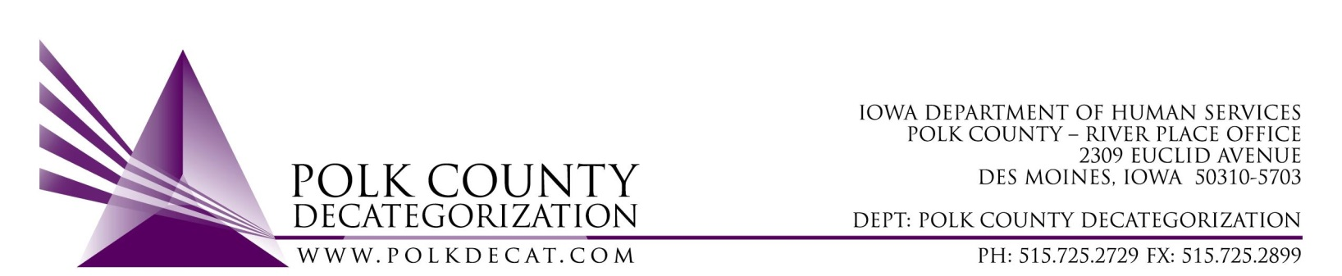

Polk Decat EXECUTIVE COMMITTEE Meeting
Thursday, June 9, 2022

Meeting Minutes

- The meeting was called to order, via Microsoft Teams video and conference call, at 10:05 am by Eric Kool. Also present were Jana Rhoads, John Hawkins, Tamra Jurgemeyer, as well as Joy Ihle from Polk County CFYS, Robert Smith DHS, and Teresa Burke.. Absent was Jim Ward.

- Review and approval of the May 12, 2022, meeting minutes.
  - Tamra moved to approve the May 12, 2022, minutes with the correction from John Hawkins on item 6.a. to change the name Charles Colvin Jr. to Charles Coleman Jr. Robert seconded (for DHS) and the motion was carried by unanimous vote.

- Review of the FY22 and FY23 budgets:
  - The FY22 budget was reviewed for over and underspending.
    - Teresa presented estimated figures on how much in funds Polk Decat could revert if spending stayed on its current trajectory for all contracts. It appears that over $100,000.00 of FY20 State Carry-over funds could revert. The Board was reminded that the estimates are inexact as spending has become more unpredictable since the start of Covid.
    - For those contracts where underspending is occurring and where the Decat team can impact spending, spendown activities were discussed. Rather than make transfers out to other DMSA Decats, we could make concrete support purchases on their behalf as they do not have much in Flex Funds dollars remaining. Robert Smith and Teresa will work together to develop a plan on what those purchases would be. The three new Decat Contracts with Polk County could also support spend down purchases which the Decat staff will work on.
  - The FY23 estimated budget was reviewed and the new transfers of funds from JCS were included. There is no deficit of funding for FY23.

- Discussion and vote: Accept FY22 State Carry-over Transfer of Funds (letters) from JCS:
  - Thirteen Transfer of Funds letters were received from JCS by Polk Decat, all FY22 JCS State Carry-over funds, for a total of $1,200,716.00, to cover the JCS portion of Polk Decat contracts in FY23.
  - Jana moved to accept the JCS Transfer of Funds letters for the stated amount. John seconded and the motion was carried by unanimous vote.

- Update on Decat staff transition:
  - Decat Staff are now officially Polk County employees. The Polk County Board of Supervisors passed the resolutions to make Polk Decat staff county staff and also approved the 3 Decat staff contracts in their May 17, 2022, meeting. Decat staff first day as county employees was May 23, 2022. Teresa expressed appreciation to all who worked hard to make the transition happen, especially to Eric Kool and Jim Ward.
  - The Board discussed if integrating the Polk Decat website into the County website was preferable to keeping it separate. The general consensus was that keeping the Polk Decat website not connected to the county website would maintain the community-nature of the site. The County website can create a link to the Decat website.
  - The new logo, which the Board had previously seen, will be vetted with the necessary parties in Polk County to ensure there are no issues with using a separate logo for Polk Decat. Eric confirmed there may be occasions where the Polk County logo may also need to be included in communications. The new logo will be included as a voting item in the next scheduled Board meeting.

- Other Decat, RJCE and CPPC Upates:
  - DCAT5-22-121, JCS Climate Survey update: the Contractor (Public Policy Associates) is currently reviewing the old survey for incorporation of recommended changes.
  - Pre-Arrest Diversion referrals have been impacted by recent changes to the DMPD reporting system. DMPD is working on changes to the new system so diversion referrals are not missed.
  - Parent Cafes: The first Parent Café training is the week of June 20th and the second training is the week of June 27th. The partnership with both Polk County Behavioral Health and Madison, Marion, Warren Decat has been critical in ensuring that all training costs would be covered during the Polk Decat transition.
  - The next DHS and JCS Trauma Informed Supervision on-site trainings will be the week of June 20th.

- Next meeting:
  - The Board agreed that a July meeting will not be required as there currently are no voting items. This could be subject to change if a voting item arises.
  - Review of FY22 & FY23 budgets (FY22 will be close to being final)
  - Semi-annual contract performance review
  - Vote on new Polk decat logo
  - Possible discussion: re-look at Board meeting documents, review of contracts, etc., and anything else the Board would like to know about general Decat activities during Board meetings.
  - Discussion & possible vote on FY23 mini-grants procurement
  - Other Decat, RJCE and CPPC activities
  - Anything else?

- Adjourn: John moved to adjourn the meeting at 10:47 am. Tamra seconded, all were in favor, and the motion passed unanimously.

The next regularly scheduled meeting will be on Thursday, August 11, 2022, in peron in the Polk County Family Enrichment Center (FEC) Conference Room.

tkdb

