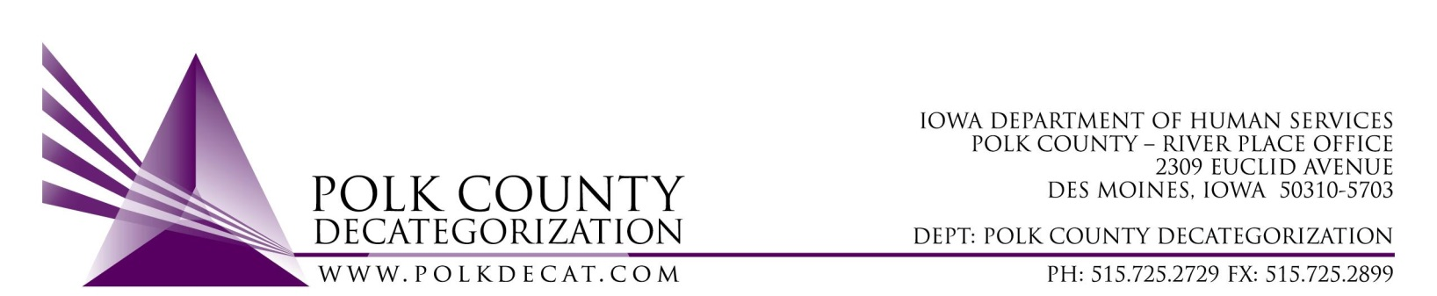

Polk Decat EXECUTIVE COMMITTEE Meeting
Thursday, May 12, 2022

Meeting Minutes

- The meeting was called to order, via Microsoft Teams video and conference call, at 10:03 am by Eric Kool. Also present were Robert Smith (sitting in for Jana Rhoads), John Hawkins, Tamra Jurgemeyer, and Jim Ward, plus Teresa Burke, and Cassie Kilgore from Polk Decat. Absent was Jana Rhoads.

- Review and approval of the April 14, 2022, meeting minutes and renewal voting addendum minutes and the April 26, 2022, special meeting minutes and renewal voting addendum minutes.
  - Tamra moved to approve the minutes for the April 14, 2022, and April 26, 2022, meetings. John seconded and the motion was carried by unanimous vote.

- Review of the FY22 and FY23 budgets:
  - The FY22 budget was reviewed for over and underspending.
    - The DCAT5-19-002 Psychological Evaluations contract does not have enough funds left to cover May, but JCOs can request that Evaluations be court-ordered and, therefore, reimbursed through JCS Court-Ordered Services funds. In addition, when available, private insurance can also reimburse or Flex Funds could be used as a last resort.
    - The DCAT5-22-112, JCS Reentry Aftercare Services contract is overspending. In our quarterly contractor meeting this week with Boys Town, we discussed how they could drastically cut down on spending to make it through the next 1 ½ months. Using virtual meeting platforms when possible and phone calls rather than face-to-face would go a long way to reducing the travel charges, which are around $4,000.00 per month.
    - The DCAT5-19-001, Fiscal Agent contract is underspending but with all the Conferences, Team Building activities and other purchses, those funds will get spent down more quickly in May and June.
  - The FY23 estimated budget was reviewed and the only shortage of funds would be the JCS funds to cover FY23 contracts. However, JCS will be sending Transfer of Funds letters to Polk Decat shortly and they will be on the June Polk Decat Board agenda for voting.

- Discussion and vote: Community Partnerships for Protecting Children (CPPC) FY23 Annual Plan and Budget:
  - The FY23 CPPC Annual Plan and Budget was sent to the Board in a earlier email so the Board had time to review the documents.
  - Cassie provided an overview of the report, which has a new format for this plan. Cassie covered the Shared Decision Making Steering Committee annual survey results and overall plans for FY23, which includes the support and expansion of Parent Cafes, community trainings and small community grants.
  - Parent Cafes will be the new method that Polk CPPC will use to address the Family and Youth Centered Engagement (formerly Individual Course of Action) strategy. Parent Café host trainings are already planned for this June with over 30 people already signed up for the 2 trainings. The FY23 plan includes how we can support those who are hosting Parent Cafes on-going as well as supporting another training.
  - John moved to accept and approve the FY23 CPPC Plan and Budget. Jim seconded and the motion was carried by unanimous vote.

- Update on Decat Staff transition:
  - The 3 Decat Staff contracts are finalized and to the Polk County Board of Supervisors for voting on Tuesday, May 17, 2022, 9:30 am. The contracts are effective on that date so Eric, Robert and Teresa will be moving quickly to get those contracts from the Board of Supervisors to the other signatories for full execution that day.
  - The last scheduled day for Polk Decat Staff as PCHS employees will be May 20th, and the first work day as Polk County employees will be Monday, May 23rd.

- Other Decat, RJCE and CPPC Upates:
  - DCAT5-22-121, JCS Climate Survey update: John indicated that they have met once with the contractor (Public Policy Associates) to start planning the survey questions and processes. Charles Coleman Jr. will be assisting with development of the questions through discussions with the Supervisors.
  - Pre-Arrest Diversion services are still going very well, right out of the gate. Purchases of Leadership camps (weekends) were made for youth who qualify under the Tier system, and some or all hours of On-line diversion training can be substituted by attending these camps.
  - Parent Cafes: Discussed under Agenda item 4.
  - Payables challenges and spending down plans: Teresa will be meeting with Liz Cox today on payables, submisions of GAX and close out activities. There are 3 invoices that we will need to figure out how to pay if PCHS is unable to pay for them. All other payables items are accounted for either through the 3 PCHS contracts, Flex Funds or other sources.

- Next meeting:
  - Does the Board need to meet in June and does the Board want to start meeting in person?
    - The Board does need to meet briefly in June to vote on accepting Transfer of Funds letters from JCS.
    - The Board elected to meet virtually in June so all members are able to attend, not meet in July if there are no voting items, and resume meeting in person starting with the August meeting, or the next scheduled meeting if there are no voting items in August.
  - Review of FY22 and FY23 budget
  - Discussion & possible vote on FY23 mini-grants procurement
  - Decat Staff transition update
  - Other Decat, RJCE, CPPC and PAD activities

- Adjourn: Jim moved to adjourn the meeting at 10:51 am. Tamra seconded, all were in favor, and the motion passed unanimously.

The next regularly scheduled meeting will be on Thursday, June 9, 2022, via video and conference call.

tkdb

