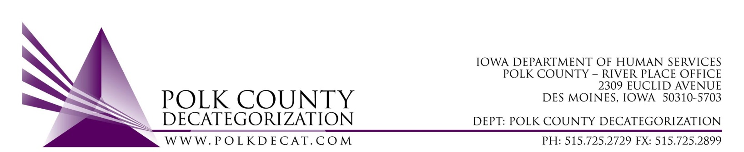

EXECUTIVE COMMITTEE
Thursday, May 9, 2019

Meeting Minutes

- Betty Devine called the meeting to order at 10:03 am. Also present were Chad Jensen, Matt Haynes, Eric Kool, Jim Ward, Stephanie Swartz, Angela Crees and Teresa Burke.

- The April 11, 2019, minutes were reviewed. Matt moved to approve the minutes and Stephanie seconded. All were in favor and the motion was carried.

- The FY19 Budget was reviewed, as well as the revised projections for FY20. Contract spending was reviewed and focus was on contracts that were underspending and overspending. Also, with the expired TANF funds removed, it is more than likely that all FY17 State Carry-over funds unspent at the end of FY19 will be able to be exchanged with spent FY18 funds.

- Discussion and vote: Add $5,000.00 to DCAT5-14-017, Diversion & Mediation contract, Polk County Attorney’s Office, to ensure coverage until the end of the year. Voting on addition of funds as well as Amendment document.
  - The Diversion & Mediation contract continues to run over budget and it is recommended that it may require up to $5,000.00 in DHS State Carry-over funds to get it through to the end of the fiscal year, at which point the contract will expire.
  - Eric moved to add the stated funds to DCAT5-14-017 this fiscal year. Chad seconded, all except Jim, who abstained, were in favor and the motion was carried.

- Discussion and vote: Transfer of FY17 JCS funds to other Decat Clusters in Des Moines Service Area:
  - The 3 transfers presented to the Board were:
    - Creston: Transfer $12,230.00 & Transfer Letter
    - Leon: Transfer $20,651.00 & Transfer Letter
    - Indianola: Transfer $50,000.00 & Transfer Letter
  - The Board elected to vote on all three transfers with one vote. Matt moved to approve the three transfers from the Des Moines Decat Cluster (Polk) to the respective Decats in the stated amounts. Stephanie seconded, all were in favor, and the motion was carried.
  - The transfers will allow Polk Decat to use up more of the large amount of unencumbered JCS Carry-over dollars. The FY17 funds must be used by the recipient Decats during the current fiscal year.

- Accept Transfer of Funds from DHS:
  - Two transfer letters were presented to the Board to be accepted:
    - $129,965.80 in FY18 DHS State Carry-over funds to replace the TANF funds which had expired.
    - $30,000.00 in FY20 PSSF funds, to be used for family reunification services which, in this circumstance, would be to assist with transportation to PSSF-eligible services by DHS clients and caregivers.
  - Chad moved to accept the two transfer of funds letters. Eric seconded, all were in favor and the motion carried.

- Discussion and vote: Decat Admin Assistant, Cassie Thomas, go to full-time effective June 1, 2018.
  - The Board was reminded that Cassie Thomas was approved to move to full-time status with the new FY20 Decat Coordination budget, dependent on when she was ready and available to do so. Cassie requested to move to full-time by June 1, 2019, if it pleased the Board.
  - Teresa met with Diane Knight, the PCHS (Decat Coordination Contractor) Accountant, and there are enough funds in the budgetto cover the costs associated with one month of Cassie moving from Part-time to Full-time. The total costs, including wages, FICA, and Insurance, would be less than $1,200.00.
  - Jim moved that Cassie Thomas be allowed to go to Full-time status as of June 1, 2019. Stephanie seconded, all were in favor, and the motion was carried.

- Discussion and vote: Accept Polk County Community Partnership for Protecting Children (CPPC) FY20 Annual Plan:
  - This is an “informal” vote since the submission of the annual CPPC Plan does not require Board approval. However, in Polk County, Community Partnerships for Protecting Children falls under the Decategorization umbrella of coordination efforts. As a part of Decategorization, the Board should review and approve any reports that are submitted at the State level. The report was emailed to the Board for review on Friday, May 3rd.
  - Stephanie moved to accept the CPPC Plan for FY20. Matt seconded, all were in favor, and the motion was carried.

- Decat Updates:
  - RJCE: Diamond is doing an excellent job and we hear very positive feedback on her performance and relationship building in the community. She has been looking into an Implicit Bias Assessment that DMPS has been using. The training will be in Minnesota this June, in case DHS and JCS are interested in implementing this assessment and results approach. It is recommended that, if interested, both DHS and JCS send one or two of their staff, in addition to Diamond, so they are able to administer and evaluate the assessment and provide feedback.
  - CPPC: Jordan has spent a lot of time on the CPPC Report. She will now focus on organizing a couple of upcoming trainings, one coming up later in May on “Dealing With Difficult Personalities”. These community trainings are very popular.

- For the next meeting:
  - Transfer in of JCS Carry-over funds. The Board agreed to have a phone-in conference call meeting as this should be the only voting item on the agenda.
  - Other

- Adjourn: Chad moved to adjourn the meeting at 10:52 am. Matt seconded, all were in favor, and the motion was passed unanimously.

The next regularly scheduled meeting will be Thursday, June 13, 2019, 10:00 am via conference call.

