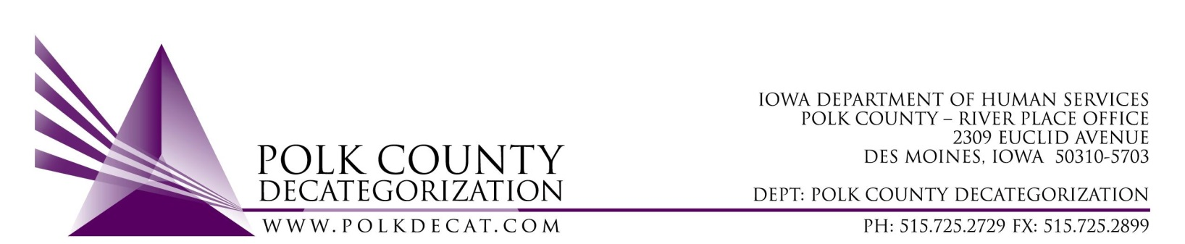

Polk Decat EXECUTIVE COMMITTEE Meeting
Thursday, April 14, 2022

Meeting Minutes

- The meeting was called to order, via Microsoft Teams video and conference call, at 10:07 am by Eric Kool. Also present were Jana Rhoads, John Hawkins, and Jim Ward, plus Teresa Burke, and Cassie Kilgore from Polk Decat. Absent was Tamra Jurgemeyer.

- Review and Approval of the March 10, 2022, meeting minutes.
  - John moved to approve the minutes for the March 10, 2022, meeting. Jana seconded and the motion was carried by unanimous vote.

- Review of the FY22 and FY23 budgets:
  - The FY22 budget was reviewed for over and underspending. In addition, the aggregate spending was reviewed for possible reversion of older funds.

- Discussion and vote: Transfer of funds (Letter) of $12,000.00 of FY20 DHS State Carry-over dollars to Creston Decat Cluster.
  - The Board was reminded that State Carry-over funds can be transferred between Decat Clusters that are in the same Service Area in order for the funds to get used and to avoid possible reversion. The Creston Cluster is in need of State Carry-over funds this fiscal year to support Flex Funds concrete supports.
  - Jana moved to approve the Transfer of Funds (Letter) as stated. John seconded and the motion was carried by unanimous vote.

- Discussion and vote: Refer to Minutes Addendum on FY23 contract renewal voting.
  - The Board agreed to convene a special meeting on Tuesday, April 26, 2022, at 1:00 pm, via Microsoft Teams, to complete new contract voting and other contract voting business.

- Decat Staff budgets and Fiscal Agent budget updates and plans to spend down funds:
  - The small grants opportunity is now closed and 15 grants will be supported, first come, first approved. The Shared Decision Making Steering Committee was provided 47 grants for review. Grants were reviewed in order of receipt and approved or denied with simple yes/no voting. The list of approved grants was shared with the Board. Only grantees who submit their signed MOU will receive funding.

- Other Decat, RJCE and CPPC Upates:
  - Cassie provided a view of the new Polk Decat Logo. The Board agreed to table implementation of the new logo until the new contracts are settled and it is determined if the logo can be used.
  - Other updates tabled until the next meeting due to time constraints

- Next meeting:
  - Review of FY22 and FY23 budget
  - Vote on remaining FY23 new contracts
  - Other Decat, RJCE, CPPC and PAD activities

- Adjourn: Jana moved to adjourn the meeting at 11:20pm. John seconded, all were in favor, and the motion passed unanimously.

The next regularly scheduled meeting will be on Thursday, May 12, 2022, via video and conference call.
The next Special Board meeting to complete contract voting will be on Tuesday, April 26, 2022, at 1:00 pm, via video and conference call.

tkdb

