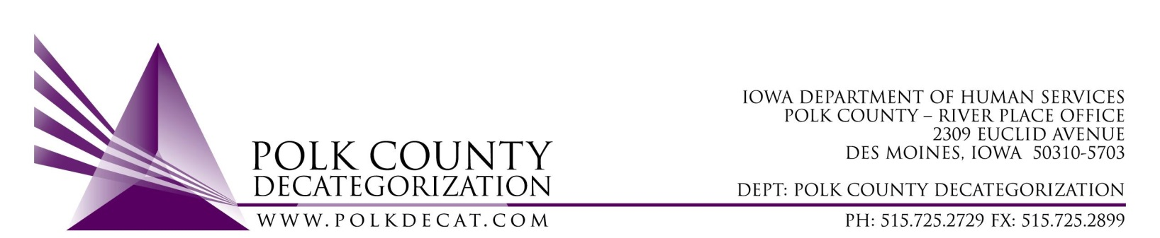

EXECUTIVE COMMITTEE Meeting
Thursday, March 11, 2021

Meeting Minutes

- The meeting was called to order, via Microsoft Teams video and conference call, at 10:06 am by Eric Kool. Also present were Robert Smith, Tamra Jurgemeyer, Jim Ward, Jana Rhoads, Christy Burkhart, John Hawkins, Teresa Burke and Cassie Kilgore.

- The February 11, 2021, minutes were reviewed. Tamra moved to approve the minutes and Jana seconded. All were in favor and the motion was carried by unanimous vote.

- Review FY21 budget and financial status of Polk.
  - Spending of contracts was reviewed and, overall, spending is still down.
  - Reviewed the impact of the most recent transfers out and how it will hopefully reduce or eliminate any reversion of old state funds at the end of the fiscal year.

- Discussion and vote: Increase the amount of FY19 DHS State Funds in the Volunteer Coordination Services contract (V2019-01-05) in FY21 form $19,511.11 to $19,600.00 (a total of $86.00) to match the amount that was submitted in the renewal amendment:
  - Teresa explained the snafu that was caught when, after reviewing GAX where Decat funds were used, their appeared to be an overage of $86.00 in Decat funds available for that contract. After review of the PCQ that attended the renewal amendment for this contract, it was discovered that the documents reflected Decat funds in the amount of $19,600.00 rather than the board approved amount of $19,511.00. If the board approves the increase, it will be the most efficient fix to the issue.
  - Jim moved to increase the amount of Decat funds in V2019-01-05 to $19,600.00. Jana seconded and the motion was approved by unanimous vote.

- Discussion and vote: Decision on some of Polk Decat contract renewals for FY22. Refer to the March 11, 2021 Agenda Addendum and Minutes Addendum for voting results.

- Other Decat, RJCE and CPPC updates:
  - Teresa provided updates on the 3 RFPs:
    - DCAT5-22-001, Sex Offender Treatment Services – Bids are in and with reviewers. Only one bid was received.
    - DCAT5-22-112, JCS Reentry Aftercare Services – Bids are due next week. There has been a lot of interest and many bidder questions were received and answers posted to the Bid Opportunities site.
    - DCAT5-22-116, JCS Transition Youth Services – Bids are due next week. There also has been a lot of interest in this RFP. The Bidder Q&A has also been posted to the Bid Opportunities site.
  - Decat issue in the norther area and what Polk Decat should ensure is in place to avoid and mitiage misusage of funds.
    - The board agreed that Polk Decat has many safeguards in place to mitigate misuse of funds. Teresa explained how having staff other than her initiate and enter expenditures with her oversight ensures that more than one set of eyes reviews each expenditure. This lessens the opportunity for misappropriation.
    - Teresa welcomed board members to go through expenditure/payment processes with her if they felt the need.
  - Cassie provided an update on Community Partnership projects:
    - The Black Doula pilot with Bethany Christian services provided them with the opportunity to expand funding through matches. They also have interest from other funding entities on results from their pilot.
    - We are partnering with collaborative efforts to bring Sesame Street In Communities (SSIC) trainings and materials to diverse populations in Polk County.

- Next meeting topics:
  - Any other Transfers of funds
  - Review of FY21 budget
  - Complete FY22 Contract Renewals and new contracts that result from RFPs
  - Discussion on use of some of the JCS unencumbered funds
  - Other Decat, RJCE and CPPC activities
  - Anything else?

- Adjourn: Jim moved to adjourn the meeting at 11:04 am. John seconded, all were in favor, and the motion passed unanimously.

The next regularly scheduled meeting will be Thursday, April 8, 2021, 10:00 am, via video and conference call.

tkdb

