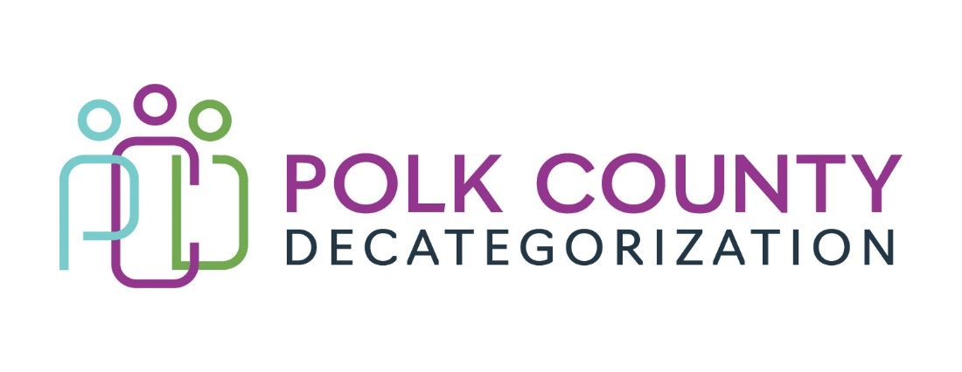

Polk Decat EXECUTIVE COMMITTEE Meeting
Thursday, March 9, 2023

Meeting Minutes

- The meeting was called to order in person at the Polk County Family Enrichment Center Conference Room, at 10:06 am by Eric Kool. Also present were Amanda Marshall sitting in for Jana Rhoads, John Hawkins, Amber Leon sitting in for Andrea Vitzthum, and Teresa Burke. Absent was Stacie Nessa, Jana Rhoads and Andrea Vitzthum. Also in attendance was Joy Ihle from Polk County.

- Review and approval of the February 9, 2023, meeting minutes.
  - John moved to approve the February 9, 2023, minutes. Amanda seconded to approve the minutes as amended and the motion was carried by unanimous vote.

- Review of the FY23 budget discussion:
  - Most contracts are underspending except for the DCAT5-22-112 Reentry Aftercare Services and DCAT5-19-002 Psychological Evaluations, which are running over budget.
  - The transfers to CJJP and the Indianola Decat Cluster which are later voting items was included in the aggregate funds page.
  - The Board was reminded that there would be no transfer of DHHS funds to Decats for FY24.

- Follow-up discussion: Support for the Foster Care Review Board (FCRB) Expansion.
  - There were still only the 7 respondents to the FCRB survey, i.e., no more than last month. Amanda will send a reminder out again to DHHS Workers and Judges to take the survey. Amanda indicated that all the respondents so far were not supportive, and some indicated that FCRB members were not always aware or educated on DHHS practice and law when providing feedback.
  - Due to lack of interest and funding, this topic will be tabled indefinitely.

- Discussion and vote: transfer of $12,000.00 in FY21 Polk Decat Legislative Allocation funds to the Indianola Cluster Decat for Decat and CPPC Coordination services and activities.
  - Teresa explained that the small transfer of FY21 Decat Legislative Allocation funds to the Indianola cluster will allow that area to better utilize newer monies in the next two fiscal years. It has been traditional for the DMSA Decats to assist each other so funds do not revert and all Decats are able to push newer funds out for future use.
  - John moved to approve the transfer of FY21 Polk Decat Legislative Allocation funds to the Indianola Decat Cluster. Amanda seconded and the motion was carried by unanimous vote.

- Discussion and vote: Transfer of $6,500.00 in FY21 JCS State Carry-over funds to CJJP for the National Drug Court Conference for JCS Staff.
  - John Hawkins provided a brief explanation of how helpful it is to have Drug Court judges, attorneys and JCOs all attend this conference to develop a unified and effective approach. The transferred funds will assist with sending Drug Court JCS staff to the National Drug Court Conference in Houston with other Drug Court members.
  - Amanda moved to approve the Transfer of Funds letter for $6,500.00 in FY21 JCS State Carry-over funds to CJJP. John seconded and the motion was carried by unanimous vote.

- Discussion and vote: Increase DCAT5-22-112, JCS Reentry and Aftercare Services contract by $26,000.00, from $262,529.00 to $288,529.00, to ensure services can be covered until the end of FY23, and to approve the 2nd Amendment.
  - Teresa had a discussion with a Bureau of Service Contracts and Support (BSCS) representative about increasing a competitively procured contract. There are not rules about this although guidance was provided. A justification for the increase for the contract file was provided to the Board for review.
  - BSCS advised that, if the RFP had a cap on the total value of the full term of the contract, then it was important to not go over that capped amount. This contract does have a cap and, after discussion between John Hawkins and Teresa, it was decided to increase this fiscal year and each subsequent fiscal year by about 10%, basically borrowing from the final extension year of the contract, thus shortening the duration of the full term of the contract by one year. So, rather than being able to renew into FY27, the contract would end June 30, 2026. This option was also discussed with Jana Rhoads as she is the contract owner.
  - Amanda moved to increase the DCAT5-22-112 value for FY23 by $26,000.00, from $262,529.00 to $288,529.00, and approve the Second Amendment. John seconded and the motion was carried by unanimous vote.

- Discussion and vote: Increase amount of FY21 DHHS State Carry-over funds in V2019-01-05, Volunteer Coordination Services contract, by $11,000.00.
  - The Volunteer Coordination Services contract is not a Polk Decat contract, but Decat funds are used to supplement the contract as there is some cross over in activities. Because DHHS State Carry-over funds are used to supplement this contract, it will deplete some of the critical reserve of DHHS funds for FY24. However, it is possible that this contract will not be renewed for FY24 as the focus is to solicit for Dependent Adult guardians and conservators. The Dependent Adult unit will move under the Department of Aging in the DHHS restructure so it is likely that the Polk Decat funds previously slated to support this contract in FY24 will not be required.
  - John moved to increase the amount of FY21 DHHS State Carry-over funds in V2019-01-05, Volunteer Coordination Services contract, by $11,000.00. Amanda seconded and the motion was carried by unanimous vote.

- Performance outcomes highlights review.
  - The Board was provided the full Quarterly Reporting Spreadsheet via email for review outside of the Board meeting. A Highlights document was also provided and some of the outcomes reviewed include:
    - DCAT5-18-008, Sanctions Learning, referrals from JCS are still lower even though the contractor is ready to support higher levels post-Covid. When services stopped temporarily during Covid, JCOs found other resources for youth to complete community service such as the online trainings that are paid for out of the PAD Coordination contract.
    - The Contractor for the DCAT5-19-002, Psychological Evaluations Contract still struggles with turnaround times from referral to report completion. It is challenging to find sub-contractors who are licensed psychologists, who will accept the $2,000.00 flat charge for full evaluations and who have capacity to meet the quick turnaround timeframes. The Contractor can meet the need and provides reports that are well-regarded by judges, JCS, attorneys, and agencies where youth are referred.
    - The DCAT5-19-003 Preventive Law & Guidance contract is currently being underutilized by Social Workers, most likely due to the turnaround in staff and not being aware of the service. It is recommended that the Contractor provide a short presentation at a DHHS Lunch & Learn so Social Workers are aware of the service and can request cases for referrals for guardianships and other civil issues.
    - DCAT5-20-005, Diversion and Mediations, is underspending again and it is recommended to reduce the value of this contract in FY24. Also, the County Attorney Juvenile Bureau Chief is considering making better use of their staff time with DHHS.
    - DCAT5-21-045, RIG Services, is a low volume contract so it is easy for Social Workers and JCOs to forget to make referrals when they have refugee cases. Brianne Emunah with VNS held a Lunch & Learn at DHHS in December and has regular office hours at JCS once per month to increase visibility.
    - DCAT5-22-001, WCBS for Juvenile Sex Offender treatment now has two certified SOTP I providers on staff. They have just added to staff and that person is taking courses towards her SOTP I certification.
    - The DCAT5-22-112, Reentry and Aftercare Services, Contractor is required to ensure that youth complete their Casey’s Life Skills assessments while still in group care. Even though it is not their responsibility to administer the assessment, they have struggled collaborating with group care and STS facilities to ensure these are completed.
    - The DCAT5-22-116, Transition Youth Services contractor had a change in their Lead YCPM facilitator during the first half of FY23. The new lead is fully certified and coached and, by all reports, is performing well.
    - The DCAT5-22-121A Contractor has had a change in ownership and the contract assignment documents have been signed and sent through the contract processing chain.
    - Although the RJCE position is not filled under the DCAT5-22-144 contract, we are working on spending down the MYFI funds, so they do not revert at the end of FY23.
    - The PAD Coordinator, under the DCAT5-22-145 contract, works very independently and has been building relationships within the community for more youth pre-arrest diversion options. He was excited to work with the Street Collective, having referred youth building and repairing bicycles. A couple of the youth decided to volunteer on their own after the project was over.
    - DMPS reported under the DCAT5-23-141 contract that the average class failing rate for participating students is 1 to 2 classes. Programming did not start until October 2022, so there is room for students to improve grades and attendance.

- Discussion and vote: First round of FY24 contract renewal voting. Refer to Minutes Addendum renewal voting document.

- Discussion and vote: Successful Bidder for DCAT5-24-148, Early Services Program RFP.
  - The DCAT5-24-148 Evaluation Committee Recommendation and Evaluation spreadsheet was provided to the Board for review and the recommendations were discussed. The Evaluation Committee had bullet points for discussion with the Successful Bidder for the contract negation process. Orchard Place was recommended as the Successful Bidder.
  - After review of all the documents and discussion, John Hawkins moved to recommend Orchard Place as the Successful Bidder for the DCAT5-24-148, Early Services Program RFP. Amanda seconded and the motion was carried by unanimous vote.

- Discussion and vote: Successful Bidder for DCAT5-24-149, Sanctions Learning Services RFP.
  - The DCAT5-24-149 Evaluation Committee Recommendation and Evaluation spreadsheet was provided to the Board for review and the recommendations were discussed. The Evaluation Committee had bullet points for discussion with the Successful Bidder for the contract negation process. Orchard Place was recommended as the Successful Bidder.
  - After review of the documents and discussion, Amanda Marshall moved to recommend Orchard Place as the Successful Bidder for the DCAT5-24-149, Sanctions Learning Services RFP. John seconded and the motion was carried by unanimous vote.

- Update on hiring for Project/CPPC Coordinator and RJCE Coordinator positions.
  - Eric Kool provided a summary of the Polk County process for job reclassification and the net result of a possible increase in salaries for the three position under review. The review is still in process with Polk County Human Resources and there should be some answers within a month or less.

- Other Decat, RJCE and CPPC Updates:
  - RFP Updates: The final RFP to review, the DCAT5-24-150 Trauma Services in Polk Detention RFP, had the bid evaluation occur this week. Due to time and notification constraints, it was not possible to have those results to the Board in a timely manner. Those results will be presented and voted on in the next Board meeting.
  - There is still a hold on CPPC, Project and RJCE services due to lack of capacity. Lisa continues to grow in her job competency so there may be other duties that can be added temporarily.

- Next meeting:
  - Review of FY23 budget and expenditures
  - DCAT5-24-150 RFP Bid evaluation results and voting
  - FY24 renewal final discussion and voting on remaining contracts.
  - Other Decat, RJCE and CPPC activities, including position reclassification and hiring updates.
  - Anything else?

- Adjourn: John moved to adjourn the meeting at 11:21 am. Amanda seconded, all were in favor, and the motion passed unanimously.

The next regularly scheduled meeting will be on Thursday, April 13, 2023, 10:00 to 11:30 am, in person in the Polk County Family Enrichment Center (FEC) Conference Room.

tkdb

