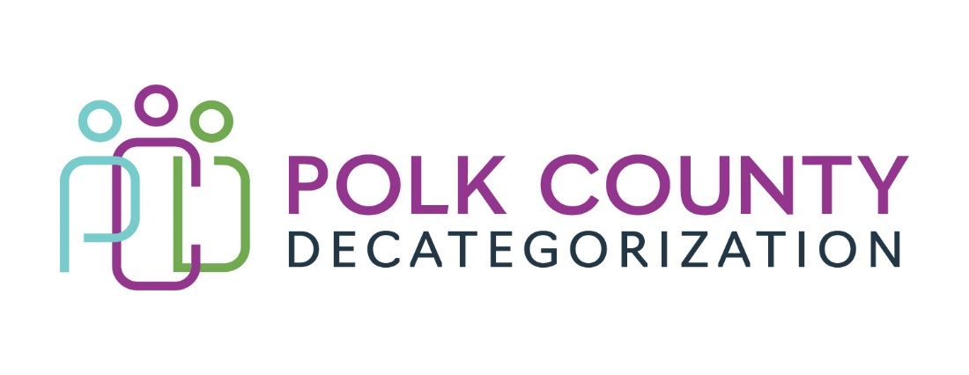

Polk Decat EXECUTIVE COMMITTEE Meeting
Thursday, February 9, 2023

Meeting Minutes

- The meeting was called to order in person at the Polk County Family Enrichment Center Conference Room, at 10:01 am by Eric Kool. Also present were Jana Rhoads, John Hawkins, and Andrea Vitzthum, and Teresa Burke. Absent was Stacie Nessa. Other guests include Mindy Norwood and Amanda Marshall from DHHS as well as Lisa Cort from Polk Decat.

- Review and approval of the January 12, 2023, meeting minutes.
  - Andrea noted a name correction was needed for Stacie Nessa’s name in the minutes.
  - John moved to approve the January 12, 2023, minutes. Jana seconded to approve the minutes as amended and the motion was carried by unanimous vote.

- Review of the FY23 budget, which was moved to after the agenda item 4 discussion:
  - Highlighted again this month was the spending for contract DCAT5-22-112, Reentry and Aftercare Services. DHHS BSCS has been contacted to confirm if and how much of an increase can be supported but no answer has yet been received.
  - The transfer to Woodbury Decat which is a later voting item was included in the aggregate funds page.
  - A small transfer of Decat Legislative allocation funds to Madison/Marion/Warren Decat is still a possibility. Jana confirmed that would benefit that area greatly.
  - A projection for FY24 of contracts by funding source was provided to the Board to indicate where funds would be short. The spreadsheet would not reflect funds contracted in FY23 but go unused at the end of the fiscal year. Since DHHS will not have funds to transfer to Decats, the Flex Funds contract will be valued much lower in FY24. However, if there were PSSF funds available again in FY24, they could be added to the Fiscal Agent contract to bolster the DHHS total amounts.

- Follow-up discussion: Support for the Foster Care Review Board (FCRB) Expansion.
  - The survey created by Amanda was just recently sent to DHHS Social Workers and Juvenile Court Officers. Only seven responses have been received thus far, but all were not supportive of the FCRB. Some felt the FCRB was duplicative of other review committees, such as the Transitioning Youth reviews and the AACCT. Others commented that some FCRB members were not trauma informed in their comments, especially when the youth being discussed was in the meeting.
  - Amanda indicated that a reminder to take the survey would be sent to SWs and JCOs to garner more responses. Eric had wondered if the survey had been sent to Polk Juvenile Court Judges. Christy Burkhart volunteered to forward the survey link to them.
  - The Board will follow-up on this item in the next meeting.

- Discussion and vote: transfer of $15,600.00 in FY21 JCS State Carry-over funds to Woodbury Decat for education and training services.
  - John Hawkins provided a brief explanation of how JCS no longer had a person coordinating statewide education and training for JCS. Each Judicial District was transferring funds to Woodbury to support a temporary contracted person to provide coordination of these services.
  - Andrea moved to approve the transfer of FY21 JCS State funds to Woodbury Decat. John seconded and the motion was carried by unanimous vote.

- Update on hiring for Project/CPPC Coordinator and RJCE positions:
  - Eric Kool summarized the difficulties hiring for the Project/CPPC Coordinator position and the anticipated similar issues with trying to hire for the RJCE Coordinator, one of which was a competitive salary to attract the most qualified persons. When Polk Decat moved under the Polk County umbrella, all the positions underwent a very quick review and classification process due to the need for a speedy turnaround. The forms have been submitted to Human Resources for reclassification review. They may not be reclassified based their decision or reclassified at varying levels. Once those job classifications have been reviewed, the Board will be notified and the positions posted for hiring.
  - The board agreed that having the education and skill set for the RJCE position was most critical, especially someone who understands the JCS and DHHS systems.

- Other Decat, RJCE and CPPC Updates:
  - RFP Updates: The bidding opportunity has closed for all three Polk Decat RFPs. Two RFPs had only one bid each that were received, and one RFP had three bids that were received. Bid evaluation packages have been delivered to all reviewers.
  - No other CPPC services can be provided due to lack of capacity. Now that Lisa is getting more competent at her job, there may be other duties that can be added temporarily.

- Next meeting:
  - Review of FY23 budget and expenditures
  - Follow-up discussion of the Foster Care Review Board support
  - Performance Reporting
  - FY24 renewal discussion and voting for some contracts
  - Other Decat, RJCE and CPPC activities, including position reclassification and hiring updates
  - Anything else?

- Adjourn: Jana moved to adjourn the meeting at 10:56 am. John seconded, all were in favor, and the motion passed unanimously.

The next regularly scheduled meeting will be on Thursday, March 9, 2023, 10:00 to 11:30 am, in person in the Polk County Family Enrichment Center (FEC) Conference Room.

tkdb

