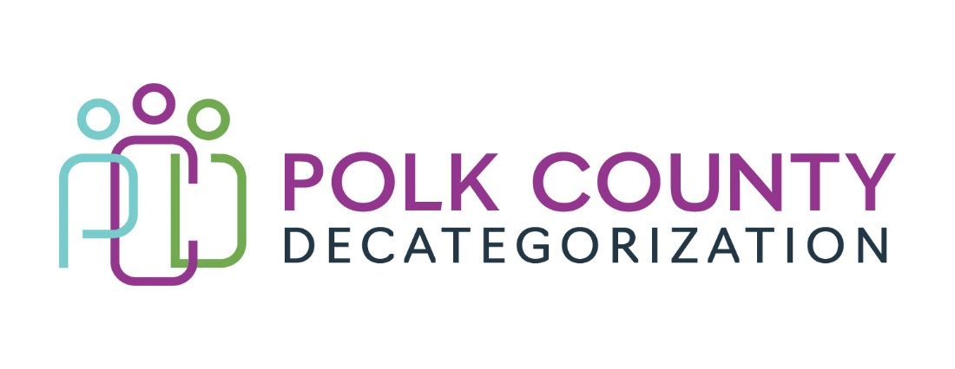

Polk Decat EXECUTIVE COMMITTEE Meeting
Thursday, January 11, 2024

Meeting Minutes

- The meeting was called to order in person at 10:06 am by Eric Kool. Present voting members were Jana Rhoads, Shannon LeFevour, Eric Kool, Stacie Ness and Andrea Vitzthum. Also in attendance were Amanda Marshall from HHS, Jaime Stevens and, Lisa Cort from Polk Decat, Joy Ihle from Polk County CFYS,

- Review and approval of the November 14th, meeting minutes.
  - Andrea moved to approve the December 14, 2023, minutes. Jana seconded to approve the minutes and the motion was carried by unanimous vote.

- Contract Budget Tracking
  - Eric reviewed spending trends in the Contract Budgets and the Contract Payment Table.
  - There was discussion about the HHS restructuring Decat/CPPC. Jana reports no changes to Decat are anticipation this session.
  - For 24/25 contracts using JCS funds SAM’s are unable to sign. They will go to Director Garcia

- FY23 Funds Transfer to CJJP for STS Re-Entry Navigator
  - A letter from JCS requested $42,915.40 to fund a Re-Entry Navigator for the STS
    - Andrea moved to approve. Jana seconded. The motion carried by unanimous vote with request to Shannon/JCS to provide more details about the long-term intent and current data, as well as definition of “disability” for this service

- Review Iowa Aces 360 Activities
  - Jana and Amanda will talk with Iowa Ace’s director about billing. The contact is out of the office on medical leave.
  - Jaime updated HHS and JCS on the amount left in their respective $15k CPPC line-time allocations for this service
    - JCS has $4,850/15k remaining. It was discussed anything over $15k could be taken out of the RJCE contract pending John Hawkins Approval
    - HHS- has over $11k remaining and Jana offered to use their allocation to help JCS.

- FY25- Preview of available FY24/25 budget and preliminary discussion of intentions
  - Jana reported on MYFI, PSSF and PEAF dollars.
    - MYFI - expected to receive allocation but will be reduced as the dollars may be spread out to other counties who could use the funding.
      - Discussion about holding AACCT meetings adhoc rather than bi-weekly.
      - Decat requested using MYFI dollars for other cultures beyond Black / African American youth. Jana said this is an option as we have remaining MYFI dollars for FY24 to use.
    - PSSF dollars estimated around $11k.
    - CPPC- expected to continue at $20k
    - PEAF- Unsure if these funds will be available next fiscal year.

- Other Decat, RJCE, and CPPC Discussion Items and Updates:
  - Jaime gave updates on Community Trainings and By-Invitation Grant Requests
    - Clarification about funding requests for unencumbered funds
      - By-Invitation Grants will not require SDMT approval. Generally the invitation is already based on SDMT priorities and requests
      - All other funding requests will have to go to the SDMT – mini-grants and other direct requests. This is consistent with that committee guiding the projects and funding allocated to such activities and it reduces pressure on Decat staff to make decisions independently
  - Lisa has been diligently updating and condensing Budget Tracking Worksheets, including developing a better way to contract overall contract not-to-exceed amounts
  - Director hiring
    - Eric reported he will be studying the HHS Delivery Alignment Assessment Report before determining if it makes sense to fill the Decat Director position. Based on Jana reporting that Janee Harvey says Decat won’t likely change this year he may be more inclined to fill the position – still some uncertainty on future and timline which may make it difficult to fill
    - For 24/25 contracts – with no Director trained in HHS contracting processes, and no training available even if a Director is to be hired, FY24/25 contracts will need to be a team effort of Decat and HHS staff

- Executive Board Updates:
  - None

- Upcoming meetings:
  - Use of remaining FY24 MYFI funds
  - 23-24 Performance Reviews
  - CPPC Budget Training
  - CPPC Immersion Training

- Adjourn: Stacie Nessa moved to adjourn. Shannon Lefevour seconded. The motion passed unanimously. The meeting was adjourned at 10:42AM.

The next regularly scheduled meeting will be on Thursday, February 8, 2024, at 10:00 a.m.at Polk County Family Enrichment Center. - JS

