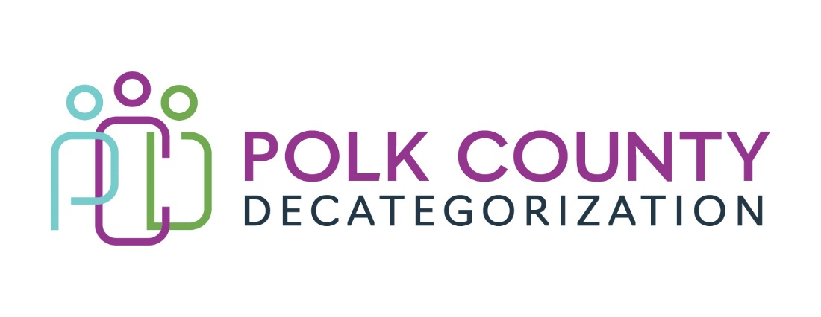

Polk Decat EXECUTIVE COMMITTEE Meeting
Thursday, January 9, 2025

Meeting Minutes

- The meeting was called to order in person at 10:05 am by Eric. Present voting members were Amanda Marshall, Jana Rhoads, Eric Kool, Joy Ihle, Andrea Vizthum Shannon LaFevour, and John Hawkins. Also, in attendance were, Jaime Stevens, Lisa Cort and Jay Hansen from Polk Decat.

- Review and approval of the November 9, 2024, meeting minutes.
- Jana moved to approve the November 9, 2024, minutes. John seconded to approve the minutes, and the motion was carried by unanimous vote.

- FY25 Contract Budget
  - Eric presented the FY25 budget contract expenditure updates. Highlights:
- LSI Trauma Informed Services at detention - 48% of their budget through November, projecting above their allocation. Lisa indicated they have used spending toward yoga and supplies such as games, workbooks for groups sessions.
  - Jaime will follow up with Amy Davis about overbudget projections
- Boys Town projected to expend all their FY25 funding before the end of the fiscal year
        - This is consistent with prior years and they will cover overages

- Voting Item to accept $90,000 FY24 HHS Transfer Funds
  - This item was voted to be removed from the agenda. The funds had already been accepted - Andrea moved to remove the voting items from the agenda and John seconded the motion. All were in favor of removing the voting item.

- SDMT Representative to the Executive Board
  - Jami Hagemeier is the new SDMT representative to the Decat Board. She will be replacing Stacie Nessa. Jami had a scheduling conflict and was unable to attend today’s meeting.
  - Carla Tripp may substitute for Jami’s absence when necessary.

- FY26 Contract and Budget Planning
  - Eric is scheduled to meet with John, Shannon, Kelly and the Decat staff to review budgets and contracts for FY26. The meeting will occur on Monday January 13, 2025

- DECAT/CPPC/ PAD updates
  - Jay shared there continues to be an uptick of youth in the PAD program. He has 36 new referrals that he’s scheduling appointments with. PAD has also implemented some new programming for youth- ServSafe Food Handling Course through ISU Extension and a monthly Girls Group with CHIC Behavioral Health Services. New boxing coach started for DMPD Pal program.
  - CPPC- Shared Decision-Making Team meets tomorrow 1/10/2025.
  - Jay, Eric and Joy have been attending Diversion and Deflection meetings with Polk County Behavioral Health Services

- Board Member Updates
  - Jana announced she will be retiring February 20, 2025. There have not been any candidates to fulfill the SAM presently. She will bring the new or Interim SAM to the next Decat board meeting on February 13, 2025.
  - Jana also shared HHS has started new initiatives for workers to have more interactions with their families. HHS will be procuring an updated system for tracking their clients.
  - Andrea shared she has been on the Multi Community Service Team focusing on kids with high needs.
  - John shared the new FSLA process for JCO’s. JCS is updating their on-call process for JCO’s. There is a district meeting on Monday 1/13/2025 and three new JCO’s will be sworn in on Wednesday 1/15/2025.
  - Eric shared that juveniles in detention centers may be Medicaid-eligible but parameters and how it will work is still being worked out with Iowa Medicaid Enterprise.

- Adjourn: John moved to adjourn. Jana seconded the motion. The motion passed unanimously. The meeting was adjourned at 11:07 a.m.

Upcoming meeting
      - FY26 Services and Budget Planning
      - JCS Transfers for Decat and Re-entry Navigator Position
      - Polk HHS Leadership Transition

The next regularly scheduled meeting will be on Thursday, February 13, 2025, at 10:00 a.m.at Polk County Family Enrichment Center. - JS

