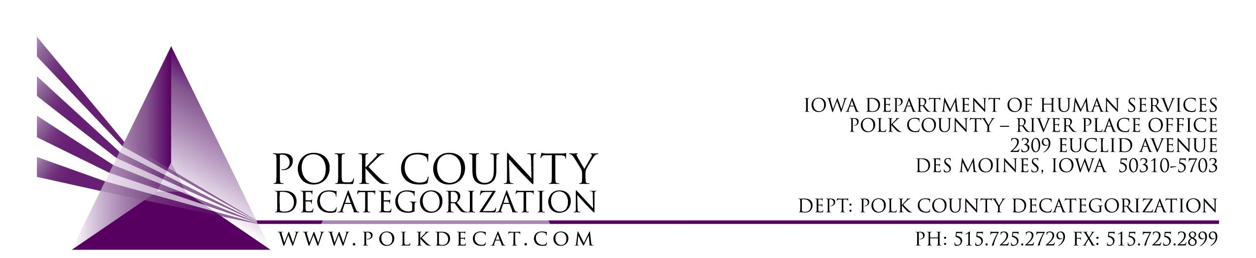

POLK DECAT EXECUTIVE COMMITTEE
Thursday, December 10, 2020
10:00 am – 11:00 am
Video Conference or Call-in
Call in: 1-469-998-6046, Conference ID 52970897#

MEETING A G E N D A

- Call to order: Time _________ | Eric Kool
- Review and approval of the November 12, 2020, meeting minutes *  1st_________ 2nd __________ Approve: Y/N | All
- Review FY21 Budget & Financial Status of Polk Decat | Teresa
- Discuss and vote: Accept DHS Transfer of Funds letter.*  1st_________ 2nd __________ Approve: Y/N  Transfer Letter amount:________________ | Teresa
- Discuss and vote: Possible adjustment of FY21 DCAT5-19-001 Fiscal Agent contract value based on available funding.*  1st_________ 2nd __________ Approve: Y/N  Current contract value: $295,000.00  Amend value by: $_____________________ | All
- Review contract performance follow-up | Cassie Kilgore
- RJCE and CPPC Updates | Teresa
- Next meeting:  - Transfer(s) of funds, if any  - Possible adjustment to DCAT5-19-001, Fiscal Agent Contract FY21 value (if not decided in December meeting)  - Review of FY21 budget  - Initial FY22 Contract Renewal discussion  - RJCE and CPPC activities  - Anything else? | All
- Adjourn: Time ___________*  1st_________ 2nd __________ Approve: Y/N | Eric Kool

Next meeting: January 14, 2020, 10:00 am, via video conference.

GoToMeeting Invitation - Polk Decat Board Meeting
Please join my meeting from your computer, tablet or smartphone.
https://global.gotomeeting.com/join/215325773
You can also dial in using your phone.
(For supported devices, tap a one-touch number below to join instantly.)
United States: 1 (571) 317-3122
- One-touch: tel: 15713173122,,215325773#
Access Code: 215-325-773

