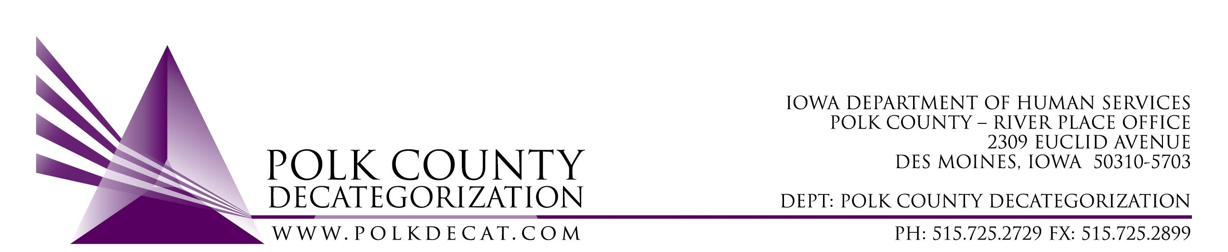

POLK DECAT EXECUTIVE COMMITTEE
Monday, November 22, 2021
1:30 – 2:30 pm
Video Conference or Call-in
Call in: 1-469-998-6046, Conference ID 964 367 558#

MEETING A G E N D A

- Call to order: Time _________ | Eric Kool
- Review and approval of the October 14, 2021, meeting minutes *  1st_________ 2nd __________ Approve: Y/N | All
- Review FY22 Budget | Teresa
- Discussion and vote: Accept Ames Decat Cluster Transfer of Funds letter for $52,000.00 for various activities as described in the Transfer of Funds letter*  1st_________ 2nd __________ Approve: Y/N | Teresa and All
- Discussion and vote: Add $40,500.00 to DCAT5-18-002 for additional community grants, trainings and to support the Trauma Informed Supervision services and approval of the Amendment. *  $35,000.00 FY20 DHS State Carry Over funds  $5,500.00 FY21 JCS State Carry Over funds  1st_________ 2nd __________ Approve: Y/N | Teresa and All
- Discussion and vote: Add $37,425.00 to DCAT5-19-001 for DHS and JCS leadership and team building activities, wellness activities, and furnish a boys drug court room at JCS and approval of the Amendment. *  $17,000.00 FY20 DHS State Carry Over funds  $20,425.00 FY21 JCS State Carry Over funds  1st_________ 2nd __________ Approve: Y/N | Teresa and All
- Discussion and vote: Approve FY21 Polk Decategorization Annual Progress Report.*  1st_________ 2nd __________ Approve: Y/N | Teresa
- Discussion and vote: Initiate an RFP to procure DCAT5-22-121, JCS Internal Climate Survey & Individual Interview services, to start spring of 2022. *  1st_________ 2nd __________ Approve: Y/N | John & Teresa
- Other Decat, RJCE and CPPC Updates:  - Pre-Arrest Diversion update  - Projects, trainings, and grants  - Discuss rebranding efforts | Teresa & Cassie
- Next meeting:  - Review of FY22 budget  - Discussion on use of some of the JCS unencumbered funds  - RFP update  - Discuss initial thoughts on renewals  - Other Decat, RJCE and CPPC activities  - Anything else? | All
- Adjourn: Time ___________*  1st_________ 2nd __________ Approve: Y/N | Eric Kool

Next meeting: January 13, 2022, 10:00 am, via video conference.

Microsoft Teams meeting
Join on your computer or mobile app
Click here to join the meeting
Or call in (audio only)
+1 469-998-6046,,964367558# United States, Dallas
Phone Conference ID: 964 367 558#
Find a local number | Reset PIN

