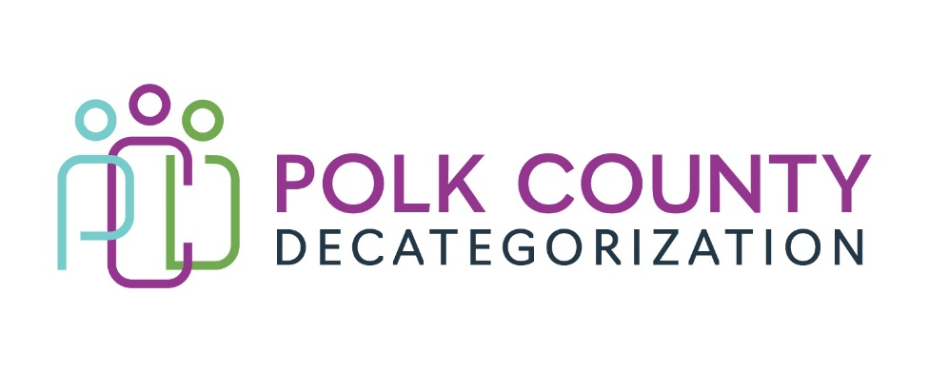

POLK DECAT EXECUTIVE COMMITTEE
Thursday, November 10, 2022
10:00 – 11:30 AM
Family Enrichment Center Conference Room, Polk County River Place

MEETING A G E N D A

- Call to order: Time _________ | Eric Kool
- Review and approval of the October 13, 2022, meeting minutes. *  1st_________ 2nd __________ Approve: Y/N | All
- Review FY23 budget  - FY23 Contract Budget Tracking Spreadsheet | Teresa Burke
- Discussion and vote: Review and approve FY22 Polk Decategorization Annual Progress Report. *  - The Annual Progress Report is a required Decat report that is due to State-level Child Welfare, Public Health Early Childhood and JCS representatives by December 1 of every year. The Executive Committee is technically the entity submitting the report, so the Board’s review and approval is necessary.  1st_________ 2nd __________ Approve: Y/N | Teresa Burke
- Discussion and vote: Replace the Project/CPPC Coordinator position that will be vacated by Cassie Kilgore. Her official last day will be November 23, 2022. *  1st_________ 2nd __________ Approve: Y/N | Teresa Burke
- Discussion and vote: Replace the Administrative and Resource Specialist position that will be vacated by Veronica Russell. Her official last day will be November 10, 2022. *  1st_________ 2nd __________ Approve: Y/N | Cassie
- Other Decat, RJCE and CPPC Discussion Items and Updates  - RFP Updates  - Actions taken to ensure Decat critical activities are covered  - Other | Teresa & Cassie
- Next meeting:  - Review of FY23 budget & expenditures  - Discussion & possible vote on use of unencumbered funds  - Other Decat, RJCE and CPPC activities  - Anything else? | All
- Adjourn: Time ___________*  1st_________ 2nd __________ Approve: Y/N | Eric Kool

Next meeting: January 12, 2023, 10:00 am, Family Enrichment Center Conference Room, Polk County River Place. No December meeting unless a voting item necessitates a meeting.

