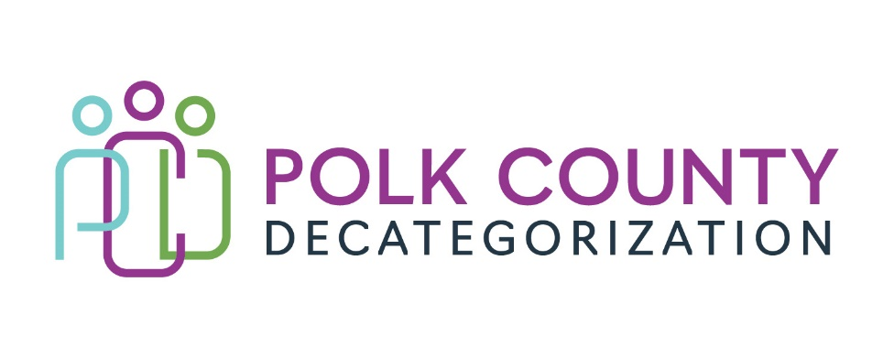

POLK DECAT EXECUTIVE COMMITTEE
Thursday, September 14, 2023
10:00 – 11:30 AM
Family Enrichment Center Conference Room, Polk County River Place

MEETING A G E N D A

- Call to order: Time _________ * | Eric Kool
- Review and approval of the August 10, 2023, meeting minutes. *  1st_________ 2nd __________ Approve: Y/N | All
- Review FY24 budget  - FY24 Contracts Budget Tracking Spreadsheet | Teresa Burke
- Discussion and vote: Add $11,000.00 in FY22 Decat Legislative Allocation funds to DCAT5-22-143, Decat & CPPC Coordination Contract, to cover salary increase due to hiring Jaime Stevens, to add to CPPC community budget, and cover other fringe costs (from $422,000.00 to $433,000.00). *  Refer to Fourth Amendment document.  1st_________ 2nd __________ Approve: Y/N | Teresa Burke
- Discussion and vote: Add $14,000.00 in FY23 JCS State Carry-over funds to DCAT5-22-145, Pre-Arrest Diversion Case Management Services Contract, to cover increased benefits and fringe costs (from $110,534.00 to $124,534.00). *  Refer to Fifth Amendment document.  1st_________ 2nd __________ Approve: Y/N | Teresa Burke
- Discussion and vote: Add $11,000.00 in FY24 HHS PSSF (Promoting Safe and Stable Families) federal funds to DCAT5-19-001, Fiscal Agent Services, to cover family preservation supports that result from Child Safety Conferences (from $210,975.00 to $221,975.00). *  Refer to Tenth Amendment document.  1st_________ 2nd __________ Approve: Y/N | Teresa Burke
- Discussion and vote: Review and approve FY24 Polk Decat Annual Service Plan. *  Refer to FY24 Plan document.  1st_________ 2nd __________ Approve: Y/N | Teresa Burke
- Review of FY23 final quarterly highlights.  Refer to FY23 Year-end Contract Performance document. | Teresa Burke
- Discussion: Contracts up for procurement in FY24 for July 1, 2024, start date:  - DCAT5-19-001, Fiscal Agent Services considerations:  - Can procure or possibly continue with CIJDC with Fiscal Agent Intergovernmental Agreement.  - Currently has both HHS and JCS funds, as well as DCAT funds.  - DCAT5-19-002, Psychological Evaluations considerations:  - Will HHS not allow JCS FY24 and beyond funds to be transferred to Decats and be contract owner for JCS Decat-funded contracts?  - DCAT5-19-003, Preventive Law & Guidance considerations:  - Will HHS be transferring state carryover funds to Decats in FY25?  - Other Considerations for starting procurements:  - Will Decats continue in FY25? | Teresa Burke
- Other Decat, RJCE and CPPC Discussion Items and Updates  - CPPC update  - Decat – helping HHS with Child Welfare Worker appreciate week.  - Teresa Burke retirement notice sent to Board. Discussion on next steps for replacement or other options.  - Other | Teresa Burke, Eric Kool, All
- Next meeting:  - Review of FY24 budget  - Possible review and vote on FY23 Polk Decat Annual Progress Report  - Discussion on procurements  - Other Decat, RJCE and CPPC activities  - Anything else? | All
- Adjourn: Time ___________*  1st_________ 2nd __________ Approve: Y/N | Eric Kool

Next meeting: October 12, 2023, 10:00 am, Family Enrichment Center Conference Room, Polk County River Place, if there are voting items.

