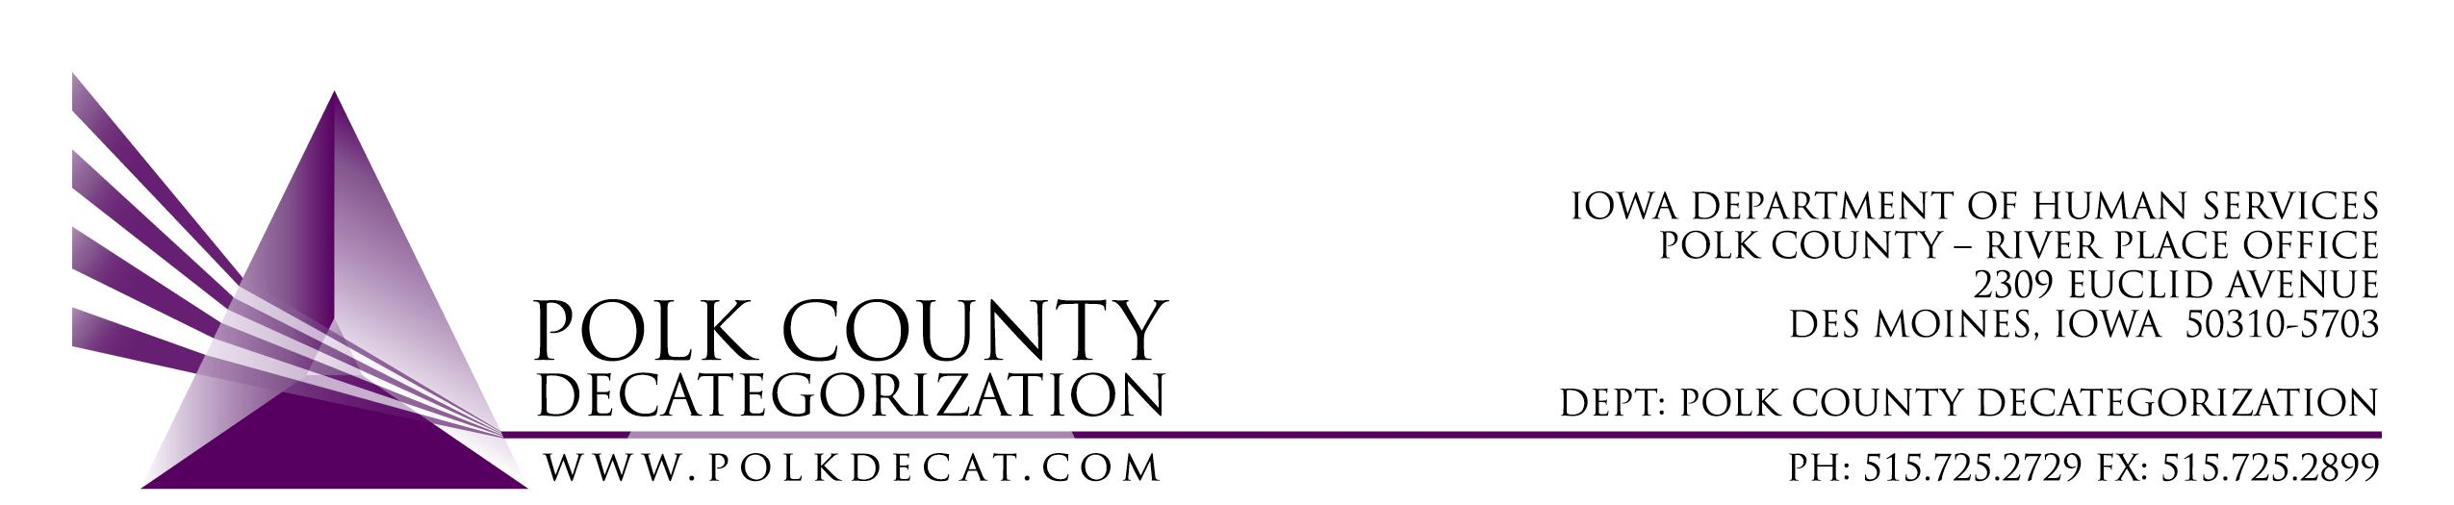

POLK DECAT EXECUTIVE COMMITTEE
Thursday, September 9, 2021
10:00 am – 11:30 am
Video Conference or Call-in
Call in: 1-469-998-6046, Conference ID 521 733 050#

MEETING A G E N D A

- Call to order: Time _________  Introduce Mindy Norwood, new DMSA EO2 | Eric Kool
- Review and approval of the August 12, 2021, meeting minutes *  1st_________ 2nd __________ Approve: Y/N | All
- Review FY22 budget | Teresa
- Discussion and vote: FY22 Polk Decat Annual Plan*  1st_________ 2nd __________ Approve: Y/N | Teresa and All
- Discussion and vote: Sole Source/Emergency contract for Child Welfare family visit services in Polk County*  1st_________ 2nd __________ Approve: Y/N | Jana, Robert and Teresa
- Polk Decat contract performance review | Cassie
- Other Decat, RJCE and CPPC Updates:  - Pre-Arrest Diversion case manager hiring update  - Black Doula project update  - New contract updates  - Projects, trainings and grants | Teresa & Cassie
- Next meeting:  - Review of FY22 budget  - Discussion on use of some of the JCS unencumbered funds  - Other Decat, RJCE and CPPC activities  - Anything else? | All
- Adjourn: Time ___________*  1st_________ 2nd __________ Approve: Y/N | Eric Kool

Next meeting: October 14, 2021, 10:00 am, via video conference.

Microsoft Teams meeting
Join on your computer or mobile app
Click here to join the meeting
Or call in (audio only)
+1 469-998-6046,,521733050# United States, Dallas
Phone Conference ID: 521 733 050#
Find a local number | Reset PIN

