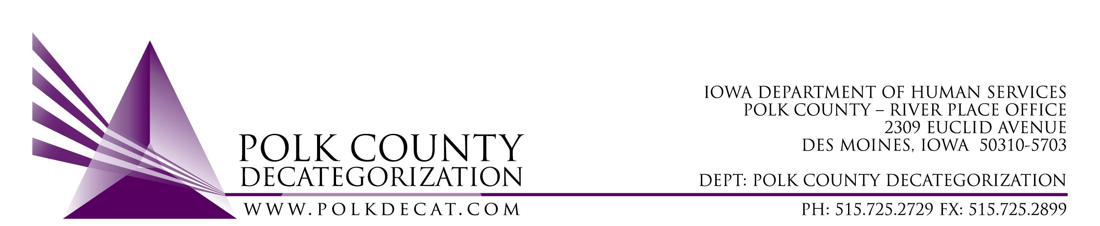

POLK DECAT EXECUTIVE COMMITTEE
Thursday, August 11, 2022
10:00 – 11:30 am
Family Enrichment Center Conference Room, Polk County River Place

MEETING A G E N D A

- Call to order: Time _________ | Eric Kool
- Review and approval of the June 9, 2022, meeting minutes. *  1st_________ 2nd __________ Approve: Y/N | All
- Review FY22 Budget and projected FY23 budget  - FY22 Contract Budget Tracking Spreadsheet – review for any reversion of funds  - Estimated FY23 Polk Decat Contracts by funding source spreadsheet  - FY23 new Contract Budget Tracking spreadsheet will be available for September Board meeting after initial reconciliation | Teresa Burke
- Discussion and vote: Accept FY22 CPPC Annual Year-end Report and Budget. *  1st_________ 2nd __________ Approve: Y/N | Cassie Kilgore
- Discussion and vote: Accept Amendments and approve inclusion of Administrative Overhead language in the following contracts: *  - DCAT5-22-143, Decat & CPPC Coordination Services  - DCAT5-22-144, Restorative Justice & Cultural Equity Coordination Services  - DCAT5-22-145, Pre-Arrest Diversion Case Management & Coordination Services  1st_________ 2nd __________ Approve: Y/N | Teresa & Eric
- Discussion and vote: Adopt new logo for Polk Decategorization. *  1st_________ 2nd __________ Approve: Y/N  Discuss next steps in the re-imaging process. | Cassie and Teresa
- Other Decat, RJCE and CPPC Updates:  - SDM Steering Committee recommendations for grants if funding available  - Pre-Arrest Diversion update  - RJCE Update  - Parent Cafes  - Flex Funds update  - Polk Decat Staff transition to Polk County update:  - Will eventually need to adjust budgets for FY22  - Rent discussion | Teresa & Cassie
- Next meeting:  - Review of FY22 final & FY23 budgets & expenditures  - Semi-annual contract performance review  - FY23 Polk Decat Annual Plan: review and vote to approve  - Discussion: re-look at Board meeting documents, review of contracts, etc., and anything else the Board would like to know about general Decat activities on-going  - Discussion & possible vote on FY23 mini-grants procurement  - FY22 Flex Funds usage review  - Other Decat, RJCE and CPPC activities  - Anything else? | All
- Adjourn: Time ___________*  1st_________ 2nd __________ Approve: Y/N | Eric Kool
- Closed session: Personnel Performance Review †

Next meeting: September 8, 2022, 10:00 am, Family Enrichment Center Conference Room, Polk County River Place.

