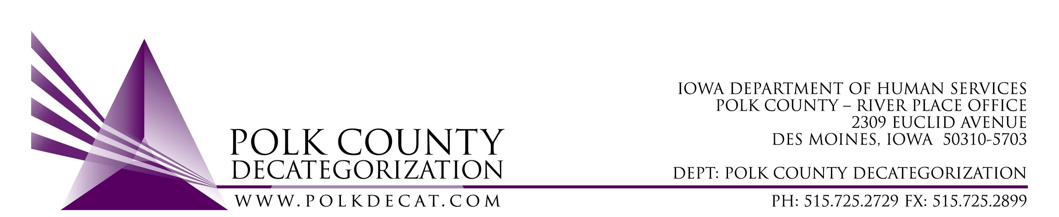

POLK DECAT EXECUTIVE COMMITTEE
Thursday, May 13, 2021
10:00 am – 11:30 am
Video Conference or Call-in
Call in: 1-469-998-6046, Conference ID 521 733 050#

MEETING A G E N D A

- Call to order: Time _________ | Eric Kool
- Review and approval of the April 8, 2021, meeting minutes *  1st_________ 2nd __________ Approve: Y/N | All
- Review FY21 Budget & Financial Status of Polk Decat | Teresa
- Discussion and vote: FY22 Polk CPPC Annual Plan.*  1st_________ 2nd __________ Approve: Y/N | All
- Discussion and vote: Accept Transfer of Funds letters from JCS  1st_________ 2nd __________ Approve: Y/N | Teresa
- Discussion and vote: Add $6,000.00 in Decat FY19 State Funds to the DHS Volunteer Coordination contract, V2019-01-05, for FY21, increasing Polk Decat funding from $19,600.00 to $25,600.00 and the total contract value from $60,000.00 to $66,000.00.  1st_________ 2nd __________ Approve: Y/N | Robert & Teresa
- Review contract performance | Cassie
- Polk Decat logo and image rethink | Cassie
- Other Decat, RJCE and CPPC Updates:  - Renewal & new contract updates  - Projects, trainings and grants | Teresa & Cassie
- Next meeting:  - Transfers of funds?  - Review of FY21 budget  - Discussion on use of some of the JCS unencumbered funds  - Other Decat, RJCE and CPPC activities  - Anything else? | All
- Adjourn: Time ___________*  1st_________ 2nd __________ Approve: Y/N | Eric Kool

Next meeting: June 10, 2021, 10:00 am, via video conference.

Microsoft Teams meeting
Join on your computer or mobile app
Click here to join the meeting
Or call in (audio only)
+1 469-998-6046,,521733050# United States, Dallas
Phone Conference ID: 521 733 050#
Find a local number | Reset PIN

