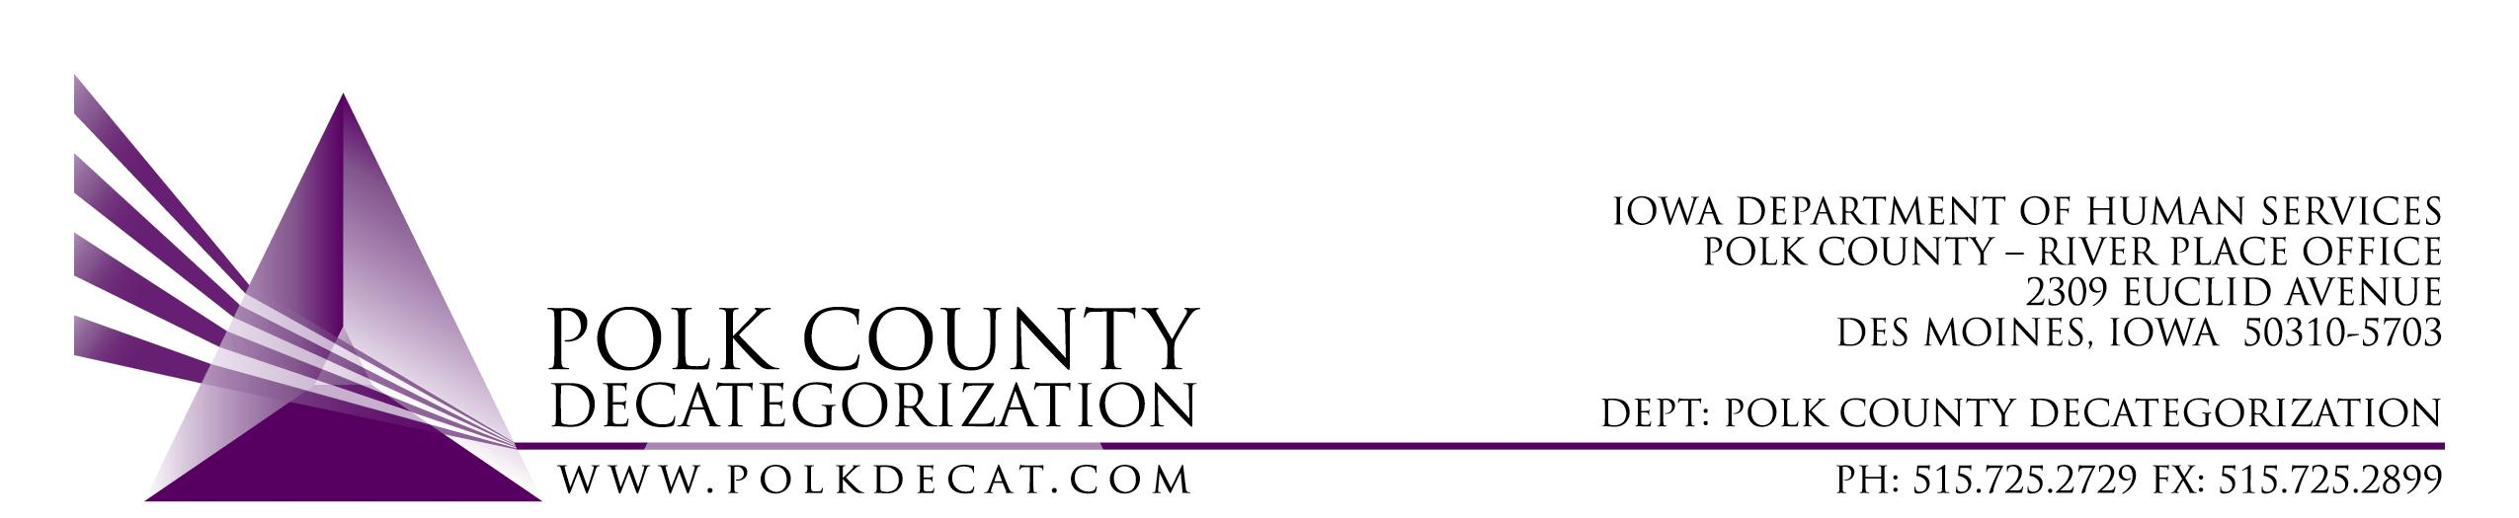

POLK DECAT EXECUTIVE COMMITTEE
Thursday, May 12, 2022
10:00 – 11:30 am
Video Conference or Call-in
Call in: 1-469-998-6046, Conference ID 521 733 050#

MEETING A G E N D A

- Call to order: Time _________ | Eric Kool
- Review and approval of the April 14, 2022, meeting minutes and renewal voting addendum minutes and the April 26, 2022, special meeting minutes and renewal voting addendum minutes. *  1st_________ 2nd __________ Approve: Y/N | All
- Review FY22 Budget and projected FY23 budget  - FY22 Contract Budget Tracking Spreadsheet  - Estimated FY23 Polk Decat Contracts by funding source spreadsheet | Teresa
- Discussion and vote: Community Partnership for Protecting Children (CPPC) FY23 Annual Plan and Budget. *  1st_________ 2nd __________ Approve: Y/N | Teresa & Cassie
- Update on Decat Staff transition. | Teresa, & Eric
- Other Decat, RJCE and CPPC Updates:  - DCAT5-22-121, JCS Climate Survey update  - Pre-Arrest Diversion update  - Parent Cafes  - Payables challenges and spending down plans | Teresa & Cassie
- Next meeting:  - Does the board need to meet in June and does the board want to start meeting in person?  - Review of FY22 & FY23 budgets  - Discussion & possible vote on FY23 mini-grants procurement  - Decat staff transition update  - Other Decat, RJCE and CPPC activities  - Anything else? | All
- Adjourn: Time ___________*  1st_________ 2nd __________ Approve: Y/N | Eric Kool

Next meeting: June 9, 2022, 10:00 am, via video conference.

Microsoft Teams meeting
Join on your computer or mobile app
Click here to join the meeting
Or call in (audio only)
+1 469-998-6046,,521733050# United States, Dallas
Phone Conference ID: 521 733 050#
Find a local number | Reset PIN

