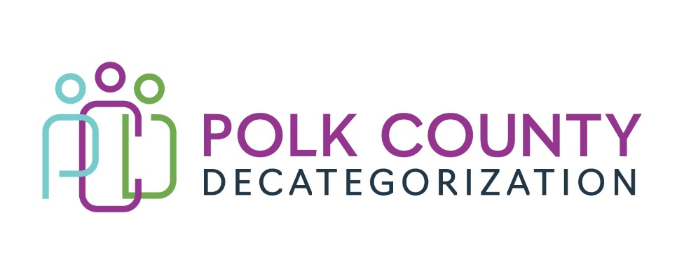

POLK DECAT EXECUTIVE COMMITTEE
Thursday, April 13, 2023
10:00 – 11:30 AM
Family Enrichment Center Conference Room, Polk County River Place

MEETING A G E N D A

- Call to order: Time _________ | Eric Kool
- Review and approval of the March 9, 2023, meeting minutes and minutes addendum for renewal voting. *  1st_________ 2nd __________ Approve: Y/N | All
- Review FY23 and FY24 budgets  - FY23 Contract Budget Tracking Spreadsheet  - FY24 Contracts by funding source spreadsheet | Teresa Burke
- Discussion and vote: Second round of FY24 contract renewal voting*  Refer to Renewal Voting Addendum document and Amendments. | Teresa Burke
- Discussion and vote: Successful Bidder for DCAT5-24-150, Trauma Informed Services in Polk County Detention RFP. *  Refer to DCAT5-24-150 Evaluation Committee Recommendation to the Polk Decat Board and Evaluation spreadsheet.  1st_________ 2nd __________ Approve: Y/N | Teresa Burke
- Update on hiring for Project/CPPC Coordinator and RJCE Coordinator positions. | Teresa Burke & Eric Kool
- Other Decat, RJCE and CPPC Discussion Items and Updates  - Spend down activities.  - DHHS name change amendments.  - Hold still on CPPC and RJCE activities.  - Other | Teresa Burke
- Next meeting:  - Review of FY23 budget & expenditures  - Review and vote on FY24 Polk CPPC Annual Plan & Budget  - Other Decat, RJCE and CPPC activities  - Anything else? | All
- Adjourn: Time ___________*  1st_________ 2nd __________ Approve: Y/N | Eric Kool

Next meeting: May 11, 2023, 10:00 am, Family Enrichment Center Conference Room, Polk County River Place.

