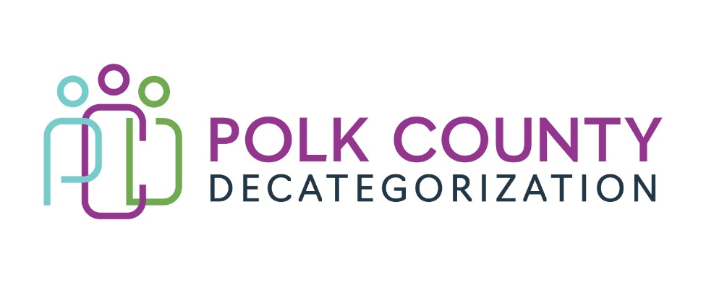

POLK DECAT EXECUTIVE COMMITTEE
Friday, April 26, 2024
Votes to be submitted electronically 04/26/2024

MEETING A G E N D A

- Discussion and vote: Accept Transfer of Funds letters from Juvenile Court Services to support Decat contracts in FY25. *
*Any board member wishing for a discussion prior to vote may request a virtual meeting be scheduled 04/26/2024.
Refer to transfer of funds letter documents for amounts and provisions.
1st_________ 2nd __________ Approve: Y/N

Next Meeting:

Thursday, May 9, 2024 – 10:00am – Polk County Family Enrichment Center

