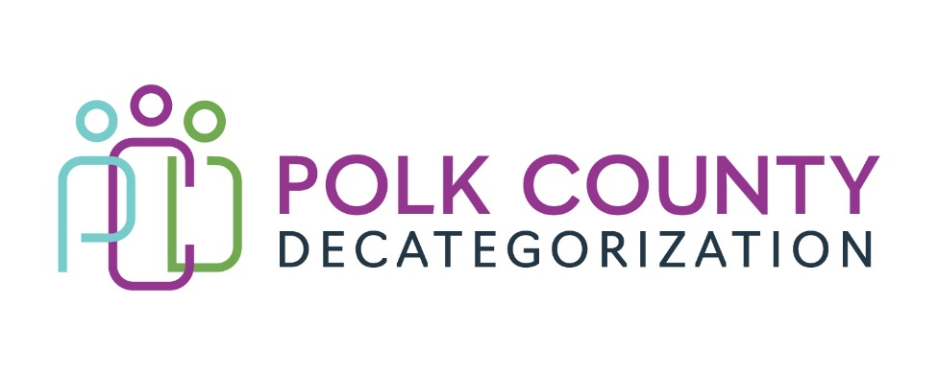

POLK DECAT EXECUTIVE COMMITTEE
Thursday, March 9, 2023
10:00 – 11:30 AM
Family Enrichment Center Conference Room, Polk County River Place

MEETING A G E N D A

- Call to order: Time _________ | Eric Kool
- Review and approval of the February 9, 2023, meeting minutes. *  1st_________ 2nd __________ Approve: Y/N | All
- Review FY23 budget  - FY23 Contract Budget Tracking Spreadsheet  - Includes transfers to Indianola Decat Cluster and CJJP  - No DHHS transfer this year. | Teresa Burke
- Follow-up Discussion: Support for Foster Care Review Board (FCRB) Expansion.  - Survey status.  - Next Steps. | All
- Discussion and vote: Transfer of $12,000.00 in FY21 Polk Decat Legislative Allocation funds to Indianola Decat Cluster for Decat and CPPC Coordination services and activities. *  Refer to Transfer of Funds letter.  1st_________ 2nd __________ Approve: Y/N | Teresa Burke
- Discussion and vote: Transfer of $6,500.00 in FY21 JCS State Carry-over funds to CJJP for the National Drug Court Conference for JCS Staff. *  Refer to Transfer of Funds letter.  1st_________ 2nd __________ Approve: Y/N | John Hawkins & Teresa Burke
- Discussion and vote: Increase DCAT5-22-112, JCS Reentry and Aftercare Services contract by $26,000.00, from $262,529.00 to $288,529.00, to ensure services can be covered until the end of FY23, and to approve the 2nd Amendment. *  Refer to the 2nd Amendment and “Justification” document.  1st_________ 2nd __________ Approve: Y/N | John Hawkins and Teresa Burke
- Discussion and vote: Increase amount of FY21 DHHS State Carry-over funds in V2019-01-05, Volunteer Coordination Services contract, by $11,000.00. *  1st_________ 2nd __________ Approve: Y/N | Jana Rhoads, Amanda Marshall, Teresa Burke
- Performance outcomes highlights review | Teresa Burke
- Discussion and vote: First round of FY24 contract renewal voting*  Refer to Renewal Voting Addendum document and Amendments. | Teresa Burke
- Discussion and vote: Successful Bidder for DCAT5-24-148, Early Services Program RFP. *  Refer to DCAT5-24-148 Evaluation Committee Recommendation to the Polk Decat Board and Evaluation spreadsheet.  1st_________ 2nd __________ Approve: Y/N | Teresa Burke
- Discussion and vote: Successful Bidder for DCAT5-24-149, Sanctions Learning Services RFP. *  Refer to DCAT5-24-149 Evaluation Committee Recommendation to the Polk Decat Board and Evaluation spreadsheet.  1st_________ 2nd __________ Approve: Y/N | Teresa Burke
- Update on hiring for Project/CPPC Coordinator and RJCE Coordinator positions. | Teresa Burke & Eric Kool
- Other Decat, RJCE and CPPC Discussion Items and Updates  - RFP Updates  - Hold still on CPPC and RJCE activities  - Other | Teresa Burke
- Next meeting:  - Review of FY23 budget & expenditures  - Finish FY24 renewal discussion and voting on remaining contracts  - Other Decat, RJCE and CPPC activities  - Anything else? | All
- Adjourn: Time ___________*  1st_________ 2nd __________ Approve: Y/N | Eric Kool

Next meeting: April 13, 2023, 10:00 am, Family Enrichment Center Conference Room, Polk County River Place.

