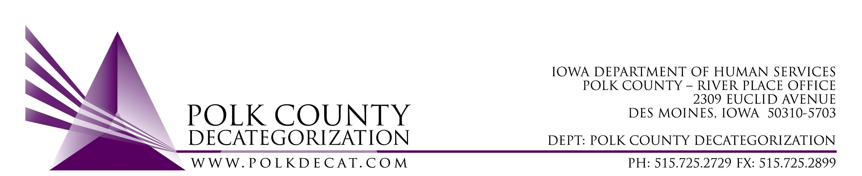

POLK DECAT EXECUTIVE COMMITTEE
Thursday, February 11, 2021
10:00 am – 11:30 am
Video Conference or Call-in
Call in: 1-469-998-6046, Conference ID 521 733 050#

MEETING A G E N D A

- Call to order: Time _________ | Eric Kool
- Review and approval of the January 14, 2021, meeting minutes *  1st_________ 2nd __________ Approve: Y/N | All
- Review FY21 Budget & Financial Status of Polk Decat | Teresa
- Discuss and vote: Transfer of FY19 JCS State funds from Polk Decat to CJJP and to Leon, Creston and Indianola Decat Clusters.*  1st_________ 2nd __________ Approve: Y/N  Transfer Letter To Amount Stipulation  CJJP $40,000.00 EPICS Training  Leon Decat Cluster $50,000.00 Decat Coordination, Special Community Projects and Flex Funds  Creston Decat Cluster $23,000.00 Decat Coordination and Special Community Projects  Indianola Decat Cluster $100,662.00 Decat & CPPC Coordination, Flex Funds, Als Pals, Parent Cafes, Dads Cafes, Addiction Cafes  Total $213,662.00  This will increase the amount of FY20 JCS State (newer) contracted funds to $331,340.42 in an effort to reduce the large amount of JCS unencumbered funds and avoid reversion of state funds at the end of the fiscal year. | Teresa
- FY22 Renewal initial discussion:  - Contemplate what services do we continue and what do we not renew? | All
- Other Decat, RJCE and CPPC Updates | Teresa
- Next meeting:  - Transfers of funds  - Review of FY21 budget  - Continue FY22 Contract Renewal discussion and possible renewal voting on some contracts  - Discussion on use of some of the JCS unencumbered funds  - Other Decat, RJCE and CPPC activities  - Anything else? | All
- Adjourn: Time ___________*  1st_________ 2nd __________ Approve: Y/N | Eric Kool

Next meeting: March 11, 2021, 10:00 am, via video conference.

Microsoft Teams meeting
Join on your computer or mobile app
Click here to join the meeting
Or call in (audio only)
+1 469-998-6046,,521733050# United States, Dallas
Phone Conference ID: 521 733 050#
Find a local number | Reset PIN

