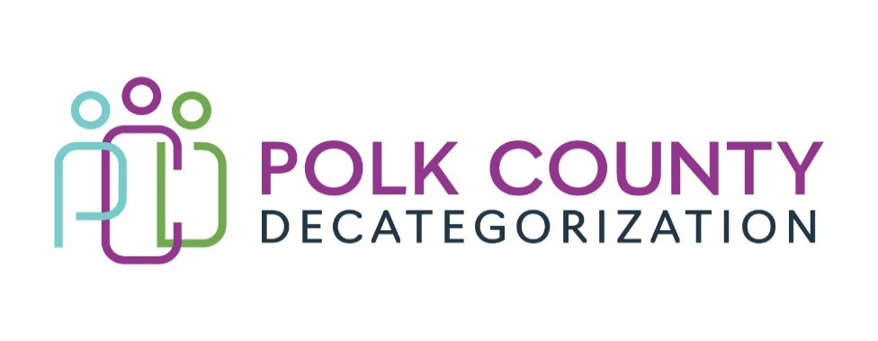

POLK DECAT EXECUTIVE COMMITTEE
Thursday, February 13, 2025
10:00 – 11:30 AM
Family Enrichment Center Conference Room, Polk County River Place

MEETING A G E N D A

- Call to Order: Time: _____________________ Eric

- Welcome – New SDMT Representative to Executive Board – Jami Hagemeier Jaime S.

- * Review and approval of the January 9, 2025 meeting minutes Eric
- See document: Executive Committee Meeting Minutes 01-09-25
1st ______________ 2nd _____________ Approve: Yes / No

- FY25 Contract Budget Tracking Jaime
- See document: FY25 Contract Budget Tracking January 2025
- Update: conversation with LSI about overspending projection

- * Voting item – Transfer $57,661.20 to CJJP for aftercare services Shannon
- See document: Transfer of FY24 Des Moines Decat Funds to CJJP
1st ______________ 2nd _____________ Approve: Yes / No

- * Voting item – acceptance of Jasper/Powesheik/Tama Decat funds Shannon
- See document: Judicial Branch Transfer Letter – Decat funds
1st ______________ 2nd _____________ Approve: Yes / No

- * Voting item – Contract termination Shannon
- DCAT-22-112 – JCS Re-Entry Aftercare Services
1st ______________ 2nd _____________ Approve: Yes / No

- * Voting item – Contract termination Shannon
- DCAT5-22-116 – JCS Youth Transition Planning
1st ______________ 2nd _____________ Approve: Yes / No

- * Voting item – acceptance of $462,897.00 JCS funds transfer Shannon
- See document: Judicial Branch Transfer Letter
- Juvenile Sex Offender Treatment and Trauma Services – FY26
1st ______________ 2nd _____________ Approve: Yes / No

- * Voting item – acceptance of $23,500 JCS funds transfer Shannon
- See document: Judicial Branch Transfer Letter
- Decat Management – FY26
1st ______________ 2nd _____________ Approve: Yes / No

- FY26 Contract and Budget planning - remaining current services All
  - JCS Pre-Arrest Diversion
  - JCS Early Services Program
  - JCS Sanctions Learning
  - Refugee Immigrant Guide
  - DMPS Student Supports
  - Fiscal Agent / Flex Funds

- * Voting item – Iowa Child Abuse Prevention Program grant application Jaime
1st ______________ 2nd _____________ Approve: Yes / No

- Other Decat, CPPC, RJCE, PAD updates Jaime, Jay

- Board Updates and Other Business All

- Thank you and farewell – Jana Rhodes Eric

- Next or Future Meetings: All
- FY26 Services and Budget Planning

- * Adjourn: Eric
1st ______________ 2nd _____________ _ Approve: Yes / No
Time: _______________________

Next Meeting:

Thursday, March 13, 2025 – 10:00am to 11:30am – Polk County Family Enrichment Center

