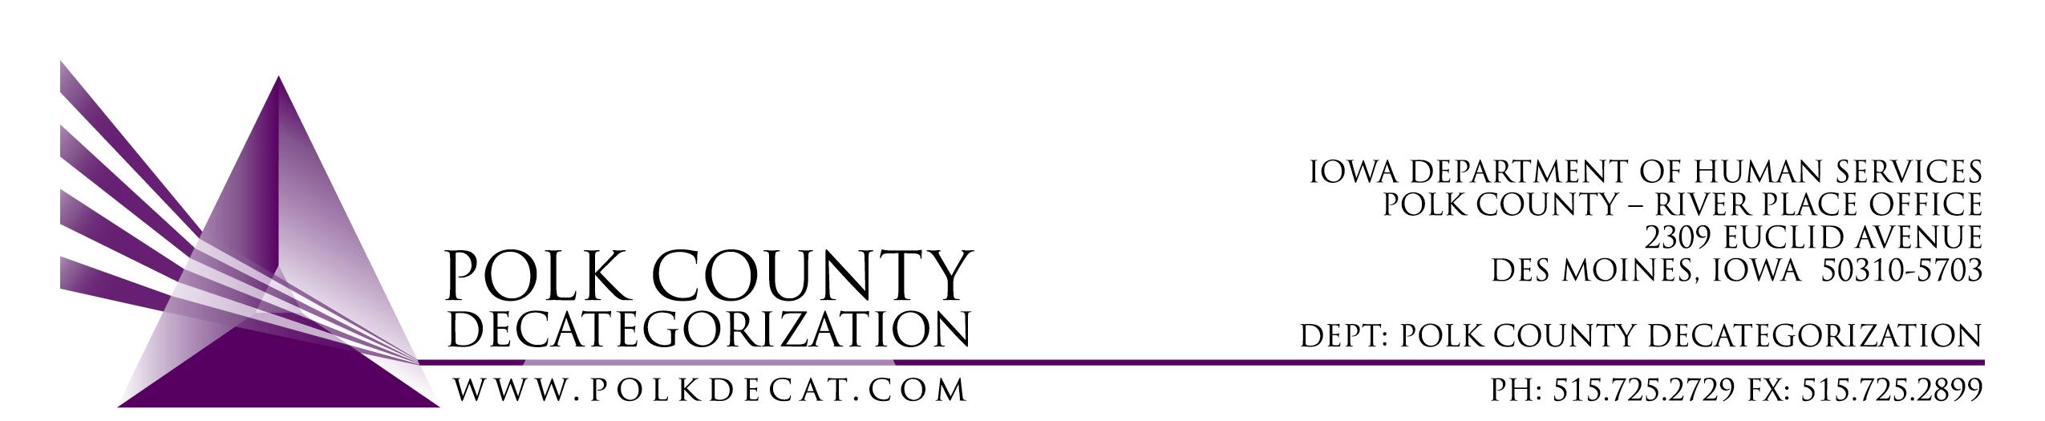

POLK DECAT EXECUTIVE COMMITTEE
Thursday, January 14, 2021
10:00 am – 11:30 am
Video Conference or Call-in
Call in: 1-469-998-6046, Conference ID 521 733 050#

MEETING A G E N D A

- Call to order: Time _________ | Eric Kool
- Review and approval of the December 10, 2020, meeting minutes *  1st_________ 2nd __________ Approve: Y/N | All
- Review FY21 Budget & Financial Status of Polk Decat  - Fiscal Agent contract review | Teresa
- Discuss and vote: Accept DHS Transfer of Funds letter.*  1st_________ 2nd __________ Approve: Y/N  Transfer Letter amount: $361,844.97 | Teresa
- Discuss and vote: Amend re-procurement of JCS Youth Re-entry and & Transition Youth Services into two procurements, one for Re-entry Services and one for Transition Youth Services, to be effective July 1, 2021.*  1st_________ 2nd __________ Approve: Y/N | All
- FY22 Renewal initial discussion:  - Decat & CPPC and RJCE Coordination salaries and budgets  - Contemplate what services do we continue and what do we not renew?  - Other considerations? | All
- Other Decat, RJCE and CPPC Updates | Teresa
- Next meeting:  - Possible adjustment to DCAT5-19-001, Fiscal Agent Contract FY21 value, depending on spending  - Review of FY21 budget  - Continue FY22 Contract Renewal discussion  - Other Decat, RJCE and CPPC activities  - Anything else? | All
- Adjourn: Time ___________*  1st_________ 2nd __________ Approve: Y/N | Eric Kool

Next meeting: February 11, 2021, 10:00 am, via video conference.

Microsoft Teams meeting
Join on your computer or mobile app
Click here to join the meeting
Or call in (audio only)
+1 469-998-6046,,521733050# United States, Dallas
Phone Conference ID: 521 733 050#
Find a local number | Reset PIN

