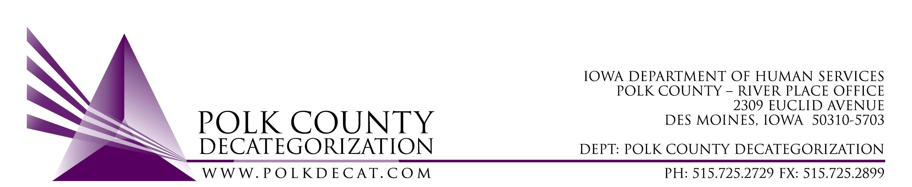

POLK DECAT EXECUTIVE COMMITTEE
Thursday, October 8, 2020
10:00 am – 11:30 pm
Video Conference and/or conference call
1-866-685-1580, pass code 000 999 0270

MEETING A G E N D A

- Call to order: Time _________ | Eric Kool
- Review and approval of the September 10, 2020, meeting minutes *  1st_________ 2nd __________ Approve: Y/N | All
- Review FY21 Budget | Teresa
- Discuss and vote: Accept DHS and/or JCS Transfer of Funds letter.*  1st_________ 2nd __________ Approve: Y/N  Transfer Letter(s) amount(s):________________ | Teresa
- Discuss and vote: Possible adjustment of FY21 DCAT5-19-001 Fiscal Agent contract value based on available funding.*  1st_________ 2nd __________ Approve: Y/N  Current contract value: $295,000.00  Amend value by: $_____________________ | All
- Next meeting:  - Transfer(s) of funds, if any  - Possible adjustment to DCAT5-19-001, Fiscal Agent Contract FY21 value (if not decided in October meeting)  - Review of FY21 budget  - Trauma Informed Supervision project  - RJCE and CPPC activities  - Anything else? | All
- Adjourn: Time ___________*  1st_________ 2nd __________ Approve: Y/N | Eric Kool

Next meeting: November 12, 2020, 10:00 am, via video conference.

