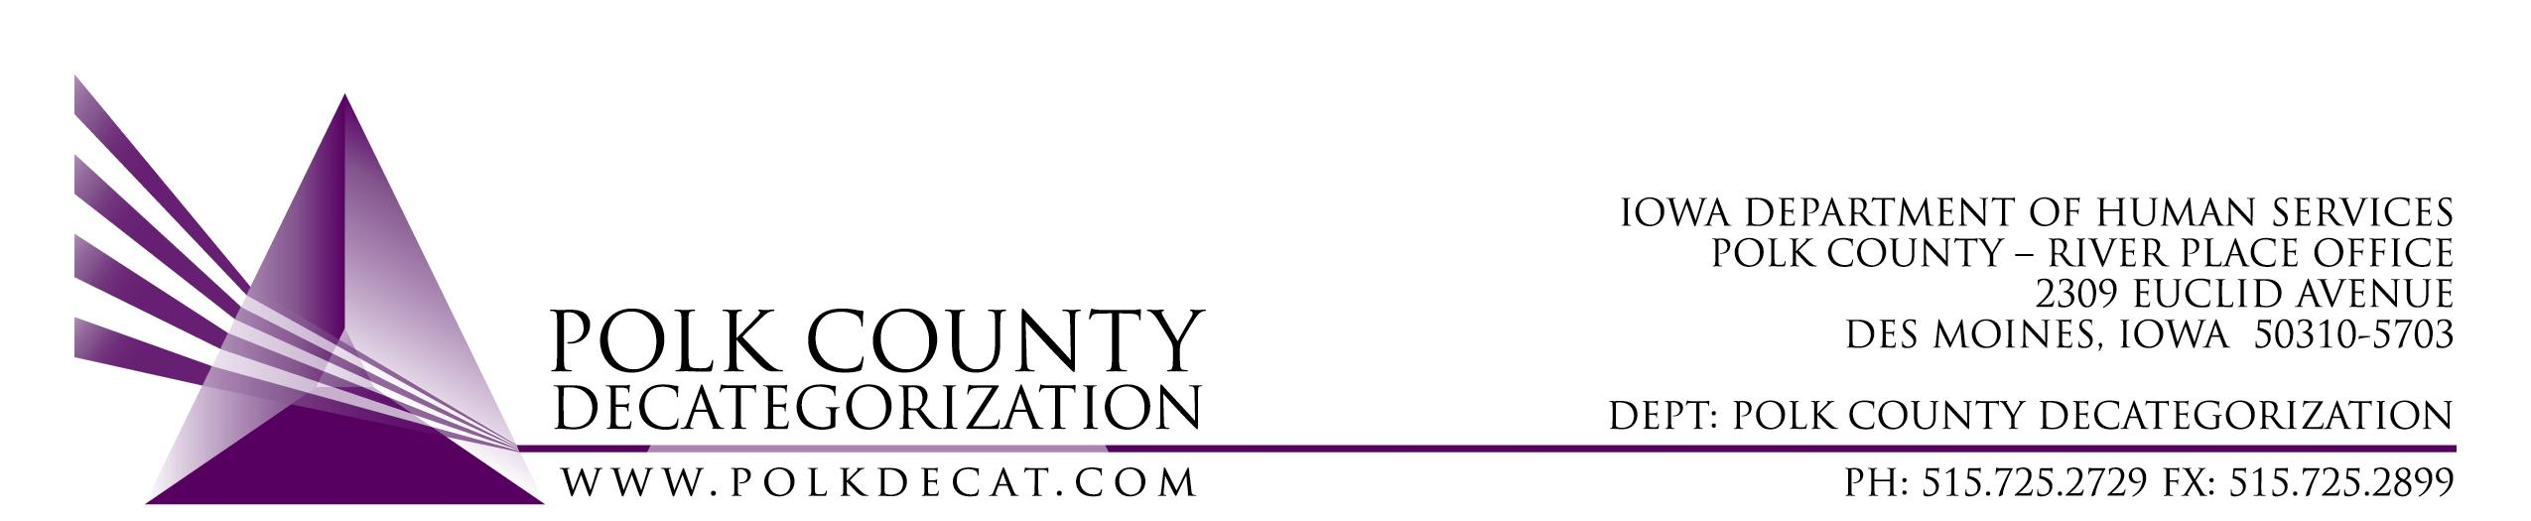

DECAT EXECUTIVE COMMITTEE
Thursday, December 13, 2018
10:00 – 11:30 am
Polk County River Place, Conference Room 3

MEETING A G E N D A

- Call to order: Time _________ | Mike
- Review and approval of the October 11, 2018, and November 8, 2018, meeting minutes*  1st_________ 2nd __________ Approve: Y/N | All
- FY19 Budget review and projection for FY20 | Teresa
- Closed discussion: Review top Administrative Assistant applicants and select those to be interviewed. † (Closed due to discussion of confidential applicant information.) | All
- Discussion and vote: RFP for JCS Internal Climate Survey for bids, with a contract effective date of April 8, 2019.*  1st_________ 2nd __________ Approve: Y/N  Full value of contract: _______________ | Chad
- Discussion and vote: Approve amendment to add $8,732.00 of unencumbered MYFI funds to DCAT5-17-052, the RJCE contract, to cover increase in activity in the Student Mentoring Project.*  1st_________ 2nd __________ Approve: Y/N | Teresa
- Discussion and vote: Possible change of use of FY17 Decat unencumbered funds.* (Tabled from September 13, 2018, October 11, 2018, and November 8, 2018, meetings)  1st_________ 2nd __________ Approve: Y/N  Other details: ________________________________ | All
- Decat Updates:  - RJCE Updates  - Decat/CPPC Updates | Teresa
- Next meeting:  - Review contracts for renewals (already)  - Anything else? | All
- Adjourn: Time ___________  1st_________ 2nd __________ Approve: Y/N | Mike

Next meeting: January 10, 2018, 10:00 am, Polk County River Place, Conference Room 3

