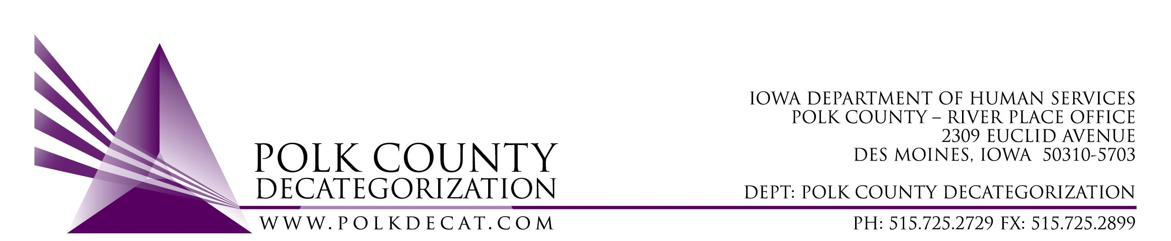

POLK DECAT EXECUTIVE COMMITTEE
Thursday, November 14, 2019
10:00 – 11:30 am
Polk County River Place, Conference Room 3

MEETING A G E N D A

- Call to order: Time _________ | Betty
- Review and approval of the October 10, 2019, meeting minutes *  1st_________ 2nd __________ Approve: Y/N | All
- Review and feedback of Decat Annual Plan | All
- Update on Flex Fund Bed Costs | Cassie
- Updates:  - RJCE and CPPC activities | Cassie & Diamond
- Next meeting:  - RFPs  - On-site Monitoring results  - RJCE and CPPC Updates  - Anything else? | All
- Adjourn: Time ___________*  1st_________ 2nd __________ Approve: Y/N | Betty
Next meeting: December 12, 2019, 10:00 am, Polk County River Place, Conference Room 3.

