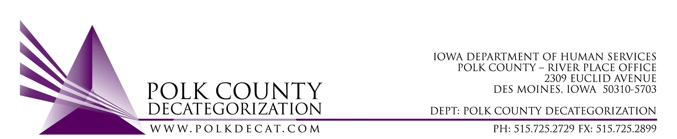

DECAT EXECUTIVE COMMITTEE
Thursday, November 9, 2017
10:00 – 11:30 am
Polk County River Place, Conference Room 3

MEETING A G E N D A

- Call to order | Mike
- Review and approval of October 12, 2017, meeting minutes*  1st_________ 2nd __________ Approve: Y/N | All
- Discussion and vote: Accept Transfer Letter from DHS to Polk Decat for $211,207.00 in FY17 DHS State Carry-over funds for use in FY18 and FY19.*  1st_________ 2nd __________ Approve: Y/N | All
- Discussion and vote: Re-procurement of contract DCAT5-15-007 ending 6/30/2017, Refugee Immigrant Guide Services, *  1st_________ 2nd __________ Approve: Y/N  If approved, target annual value: $____________ | Mike and All
- Discussion and vote: Re-procurement of contract ending 6/30/2018, DCAT5-16-113, Preventive Law & Guidance Services*  1st_________ 2nd __________ Approve: Y/N  If approved, target annual value: $____________ | Mike and All
- Discussion and vote: Review and approve FY17 Polk Decategorization Annual Progress Report* | Teresa and All
- Discussion and vote: Polk CPPC to apply for ICAPP/CBCAP funding on behalf of a community partner agency.*  1st_________ 2nd __________ Approve: Y/N | Teresa and All
- Budget Update | Teresa
- Discussion and vote: No Board meeting in December unless determined necessary by one of the board members*
1st_________ 2nd __________ Approve: Y/N

- Updates:  - Trauma Informed Services for youth in Polk County Detention Technical Assistance  - DCAT5-18-044, Behavioral Health Intervention & Prevention Coordination Services  - RJCE Coordinator position  - Fiscal Agent procurement status  - Decat Staff Status | Teresa
- Next meeting:  - Quarterly report review  - Anything else? | All
- Adjourn  1st_________ 2nd __________ Approve: Y/N | Mike

Next meeting: January 11, 2018, 10:00 am, Polk County River Place, Conference Room 3

