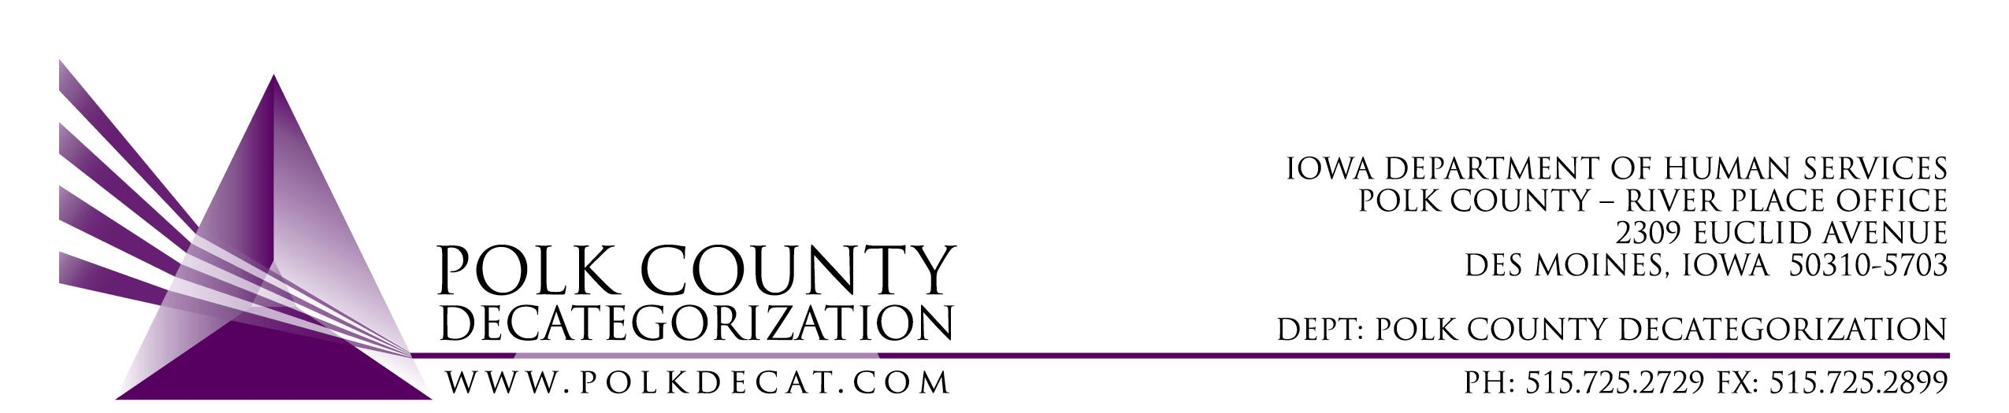

DECAT EXECUTIVE COMMITTEE
Thursday, October 12, 2017
10:00 – 11:30 am
Polk County River Place, Conference Room 3

MEETING A G E N D A

- Call to order | Mike
- Review and approval of September 14, 2017, meeting minutes*  1st_________ 2nd __________ Approve: Y/N | All
- Discussion and vote: Increase DCAT5-18-001, Early Service Program contract by $2,500.00 to cover training 2 facilitators in the Love and Logic Parenting curriculum*  1st_________ 2nd __________ Approve: Y/N | Chad and Teresa/All
- Budget Review | All
- Discussion and vote: Re-procurement of contract ending 6/30/2018, DCAT5-13-182, JCS Psychological Evaluations*  1st_________ 2nd __________ Approve: Y/N  If approved, target annual value: $____________ | Chad & All
- Updates:  - Trauma Informed Services for youth in Polk County Detention Technical Assistance  - DCAT5-18-044, Behavioral Health Intervention & Prevention Coordination Services  - RJCE Coordinator position posting  - Fiscal Agent procurement status  - Decat Staff Status | Teresa
- Next meeting:  - Quarterly report review  - Decat FY17 Annual Report review and approval*  - Anything else? | All
- Adjourn  1st_________ 2nd __________ Approve: Y/N | Mike

Next meeting: November 9, 2017, 10:00 am, Polk County River Place, Conference Room 3

